Chapter 6 Dallapiccola’s Compositional Development
The preceding chapters have intensively investigated the architectonic properties of four works by Dallapiccola, each one drawn from a different decade of his twelve-tone production. In order to evaluate the extent to which tonal analogue, linear structure, octatonic organization and tonal allusion are truly representative of his oeuvre, and trace their vicissitudes over time, for each work analyzed in detail, works closely preceding and/or following it will be analyzed cursorily. The works to be compared, then, are: Ciaccona, Intermezzo e Adagio (1945), Rencesvals (1946), Due Studi (1946-47); Quaderno Musicale di Annalibera (1952), Piccola Musica Notturna (1954), An Mathilde (1955); Dialoghi (1960), Preghiere (1962), Parole di San Paolo (1964); Sicut Umbra (1970), Tempus Destruendi/Tempus Aedificandi (1971), Commiato (1972). Taking Canti di Prigonia (1938-41) as Dallapiccola’s first twelve-tone work, he wrote approximately 25 such works. The sample of twelve is, therefore, fairly large.
Table 6.1 on the following page will help put Dallapiccola’s development in perspective. In his early serial period (1938-54) Dallapiccola employs twelve-tone technique to approximate tonal functions. Through Piccola Musica Notturna (1954), his works exhibit a strong linear structure in the bass, a disposition of rows mimicking the tension-relaxation properties of key organization (tonal analogue), and the use of tonal harmonic materials to emphasize important formal articulations (tonal allusion).

Table 6.1 Chronological Survey of Dallapiccola’s Compositional Technique

 | tonal analogue | linear structure | octatonic organization | tonal allusion
Ciaccona 1945 | + + | + + | + | +
Rencesvals 1946 | + + | + + | + | + +
Due Studi 1946-47 | + + | + + | _ | +
Quaderno 1952 | + | + | _ | +
Piccola Musica 1954 | + + | + + | + | + +
An Mathilde 1955 | + | + | + | _
Dialoghi 1960 | + + | + | _ | _
Preghiere 1962 | _ | _ | _ | _
Parole 1964 | + + | + | _ | _
Sicut Umbra 1970 | _ | _ | _ | _
Tempus 1971 | + + | + + | + + | _
Commiato 1972 | + | _ | + | _

++ = strong presence, + = some presence, - = little or none, shaded area = early serial period

As argued earlier, Piccola Musica Notturna is the turning point marking Dallapiccola’s farewell to the ‘phantom world of tonality’. Tonal allusion is present in the twelve-tone works up to and including it, and absent in the works following it. Among the works surveyed, all that fall within the early serial period exhibit a strong tonal analogue and linear structure. Although most works written after 1954 continue to display a strong tonal analogue and at least some arguably linear structure, starting with Preghiere (1962) there are works that show no clear indication of either device. As Dallapiccola’s twelve-tone technique became more sophisticated and flexible, the primary row became less important as a compositional building block; rows derived from replications of row segments are increasingly employed from Piccola musica notturna on. At the end of his career, in the first and last movements of Commiato there is no row at all, merely a series of twelve-tone aggregates constructed from permutations of various trichords. Where there is no definable ‘tonic’ row, it is obviously impossible to have any row areas.
Nevertheless, even in the works in which Dallapiccola abandoned the row area concept, he continued to be concerned with a definable harmonic vocabulary. For instance, in Preghiere the primary row is constructed so that different row levels yield identical tetrachords. In Commiato II, inversion of its row at the fifth and transposition at the tritone yield identical hexachords. A focus on a limited number of tetrachords or hexachords raises the possibility the Dallapiccola was erecting an edifice of tetrachordal or hexachordal levels as opposed to a level involving the entire row. However, I was unable to uncover a convincing compositional design involving the pitch levels of the tetrachords or hexachords in those pieces.
With the exception of Tempus Destruendi/Tempus Aedificandi, linear structure in the mature serial period tends to be rather weaker or absent altogether, possibly owing to a marked increase in melodic angularity.
Octatonic organization is the only formal dimension that does not show a clear difference between Dallapiccola’s early and mature serial periods; there are three works on either side of the divide that display some octatonic organization in at least one movement or section. To obtain a sharper focus, Table 6.2 on the following page samples all his twelve-tone works for octatonic row and octatonic harmonic organization. Octatonic rows are those rows that are divided into two segments, each of which consist of pcs taken from a single octatonic collection. “Wraparound” refers to octatonic rows whose first segment does not begin with op 0, i.e. 1-6, 7-0, as in the case of Job. The Roman numerals refer to movements in which octatonicism is present if it is not present throughout the work.
Whereas 10 of 13 works in the first period are constructed from a row that can be divided into two octatonic hexachords, only 4 of 11 works in the second period are so constructed. (Ex. 6.1 on p. 135 shows Dallapiccola’s octatonic rows.) The octatonic collections were used as a melodic resource more frequently during the earlier period. However, the incidence of their use as building blocks of harmonic structure in each period is roughly equal, 5/13 and 4/11. In the early period, (for instance, Sex Carmina
Alcaei and Cinque Frammenti di Saffo), different collections are often layered contrapuntally, a procedure by which the octatonic harmonic potential of each is canceled by the other.

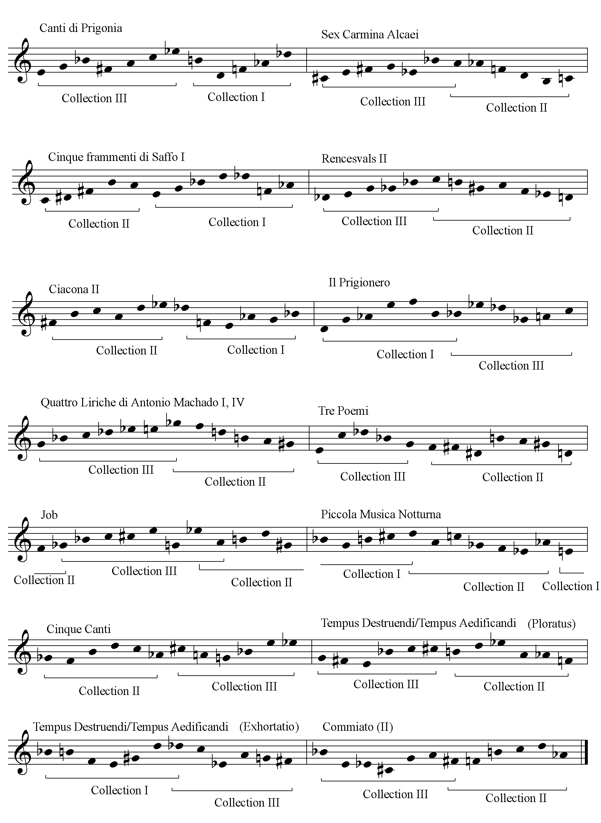
Ex. 6.1 Dallapiccola’s Octatonic Rows
However, the incidence of their use as building blocks of harmonic structure in each period is roughly equal, 5/13 and 4/11. In the early period, (for instance, Sex Carmina
Alcaei and Cinque Frammenti di Saffo), different collections are often layered contrapuntally, a procedure by which the octatonic harmonic potential of each is canceled by the other. In contrast, during Dallapiccola’s mature serial period, octatonic row segments tend to be verticalized, maximizing the row’s octatonic effect.
The third movement of An Mathilde is an interesting case of a non-octatonic row indirectly producing octatonic harmony. Here, Dallapiccola extracts an [0,1,6] trichord from the row, replicates it to create an octatonic aggregate, which is then verticalized to produce octatonic harmony. This will be discussed at greater length on pp. 154-55.
Not only is the incidence of octatonic harmony evenly balanced throughout Dallapiccola’s career but his two most intensely octatonic works, Il Prigionero (1948) (see Ex.6.2, for example) and Tempus Destruendi (1971), fall on either side of the divide.
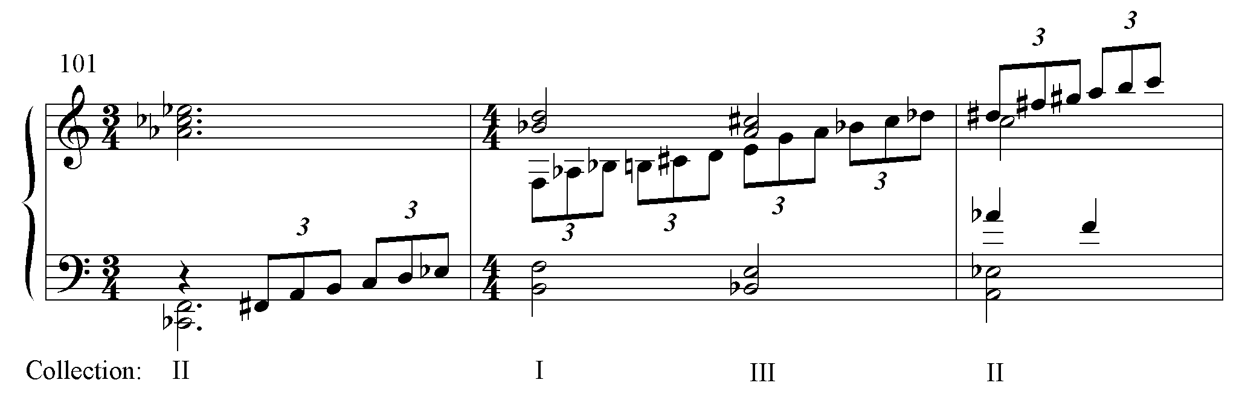
Ex. 6.2 Short range octatonic structure in Il Prigionero

Thus, I would say that Michael Eckert’s evaluation that “both melodically and harmonically, triadic and octatonic formations become increasingly rare in Dallapiccola’s music after the mid ‘50s”3 is only half-true. Yes, melodically, octatonic formations become more rare, and triads virtually disappear, but the incidence of octatonic harmony stays relatively constant. I will proceed to summarize the works surveyed in Table 6.1.
Ciaccona, Intermezzo e Adagio for solo cello
The Ciaccona is a series of variations on its row, each one of which, in the score, is marked off by a double bar. Some idea of its style and structure can be gleaned from mm.1-27 with the row forms indicated, displayed in Ex. 6.4 on the following page. Ex.6.3 below is the row from the Ciaccona.
Ex. 6.3 Ciaccona: row

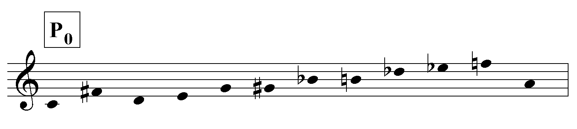
Table 6.3 on p. 137 shows the row levels for the entire movement. The qualification, (oo), indicates that the row is somewhat reordered (out of order).

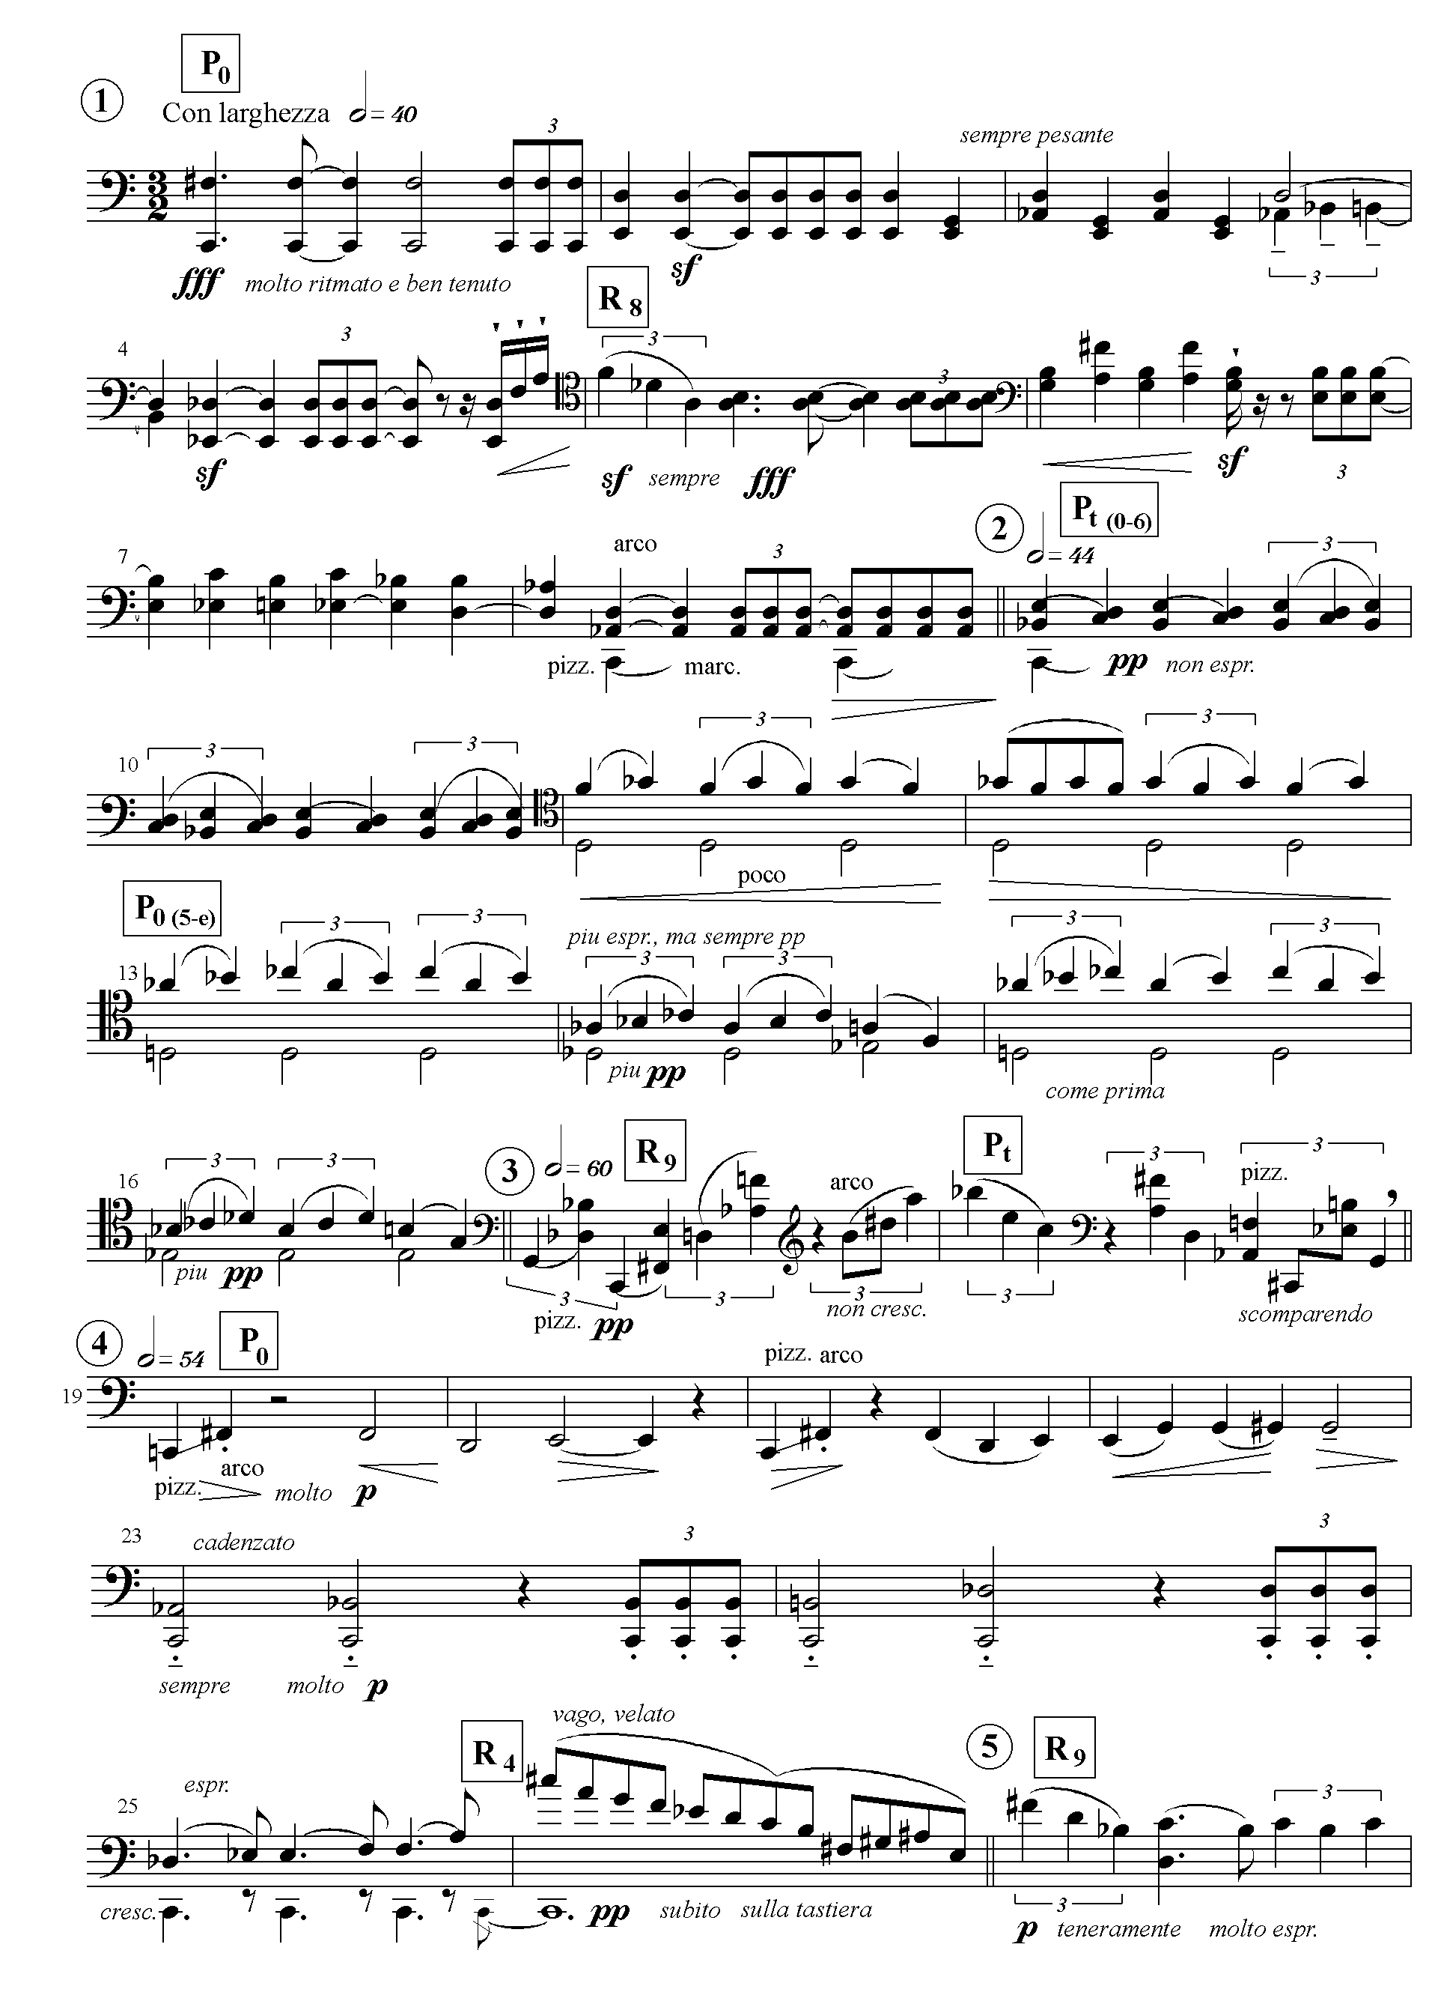
Ex. 6.4 Ciaccona: row levels

Table 6.3 Ciaccona: row levels
1 2 3
meas. | 1 | 9 | 17 | 19 | 27 | 35 | 43 | 46
var. | 1 | 2 | 3 | 4 | 5 | 6 | 7 | 8
row | P₀ R₈ | P_{t} P₀ | R₉ (oo) P_{t} | P₀ R₄ | R₉ | I₇ RI₀ | Ag₁ RI_{t} (oo) | Ag₂
4 5 6
meas | 51 | 59 | 66 | 68 | 76 | 80 | 84-92
var. | 9 | 10 | 11 | 12 | 13 | 14 | 15
row | P₀ R₉ (oo) | RI₀ | P_{t} (oo) | I₅ RI₀ | free | P₇R_{t}(oo)I₅(oo) RI₀ | P₀ R₈

The Ciaccona is divided into two sections at m.51 by the return of P₀, a new tempo (half note=54 from half note=40), and a new timbre (harmonics sandwiched between pizz./gliss.). Each section is further divided into subsections as indicated by the pattern of shaded and unshaded areas in Table 6.3. The first two subsections are articulated at m.19 by a new tempo (half note =54 from half note =60) and a new timbre (gliss.). Subsections two and three are articulated at m.34-35 by a fermata on a rest, a new tempo (half note=44 from half note=54), and triple stops. At m.84, the last section returns to the row levels of the first variation. In addition, each of the subsections begins with a reassertion of the movement’s fundamental pitch, C, with the exception of the third subsection, which begins on G.
The most striking formal device of the Ciaccona is the chain-link row level construction of the first two subsections. The opening row of the first variation, P₀, is the last row of the second variation; the opening row of the second variation, P_{t}, is the last row of the third variation, and the opening row of the third variation, R₉, constitutes the fifth variation. The pattern formed is: P₀ R₈/ P_{t} P₀/ R₉ (oo) P_{t}/P₀ / R₉/. (Also, compare Table 6.3 and Ex. 6.4)
In some cases the structure is hidden behind the variation technique. For instance, only the second hexachord of P₀ returns at m.13. Nevertheless, the structure is revealed to the extent that certain motives and harmonies are preserved, in this case, the tetrachord D-Ab-Bb-B.
In the second section, RI₀, becomes a formal pillar; it ends every even-numbered variation. Because the piece begins and ends with the same pair of row forms, P₀ and R₈, it would seem more proper to speak of a ‘tonic’ row complex rather than a ‘tonic’ row level. This concept will reoccur in Dallapiccola’s oeuvre.
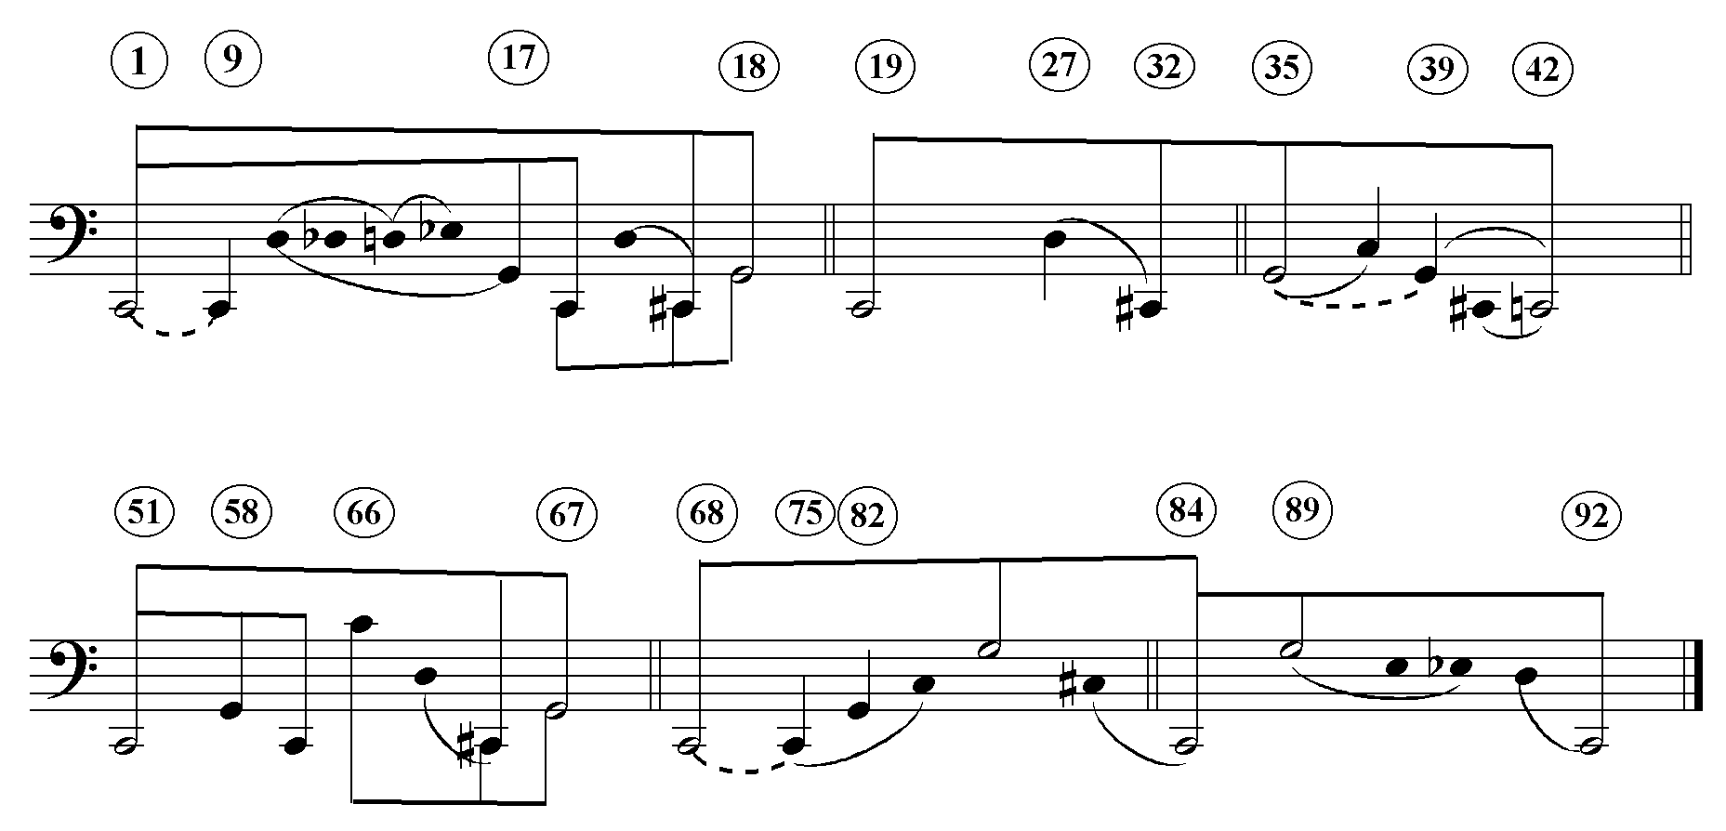
The Ciaccona’s linear structure betrays its debt to tonality. As Ex. 6.5 demonstrates, over the course of its 15 variations there is a sixfold presentation of the C-G-C bass motion. The C-C#-G-C bass motion of mm. 1-19, 19-42, and 51-68 parodies I-bII-V-I tonal bass progression. (Of course, the harmonies that are supported do not fit into a tonal scheme.)
Ex. 6.5 Ciaccona: linear analysis
The double bars of the linear graph correspond to the sectional boundaries of the table of row levels (Table 6.3). The parallelism of the linear structure elegantly reinforces the sectional structure; the basic linear shape of sections 1 and 4 are very similar, as are sections 2 and 5.
The C major triad that ends the Ciaccona and the C interjections in the Intermezzo (mm. 101, 105,109 etc.), none of which are part of any row form, illustrate that, at this point, Dallapiccola had neither abandoned the concept of hierarchical pitch levels, nor yet fully integrated it into his twelve-tone technique. By the time he completed Rencesvals in the following year, he had freed himself from nostalgia for the I-V-I tonal line. The F#-A, B-G#, Bb-G linear organization of that work ushers in a new period in which the linear structures are proper to the individual work, and the tonal allusions are integral projections of the row.
There is a considerable amount of compositional continuity between Ciaccona and Rencesvals. Both assign a different row to each movement. Both Rencesvals I and the Adagio introduce secondary rows formed by filling in chromatic segments.
Ex. 6.6 Ciaccona, Intermezzo e Adagio and Rencesvals: secondary rows
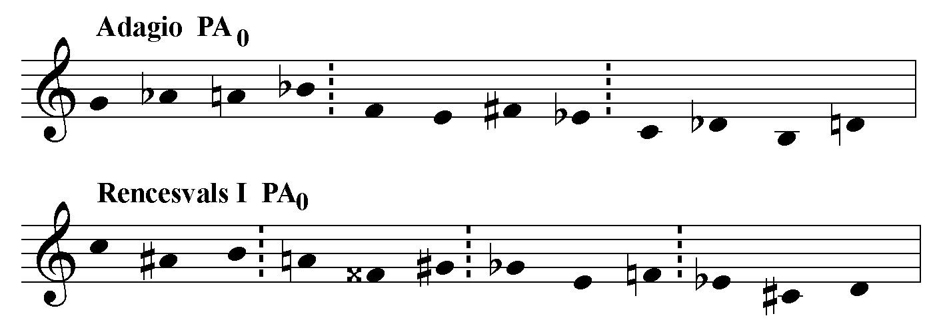

Owing to its octatonic row (see Ex. 6.1) and predominantly monophonic presentation, the Intermezzo is heard as a kind of arpeggiated octatonic harmony.
Due Studi for violin and piano
The secondary row at the beginning of Rencesvals I becomes the row of the second row area in that movement. In Due Studi, Dallapiccola modifies this device to unify the entire piece; the second row (PA) of the Sarabanda (first movement), which introduces the B section, becomes the row of the Fanfara e Fuga (second movement). Ex. 6.7 below excerpts the rows P and PA.
Ex. 6.7 Sarabanda: the two themes, P and PA
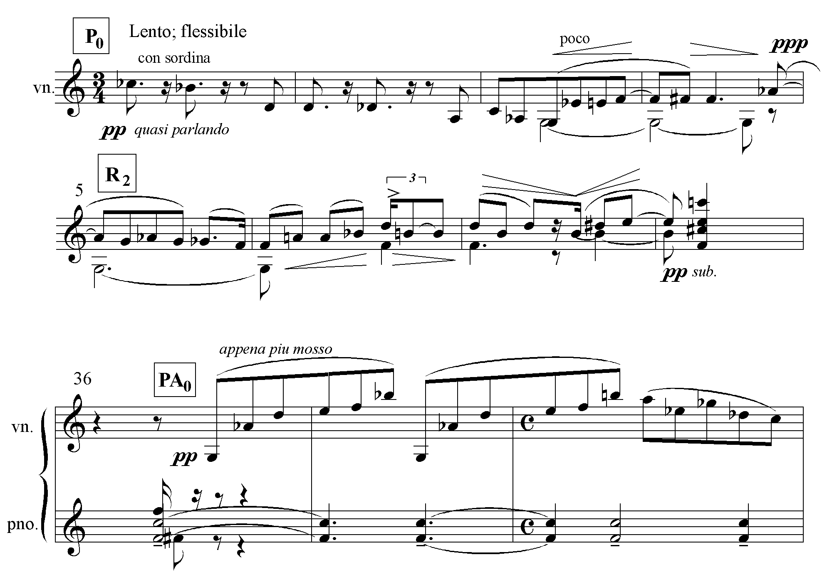
PA may, in fact, be a variation of P; Ex.6.8 demonstrates the relationship between
I₈ and PA₀.
Ex. 6.8 Sarabanda: I₈ and PA₀
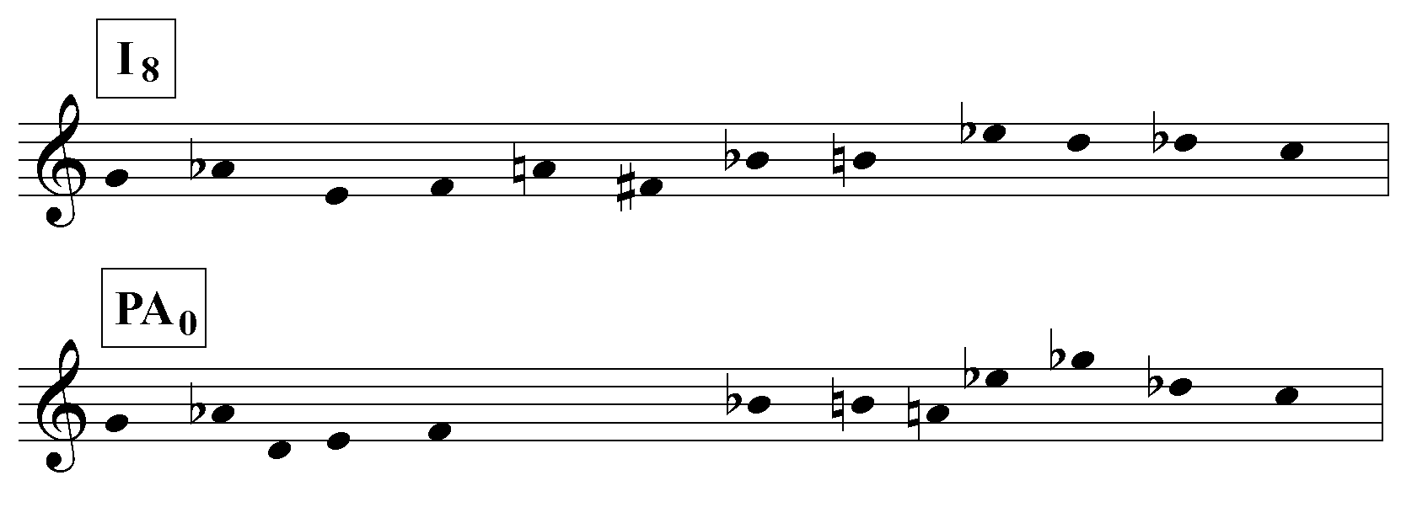
Table 6.4 below elucidates the Sarabanda’s row level organization.

Table 6.4: Sarabanda: row levels

A
meas. | 1-4 5-8 | 9-12 13-16 | 17-20 21-24 25-28 | 29-32 33-36
row: vn. | P₀ R₂ | I_{t} RI₁ | I₈ P₄ RI₉ R_{e} | P_{e} P₄ R_{e (e-8)}
row: pno. |  | I_{e} P₃  P₇ R₂ P₉ P₇ | P₉ R_{e} P_{e} I₅ | P_{t} P₂ P₂ R_{e} P_{e}

B
meas. | 36-40 42-6 | 47-50 51-4 55-60 | 61-4 65-9
row: vn. | PA₀ | P₆ PA₀ I_{t} | P₇ PA₃ IA_{t} R_{e}
row: pno. | Ag1 Ag2 Ag3 | Ag1 Ag2 Ag3  P_{e} IA₃ PA₀ I_{t} PA₀ RI₉ PA₀ | P₀ IA₄ I₄ P_{t} IA₂

A′
meas. | 70-3 74-8 | 79-84
row: vn. | R_{e} (cont’d) P₀ R₂ | P₀
row: pno. | P_{t} P₂ P₂ P_{e} P₀ | R₂

The form is tripartite. Section A (mm.1-36) exposes the row P, section B (mm.36-69) introduces the secondary row, PA, and proceeds to contrapuntal combinations of P and PA, and section A′ (mm.70-84) reprises subsections 1 and 4 of section A in reverse order so that the movement ends where it began, with the reiterated ‘tonic’ complex P₀-R₂. At the end of section A, the contrasting row level P_{e}-R_{e} is asserted. Although these ‘e’ levels are manifested in many ways, their relationship a half step lower to P₀ is usually apparent (for instance, the repeated Bb-A in the piano top voice, m.33, in relation to the Cb-Bb of the opening violin line.) The excerpt below demonstrates Dallapiccola’s use of a tonally allusive version of P_{e} to emphasize the Bb-A. Here the row is partitioned, Bb-A-C#-C; Ab-B-G-F#; D-D#-E-F so that the bass line, D-D#-E-F, is also a half step lower to the Eb-E-F-F# of the opening P₀. In retrospect, the chromatic violin line can be seen as a primitive stage in
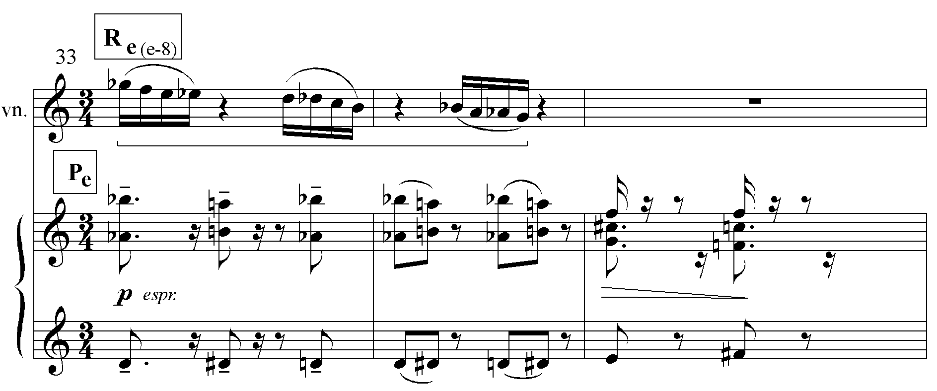
Ex. 6.9 Sarabanda: tonal allusion

the development of Dallapiccola’s technique of derived row formation by replicating row segment sets. Here, the set [0, 1, 2, 3, 4] of ops e-8 (Gb-F- E-Eb) is replicated twice to form the descending chromatic line Gb-G.
The ‘e’ level returns at the beginning of the reversed reprise to be ‘resolved’ by the ‘tonic complex’, which, this time, appears in both the violin and piano. Thus, like Rencesvals I, there is a move from a stable row area to a contrasting row area of relative instability followed by a return to stability. As in the Ciaccona, the ‘tonic’ row area is represented by a sequence of two row forms.
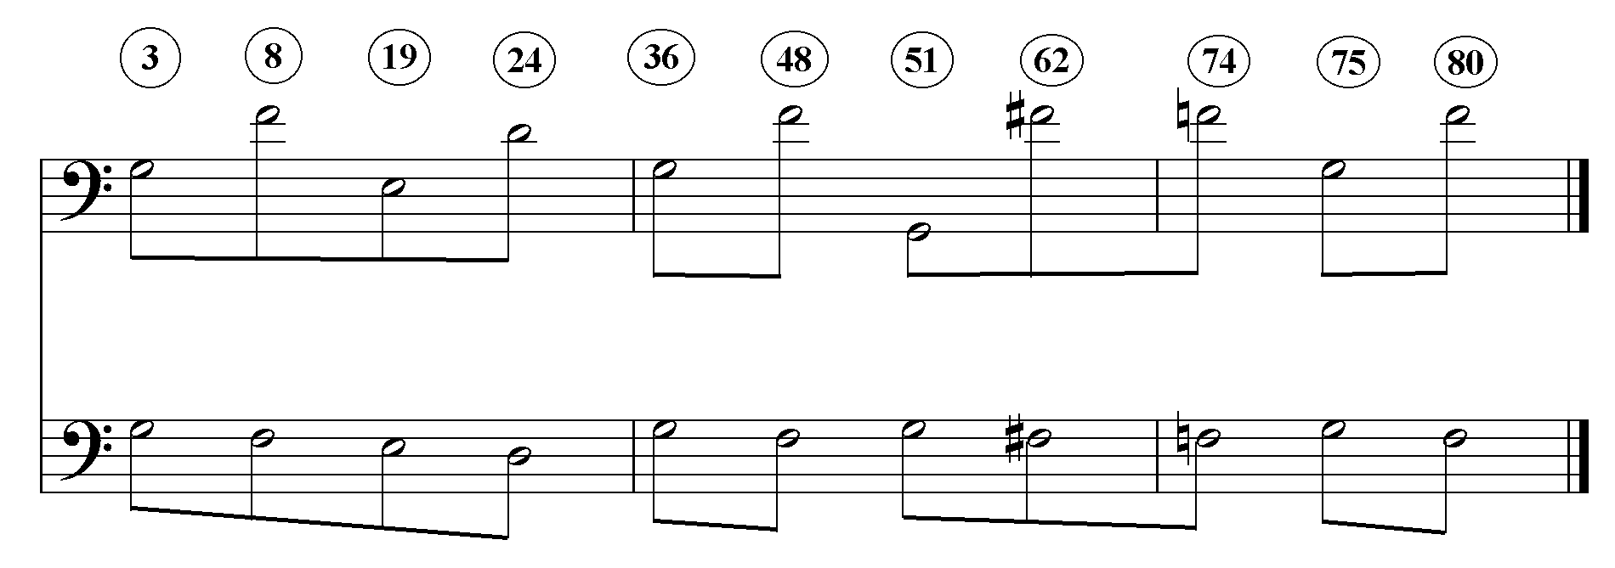
The large-scale linear structure of the Sarabanda is displayed below. If one takes the liberty of bringing the line into one octave, as is done in the lower staff, it becomes quite elegant.
Ex. 6.10 Sarabanda: linear structure

Study of the score reveals that the pitches in Ex. 6.10 are all prominent bass notes by virtue of their duration. Note that Dallapiccola constructed PA so that it would also emphasize G, the most prominent pitch of P. (See Ex. 6.7)
Although, as Michael Eckert has observed4, some measures of the Fuga are octatonic (owing to the first seven pcs of PA, which belong to the same octatonic collection), unlike the octatonic arpeggios or chords of the Intermezzo and Rencesvals I, they do not seem to play a structural role.
Quaderno Musicale di Annalibera
The Quaderno Musicale di Annalibera (1952) is a collection of 11 piano pieces addressed to Dallapiccola’s daughter, Annalibera. The debt owed by its title to Bach’s Clavier-Buchlien for Anna Magdalena Bach is made musically explicit by the use of the B-A-C-H motive in the first piece, Simbolo. All 11 pieces are based on the same row, a procedure first employed by Dallapiccola in Tre Poemi (1949). (This row is also the basis of the Canti di Liberazione (1951-55), a work for chorus and orchestra that incorporates some of the material of the Quaderno in the manner of a parody mass. The Canti were not completed until after Piccola Musica Notturna (1954), although their initial compositional stages preceded the Quaderno.) Ex. 6.11 indicates the rich tonal possibilities inherent in its row, the realization of which contribute much to making this one of Dallapiccola’s most appealing works.

Ex. 6.11 Quaderno Musicale di Annalibera: tonally allusive row
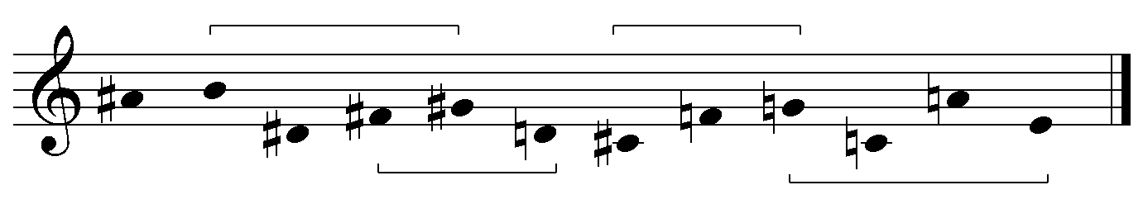
The row forms are inscribed over mm. 1-16 of Simbolo in Ex. 6.12 on the following page. Study of this excerpt reveals the intersection of tonal analogue, linear structure and tonal allusion.

Ex. 6.12 Simbolo: mm. 1-16, row forms
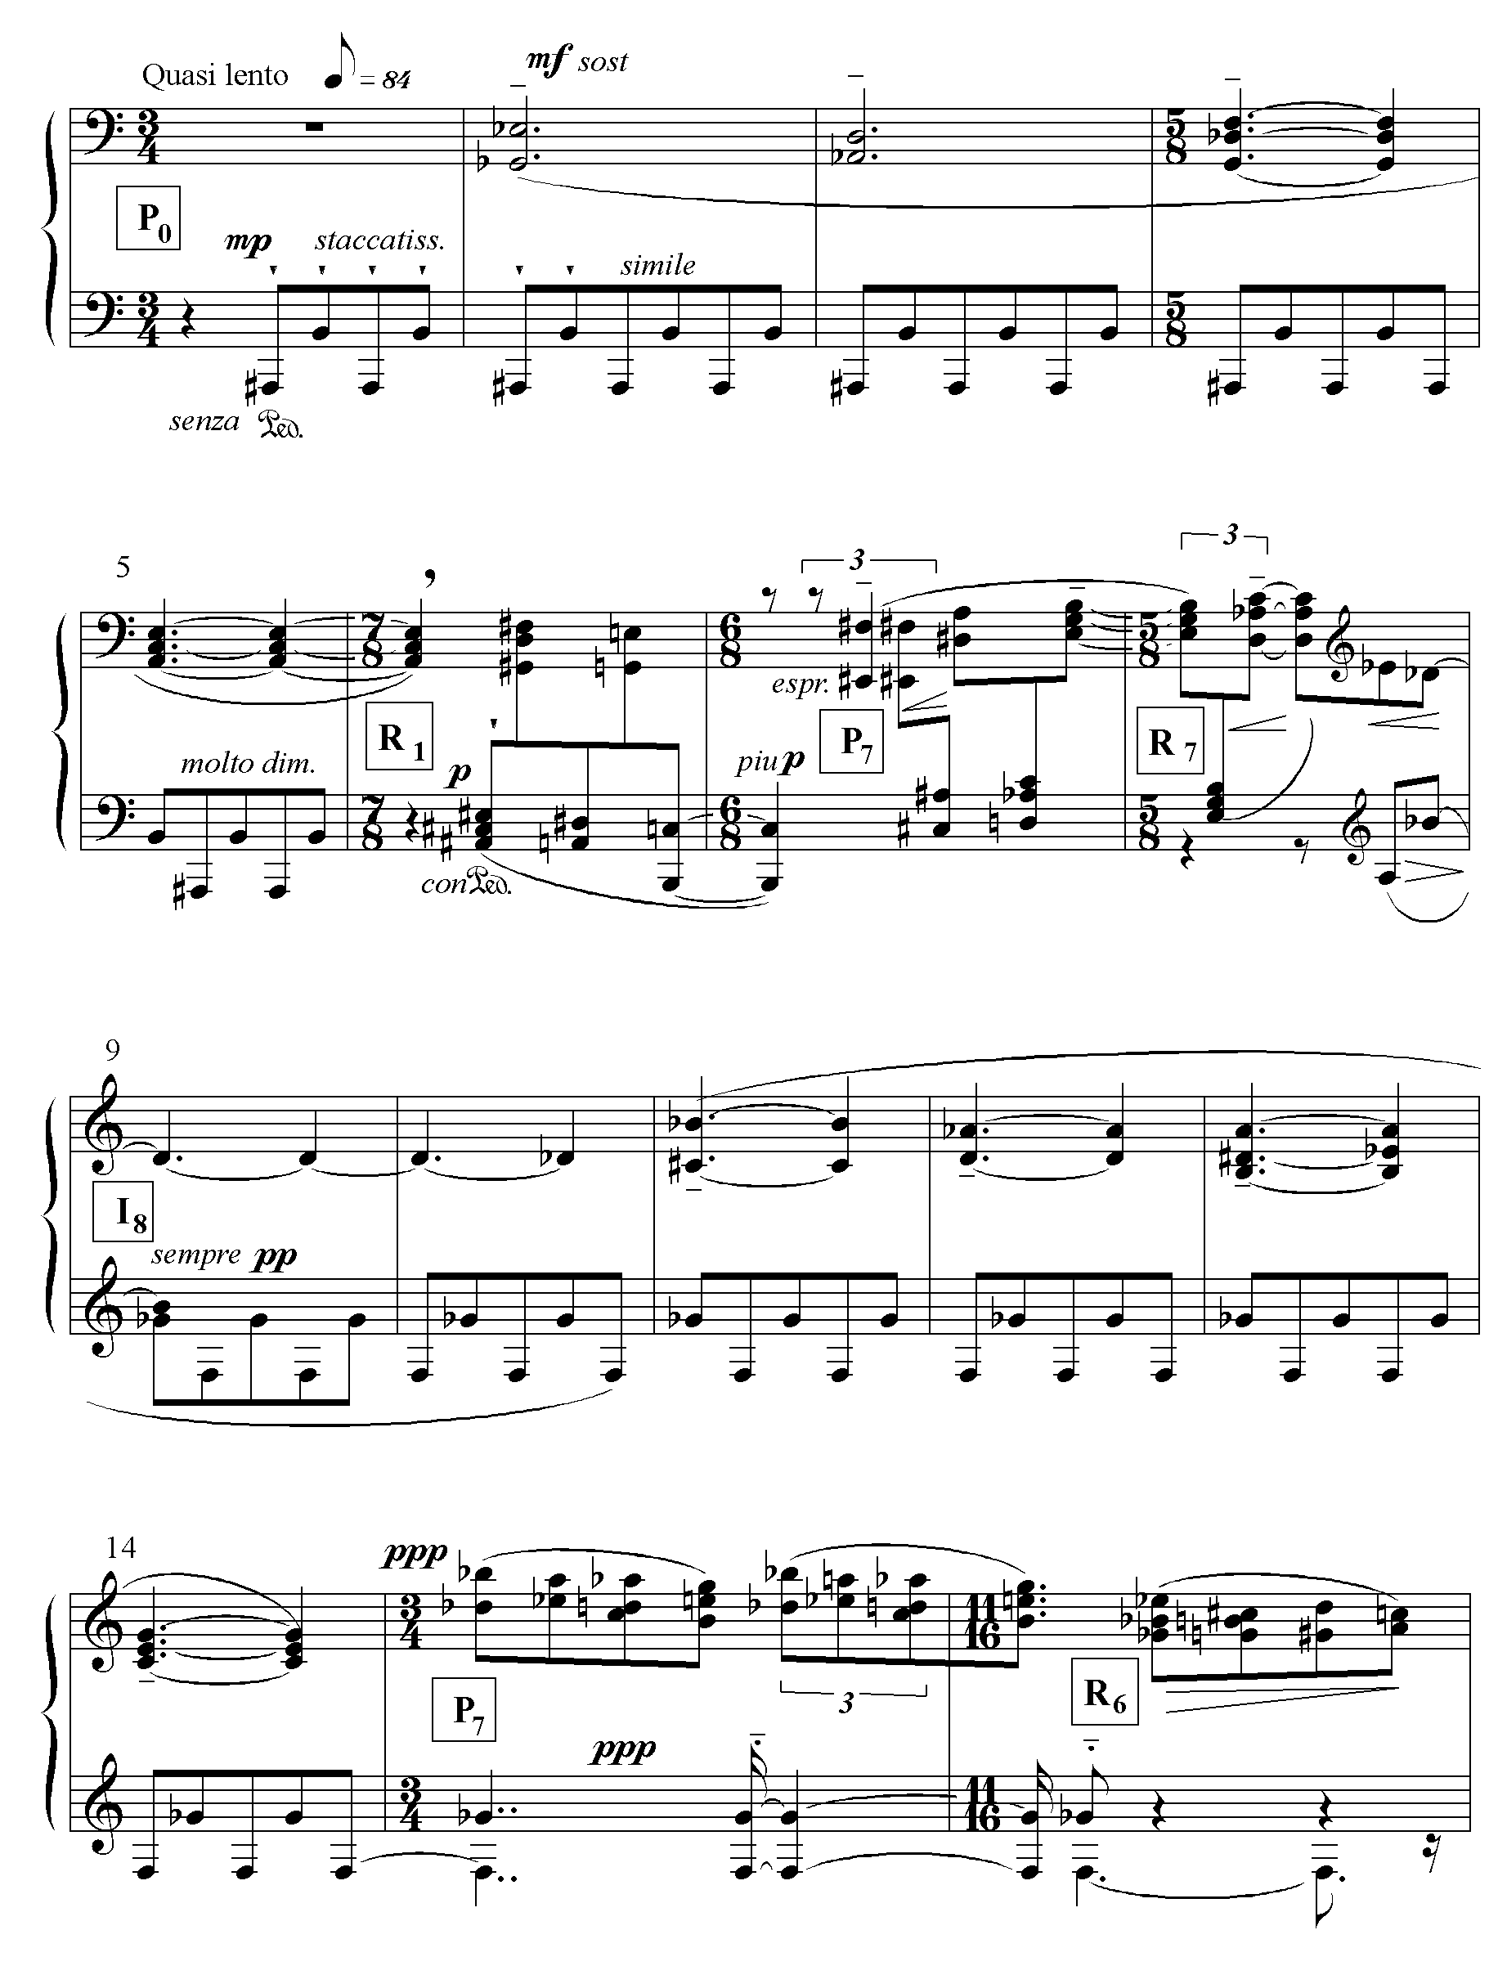
As in the Ciaccona, the row levels in Simbolo parody a modulation to the dominant. In the first four measures, Dallapiccola establishes the ‘tonic’ level, P_{0,} associated with a prolonged emphasis on A# (Bb) in the bass. The following row form, R₁, begins with an A# minor triad, a tonal allusion that simultaneously extends and strengthens A# as the referential pc of the piece and announces the row level ‘1’ by virtue of its distance a half-step higher than the A minor triad that concludes P₀. In mm.6-7, he quickly moves through level 1 to level 7 a fifth above the ‘tonic’ level. This ‘dominant’ row area is associated with a prolonged emphasis on E# (F). When a row form other than P₇ or R₇ is presented in the ‘dominant area’, he contrives to preserve the emphasis on F in the bass. During mm. 9-12, he exploits the fact that I₈ shares its first two pcs (F#-F) with the first two pcs of P₇ (F-F#). At the end of the excerpt, he layers R₆ so that it forms an F major triad with the held bass on the last eighth note. The bass line of the first 16 measures, illustrated in the combined linear-
Table 6.5 Simbolo: linear- row levels
A trans.
meas. | 1-5 6 7-8 | 9-13 14-15 | 17-20 21-24
row | P₀ R₁ P₇ R₇ | I₈ P₇ P₇ R₆ | RI₀ R₂
upper voices  bass line | E#  C#  A# B F | C  A  F→ | B-C#-C- A F#-G- E- F  E-D#-F#-F D- A-Bb-Db

B A′
meas. | 25-28 29-32 33-6 | 37-41 21-24
row | P₉ R₉ P₉ R₉ P₉ I_{t} | R₀ P₀
upper voices  bass line | G- Bb-B- A  F# → D#-E- C#-D | A#→

row level table above, recalls a I-bII-V progression, similar to that in the Ciaccona (although the harmonies have no such tonal implications). It is evident from Table 6.5 that the tonal analogue, linear structure and tonal allusion are mutually reinforcing. The ‘tonic’ row level is associated with the bass pitch A# (Bb), the bass pitch F is associated with the contrasting row level 7, and a second contrasting row level, 9, which dominates the B section, is associated with the bass pitch F#. As stated earlier, the A# and F major triads emphasize the A# and the F; not shown in the table is the F# minor triad with emphasizes the F#.
The first 20 measures of Ritmi (#8) on the following page illustrate two techniques which figure prominently in Dallapiccola’s subsequent works: the use of texture blocks to define formal sections, and the formation of derived rows by replicating the sets of row segments. The first texture block, mm.1-11, is a texture of increasing density. First one hears single notes, then single notes with a drone, then dyads with the drone, culminating in 4-note chords of punctuation in m.11. Once the derived rows enter in m. 12, the texture changes to angular melody with dyad and single-note accompaniment.
The derived row beginning in m.12 replicates the set [0,2,6] of ops 6-8 of the primary row after which the derived row beginning in m.16 replicates the set [0,1,4] of ops 0-2. (This is the first serious employment of secondary row formation by segmental replication that I have been able to find in Dallapiccola’s music.) Even in this short excerpt, its organization around the ‘tonic’ row level 2 is clearly recognizable.
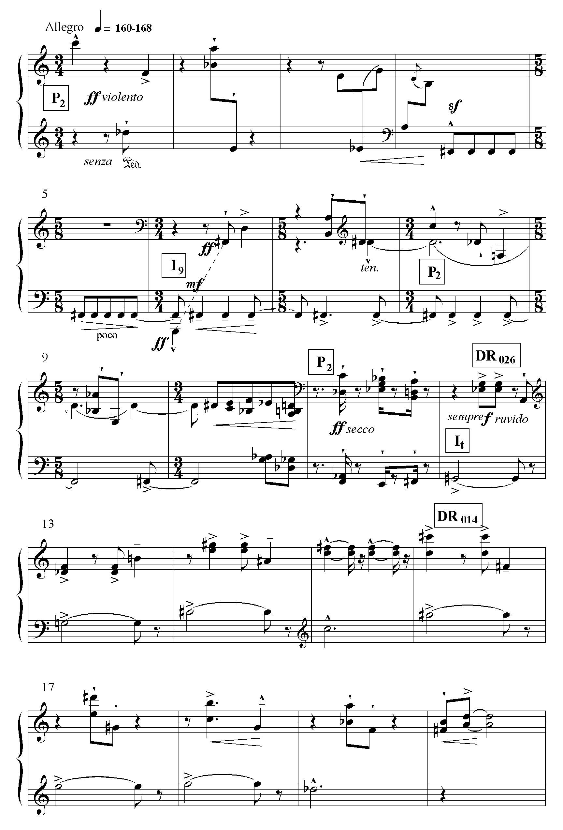
Ex.6.13 Ritmi, mm.1-20: row levels
Of the eleven pieces in the Quaderno, only Simbolo (#1) and Ritmi (#8) have very strong linear-row level structures; those of the Contrapuntus Tertius (#7) and Ombre (#10) can be plausibly argued, while the concluding row, P_{2,} of the last piece, Quartina (#11), clearly recalls the ‘tonic’ row level of Ritmi. Probably Dallapiccola felt the need of a strong tonal analogue in those pieces that are the longest. Simbolo and Ritmi are 46 and 61 measures long respectively; the remaining pieces range between 8 and 23 measures in length.
An Mathilde for soprano and orchestra
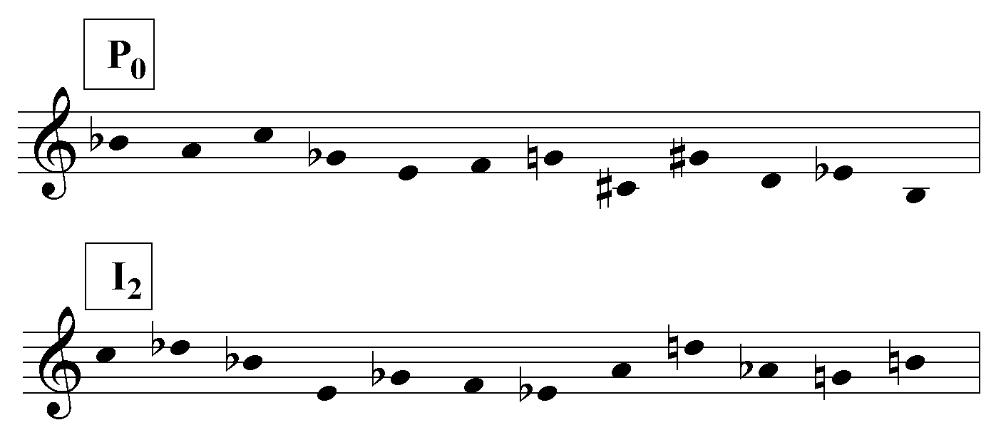
Dallapiccola’s concerted employment of tonal analogue, linear structure, octatonic organization, and tonal allusion culminated in Piccola Musica Notturna. As argued earlier, he used them to depict Machado’s poem, Noche de Verano, which symbolizes a farewell to tonal influence. In Dallapiccola’s next work, An Mathilde (1955), for the first time in his oeuvre, tonal allusion is absent. If one assumes that the first discernible linear manifestation of the row, the opening vocal line of the first movement (mm.6-9) is P₀, then the ‘tonic’ row level is identified with I₂ and RI₂.
Ex. 6.14 An Mathilde: row

The way in which the tonal analogue is constructed and the reason for my choice of I₂-RI₂ as the tonic level are clarified by Table 6.6 and the musical example that follows.
Table 6.6 An Mathilde I: row levels
meas. | 1-5 | 6-12 | 13-18 | 19-24 | 24-27 | 27-34
voice |  | P₀ R₀ |  | R₉ | R₁
orch. | RI₁  I₄  P₂  R₆ | RI₂  I_{e}  P₃  R₃ | DR 012  I₂ RI_{t} I₃ P₄ | I₂ P₉ RI₈ R₃ I₃ | RI₅  P₉  I_{t} | I_{e}  P₇  R₂  RI₄ I₄ RI₂

Coda
meas. | 35-8 | 39-42 | 43-6  DR 012 | 47-50  I₂ RI_{t} I₃ P₄ | 51-4 | 55-61 | 62-6
voice | DR 012 DR 012 | R₄ | R₄ (cont’d) | DR 012 | DR 012 |  | (I₁ RI₂)
orch. | I₂ | DR 012  I₂  I₄ | DR 012 | I₉  DR 012 | RI_{t} R₂  P₉ RI₈ R₃ I₃ | DR 012  RI₀  I₀ RI₂ | I₁ RI₂

The stacked row forms in the orchestra part are often trichordally intercut so that they do not necessarily maintain a constant registral position. The DR forms are constructed by replicating the [0,1,2] set of ops 3-5.The boundary line at mm. 18-19 is articulated by the entrance of the canto. The other boundaries between shaded and unshaded cells indicate the double bars in the score.
Table 6.6 clearly illustrates the importance of the I₂-RI₂ level. In m.13, I₂ is the first row form to be heard without any harmonic interference from other row forms; the movement ends with RI₂. Either I₂ or RI₂ appears on at least one side of the formal boundaries illustrated in the table, and at the approximate midpoint, they straddle the double bar.
Ex. 6.15 below illustrates the harmonic similarity of the I₂-RI₂ level in its first appearance, at the middle of the piece and at the end. The pre-eminence of C as a harmonic anchor is clear from both this example and the linear graph that follows it. Although the first chord of the piece is composed of notes taken from four different
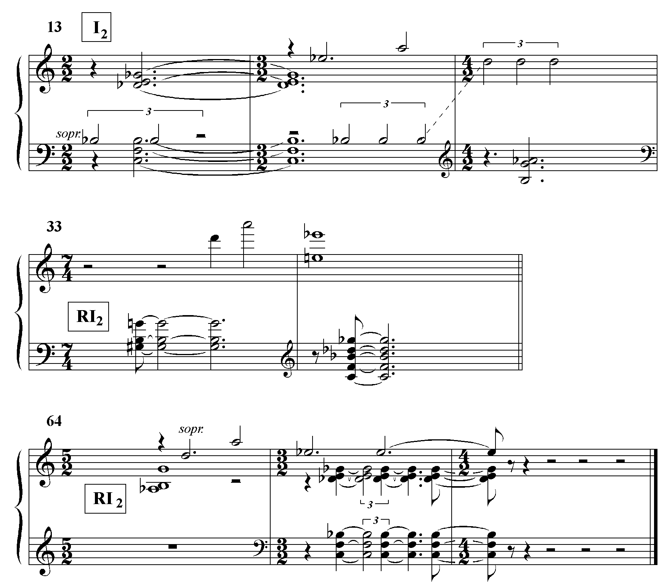
Ex. 6.15 An Mathilde I: ‘tonic’ row level

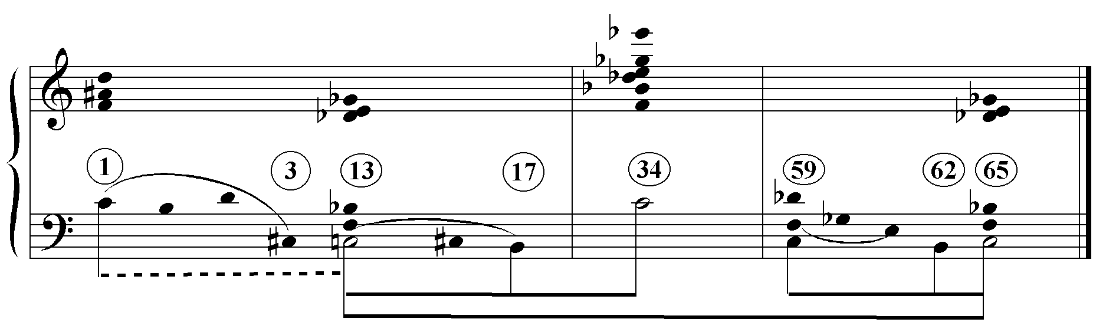
Ex. 6.16 An Mathilde I: linear graph
row forms, its lowest note is still C. Three of its four pitches are contained in the first hexachord of I₂; only the D natural is alien. The first four notes of the lowest voice, C-B-D-C#, make an arcane reference to B-A-C-H. The C-C# motion then recurs in mm.13-16. One should keep in mind that the graph only shows those important formal joints where the linear structure coalesces into some sort of a pattern. Most of the notes of the piece do not participate in any recognizable linear structure. Thus, although present to some degree, there is considerably less linear structure here than in, say, Rencesvals or Due Studi (and, of course, even there, one finds only partial hierarchies; there are always notes unaccounted for).
Although An Mathilde’s row is not octatonic, Dallapiccola contrives to create an octatonic structure in the third movement (mm.50-68) by extracting the row’s [0,1,6] trichord and using it to construct complementary octatonic hexachords. This process is evident in Ex. 6.17 on the following page. The six-note chords are bracketed in pairs corresponding to the phrase structure. Occasionally when lines coalesce to form octatonic harmony (in m.56, for instance), the octatonic collections are grouped in threes. Note that every phrase group though m.58 ends on Collection I. In m.59, the arrival on collection II articulates the section. Measures 60-68 retrograde mm.51-59. There the phrase groups end on Collection III so that over the course of the excerpt the octatonic weight is shifted from Collections I-II to Collection III. With the exception of a few non-octatonic notes marked by the N’s, the rows I₂, P₂, R₂ and RI₂ are completely integrated into the octatonic structure.

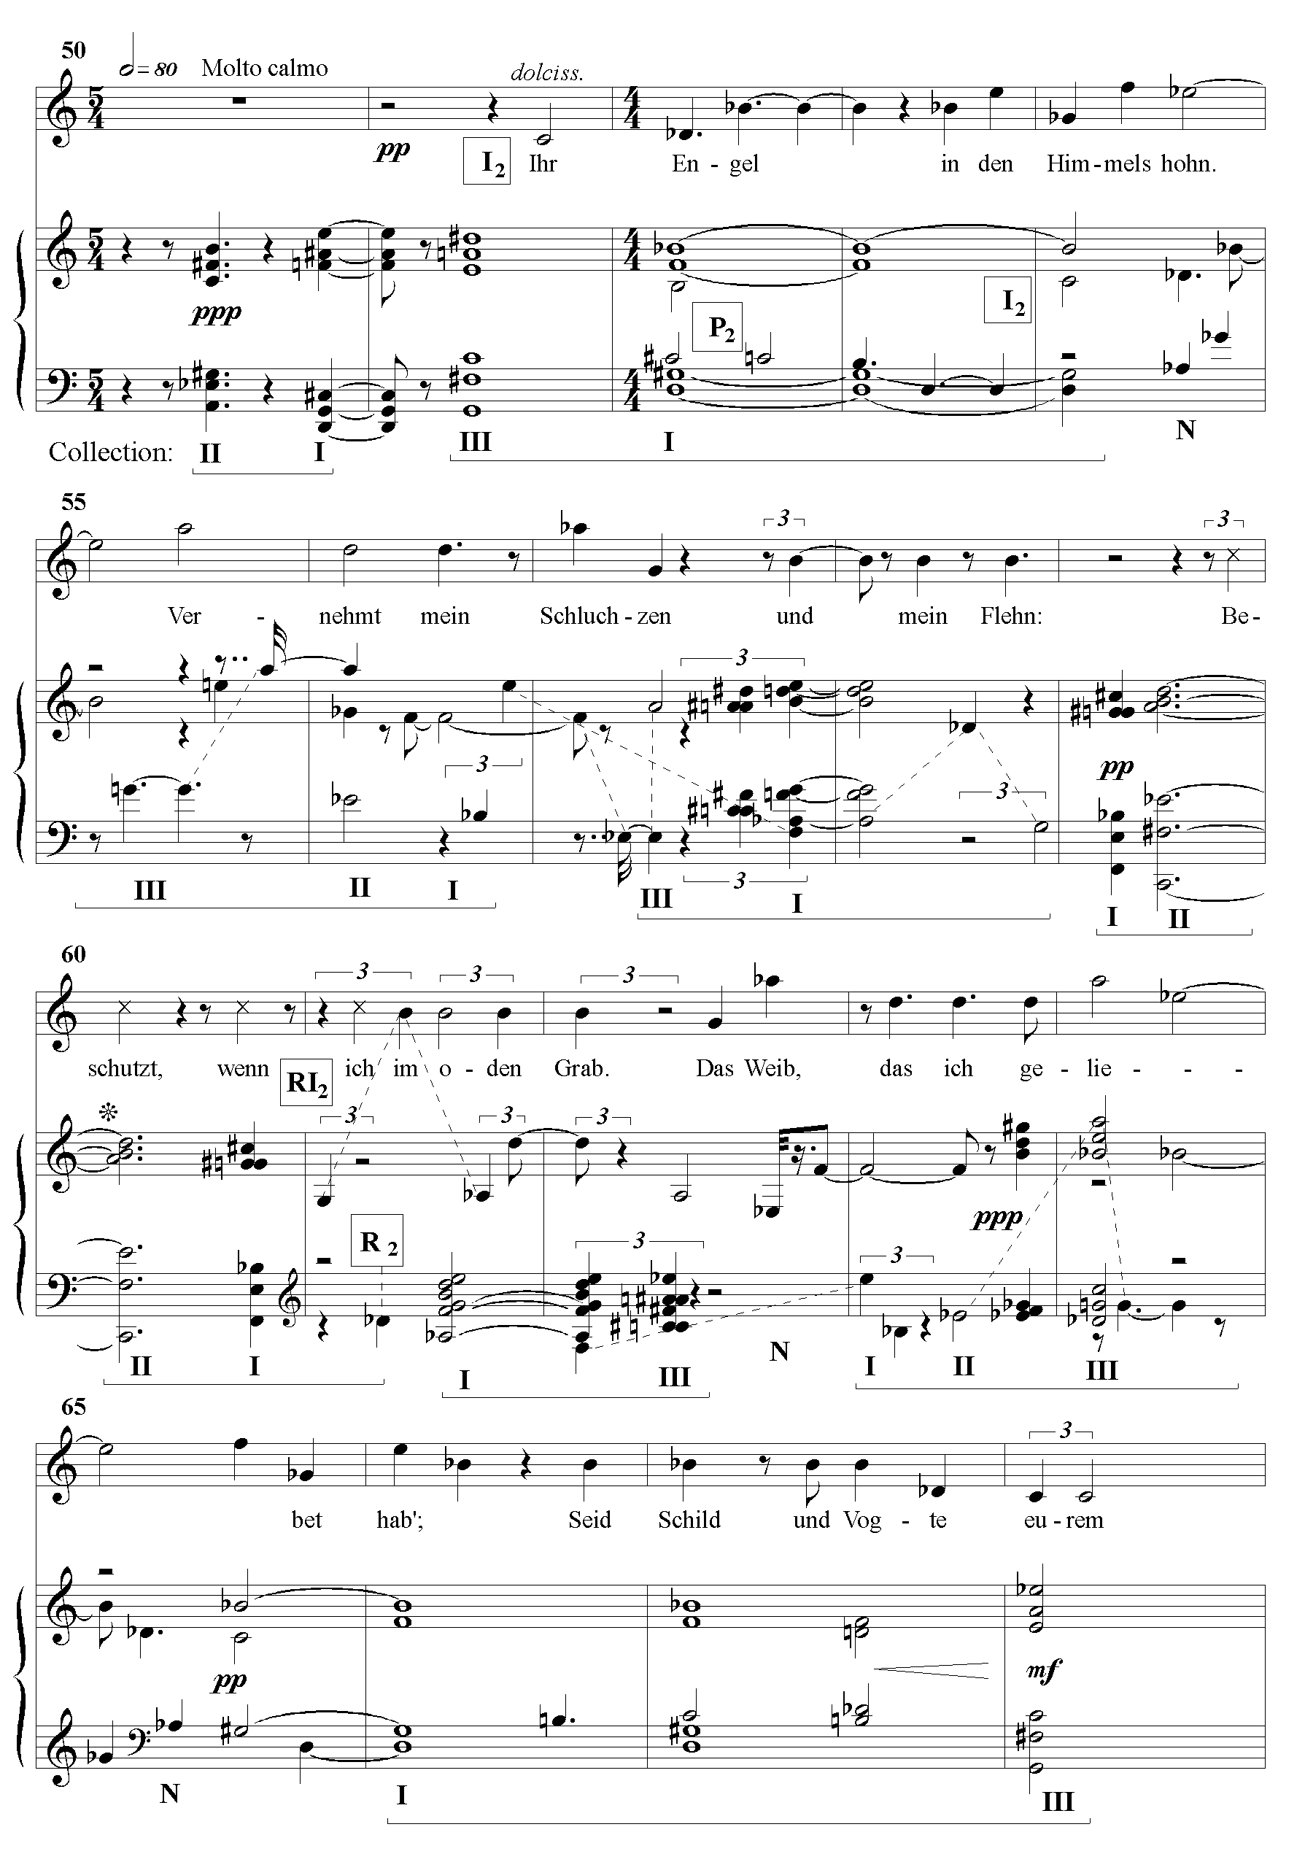
Ex. 6.17 An Mathilde III: octatonic organization
Dialoghi for cello and orchestra
The first movement of Dialoghi (1960) is built on an extremely strong tonal analogue. A threefold presentation of the ‘tonic’ row level begins the movement’s two major sections (mm.1 and 31), and ends the entire movement. (Measures 52-55 are a transition to the second movement.) In addition, the ‘tonic’ row level also appears at the beginning and end of the third phrase (mm.9 and 12) where it reaffirms the initial assertion.

Table 6.7 Dialoghi I: tonal analogue
A
meas. | 1-5 | 6-8 | 9-13 | 14-6 | 17-20 | 21-5
cello | R_{9 (e-7)} | P₀ ₍₀₋₄₎ | R₉ ₍₆₋₀₎ P_{0 (5-e)} | R₉ ₍₂₋₀₎₍₅₋₂₎ | P_{0 (9-e)(6-9)}
orch | P₀ P₀ P₀ P₃ | R₆ | R₀ R₀ R₀ | P₂ | P₃ | R_{e} R₇  P_{e} P₃

meas. | 26-30
cello | R₅
orch | P₁ P₃ R₉ R_{e} R₀

B trans.
meas. | 31-4 | 35-8 | 38-43 | 44-49 | 50-51 | 52-5
cello |  | R₂ | P₅ | P₆ ₍₀₋₅₎ R_{6 (e-6)} P_{e} |  | R₇
orch | P₀ P₀ P₀ | P₆ |  | P_{t} P₄  P₇ R₄  R₀  R₅ | P₀ P₀ P₀ | P₇  R₅

The table’s pattern of shading indicates the formal organization Of Dialoghi I. At m. 14 the percussion section enters following three bars of orchestral silence. The opening texture returns at m.31: three pillars of P₀ in the orchestra while the solo instrument is resting. At m. 44, the row is layered following five measures of nothing but E in the orchestra.
Ex. 6.18 depicts P₀ (assuming that the first three hexachordal pairs of the movement are each manifestations of P₀.) Ex. 6.19 shows how the ‘tonic’ pillars in mm.1-3 and 9-10 support the first shaded area of Table 6.7. The example is schematic; all rhythmic values are reduced to quarter notes.
Ex. 6.18 Dialoghi I: row
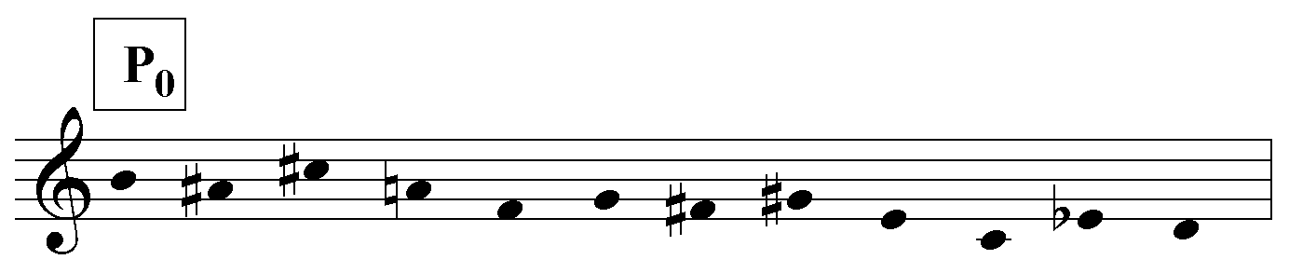
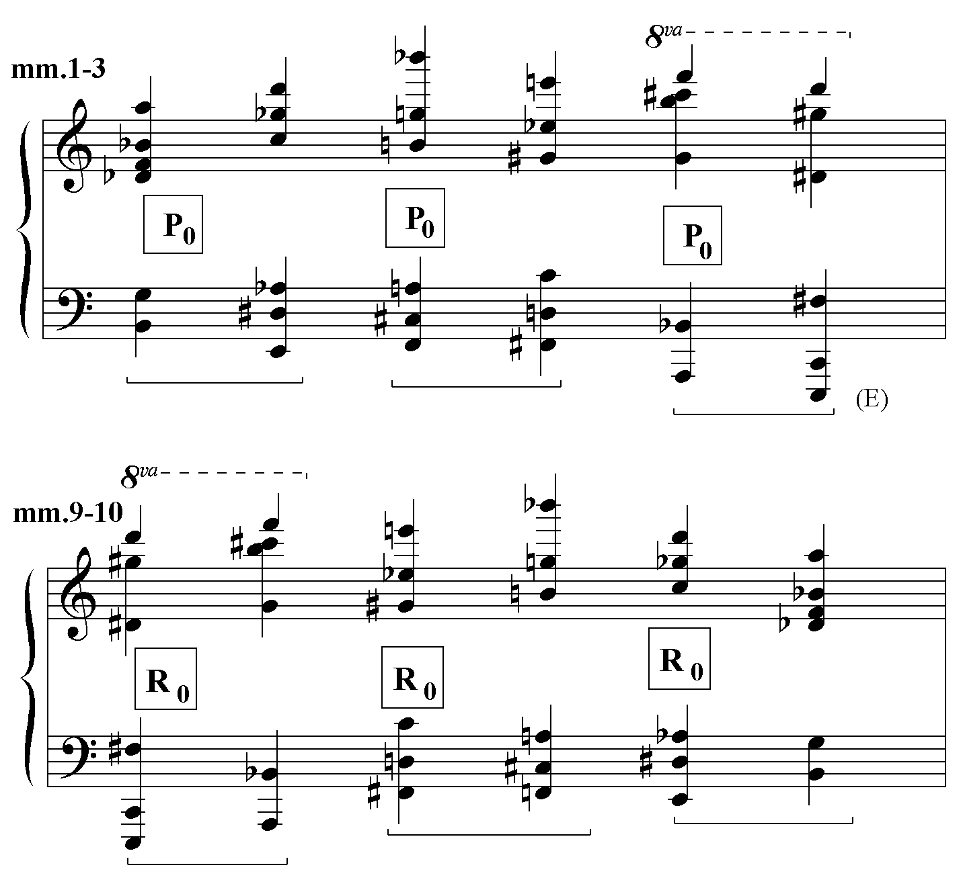
Ex. 6.19 Dialoghi I: ‘tonic’ pillars
Measures 9-10 are, in fact, a retrograde of mm.1-3. A perusal of the example suggests that E is its most significant bass tone. It is the lowest tone, appears most frequently and in the most important positions, and either precedes or is followed by B, which creates dominant-tonic allusion. The following linear graph demonstrates that the E participates in an E-Eb motion on several levels. However, there are a number of other structures that coexist with, but are unintegrated with the E-Eb motion.
Ex. 6.20 Dialoghi I: linear analysis

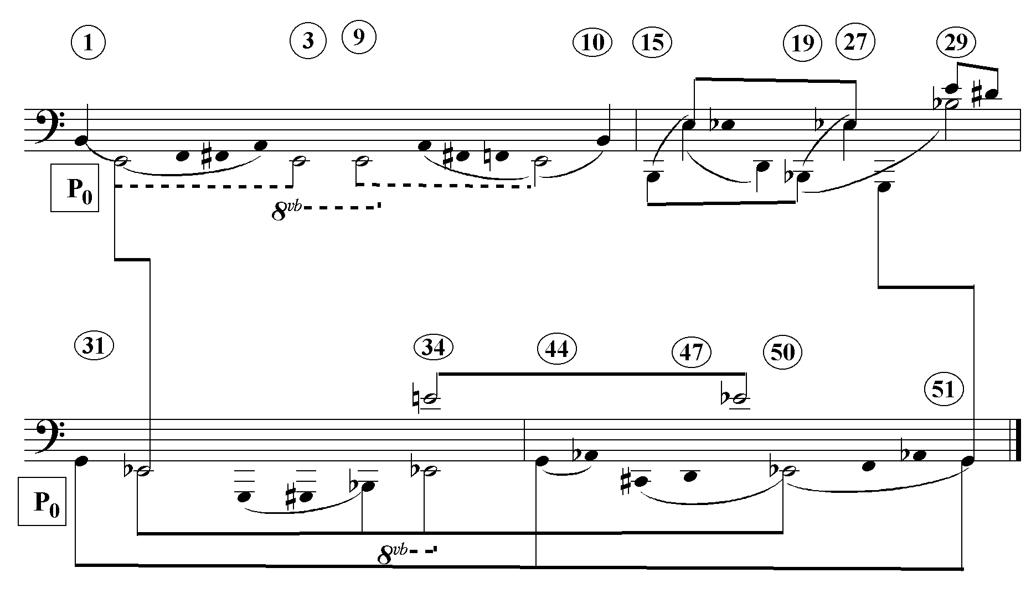
A long range E-Eb motion can be found over mm.1-50. Examples of mid- range motions are the E-Eb long tones in mm. 34-48 and the E-Eb ‘inner’ voices in mm.16 and 27. Short-range detail is represented by the E-D# tremolo in mm.29-30. Coincidentally, there is a B-Bb motion over the course of mm. 1-29. In particular, the important G, which first appears near the end of the first system and ends the movement, does not appear to participate in the E-Eb motion to any significant degree. Thus, Dialoghi is a good example of multiple hierarchies. It is also worthwhile pointing out that the E-Eb motion from m.1 to m.31 or m.50 is purely linear. The harmonies at those three spots are simply different inversions of P₀. This kind of linearity has nothing to do with the classical Schenkerian intersection of harmonic and linear structure.
The extended unison E in mm.33-44 recalls the unison E in Piccola musica notturna. One wonders whether Dallapiccola was sensitized to certain pitches, the G of Rencesvals, Due Studi and Piccola Musica Notturna, for instance.
Preghiere for baritone and orchestra
Of the works surveyed in this chapter Preghiere (1962) and Sicut Umbra (1970) are notable for their lack of significant tonal analogue or linear structure. In Preghiere, as James Dapogny states “the set is more important for the rather limited number of chords it generates. These few chords take on thematic or motivic significance through their frequent appearance and through Dallapiccola’s nearly exclusive use of only these chords as vertical structures.”5
The set and the characteristic chords it generates appear on the next page. However, neither Dapogny nor I have been able to discern any pattern of departure and return among those chords. Here, Dallapiccola seems to have created a language without a structure. The one exception, it might be argued, is the massive retrograde,
extending 16 measures on either side of the word ruota (wheel), m.69 of the second movement. Nevertheless, because it can be imposed on anything, however random, I don’t believe a retrograde can create a convincing structure in and of itself. It can only potentially enhance a pre-existent structure.
Ex. 6.21 Preghiere: set and characteristic chords6

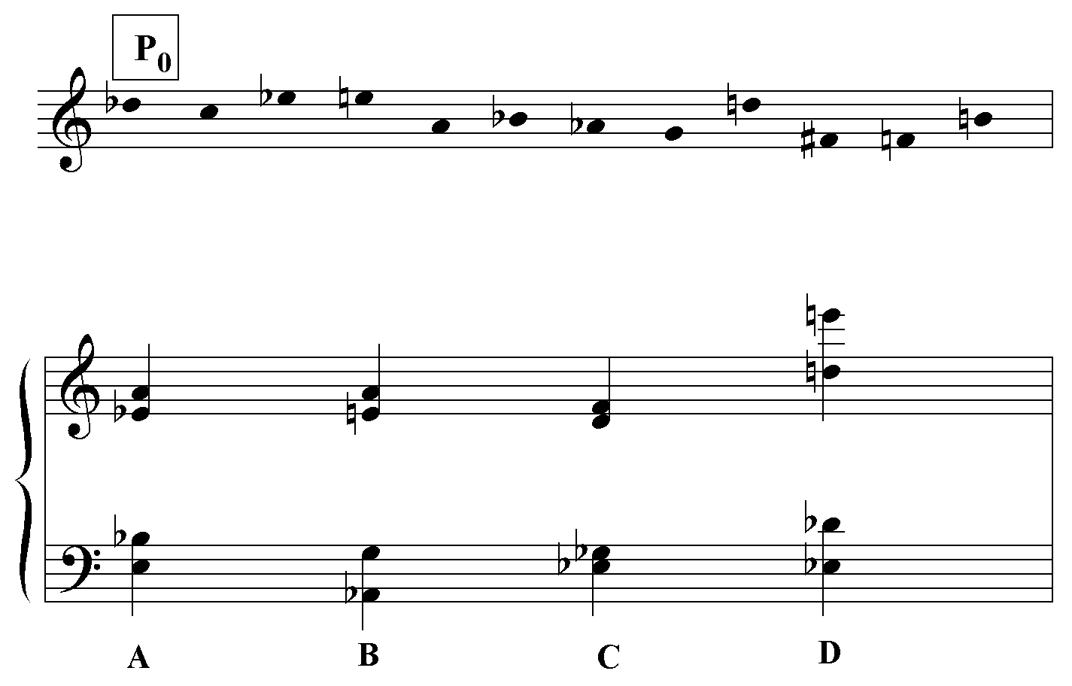
Ops 2-5 of row forms P_{n}, P_{n+6}, I_{n-1} and I_{n+5} will form identical Type A chords, ops 0-3 of P_{n} and I_{n+2} will form identical Type C chords and ops 4-7 of P_{n} and I_{n+3} will form identical Type D chords.
Although the first six ops of the row belong to the same octatonic collection
(Collection III in the case of P₀), a convincing octatonic structure is not present.

Sicut Umbra for mezzo and four groups of instruments
Sicut Umbra (1970), a setting of three poems by Juan Jimenez preceded by a short introduction for three flutes, exhibits no significant tonal analogue or linear pattern. The only example of the latter that I could discover is the motion from the held C#-C
diminished octave to the final B-Bb diminished octave over the course of the nine measures of the introduction.
Ex. 6.22 Sicut Umbra: intro and linear graph
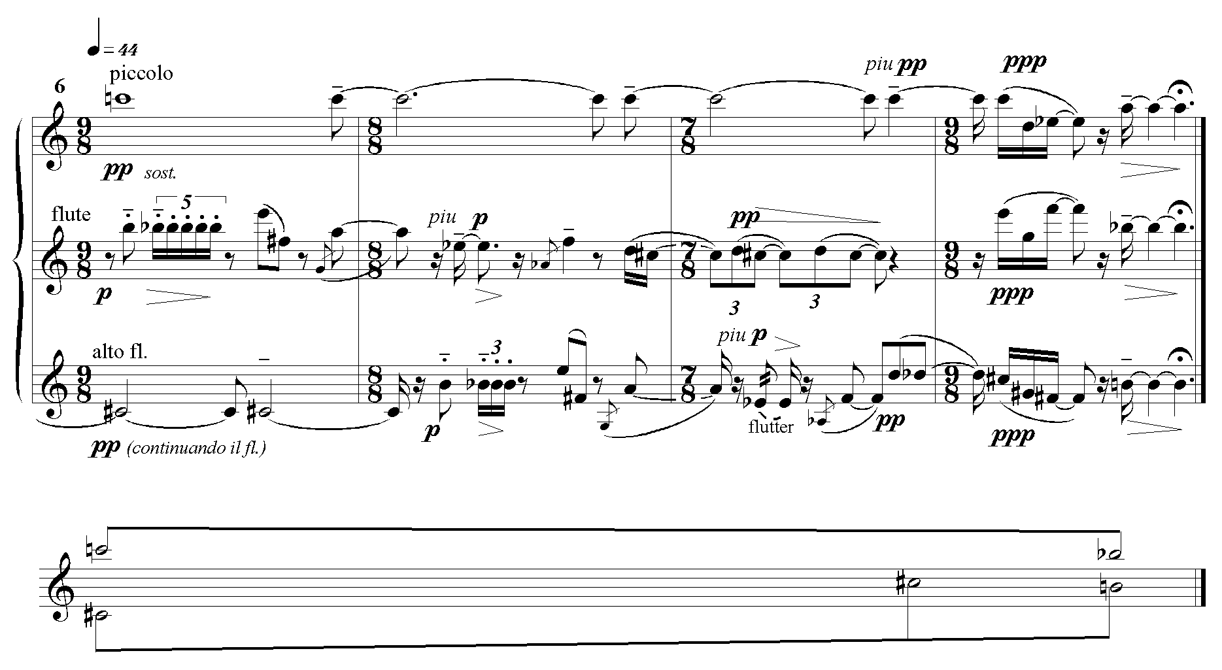
In the last song, “Ideal Epitaph of a Sailor”, Dallapiccola seems to be very interested in the appearance of the music on the page. In order to evoke the lines “One must look through the firmament to find your tomb/ Your death rains down from a star.”, he constructs aggregates from the shapes of astral constellations. The musical depiction of Ursa major and the Triangulum australe are shown on the following page. This aggregate appears to be built by replicating the [0,2,6] trichord drawn from op 2-4 of the row. In Ex. 6.24 the trichords are (A#-G#-E), (G-A-C#), (C-D-Gb), and (B-D#-F).
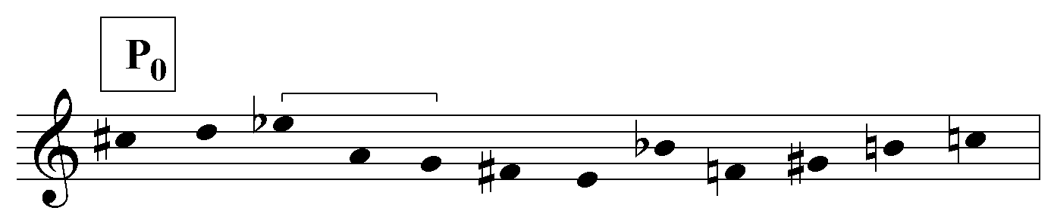
6.23 Sicut Umbra: row

Ex. 6.24 Sicut umbra IV: astral constellations

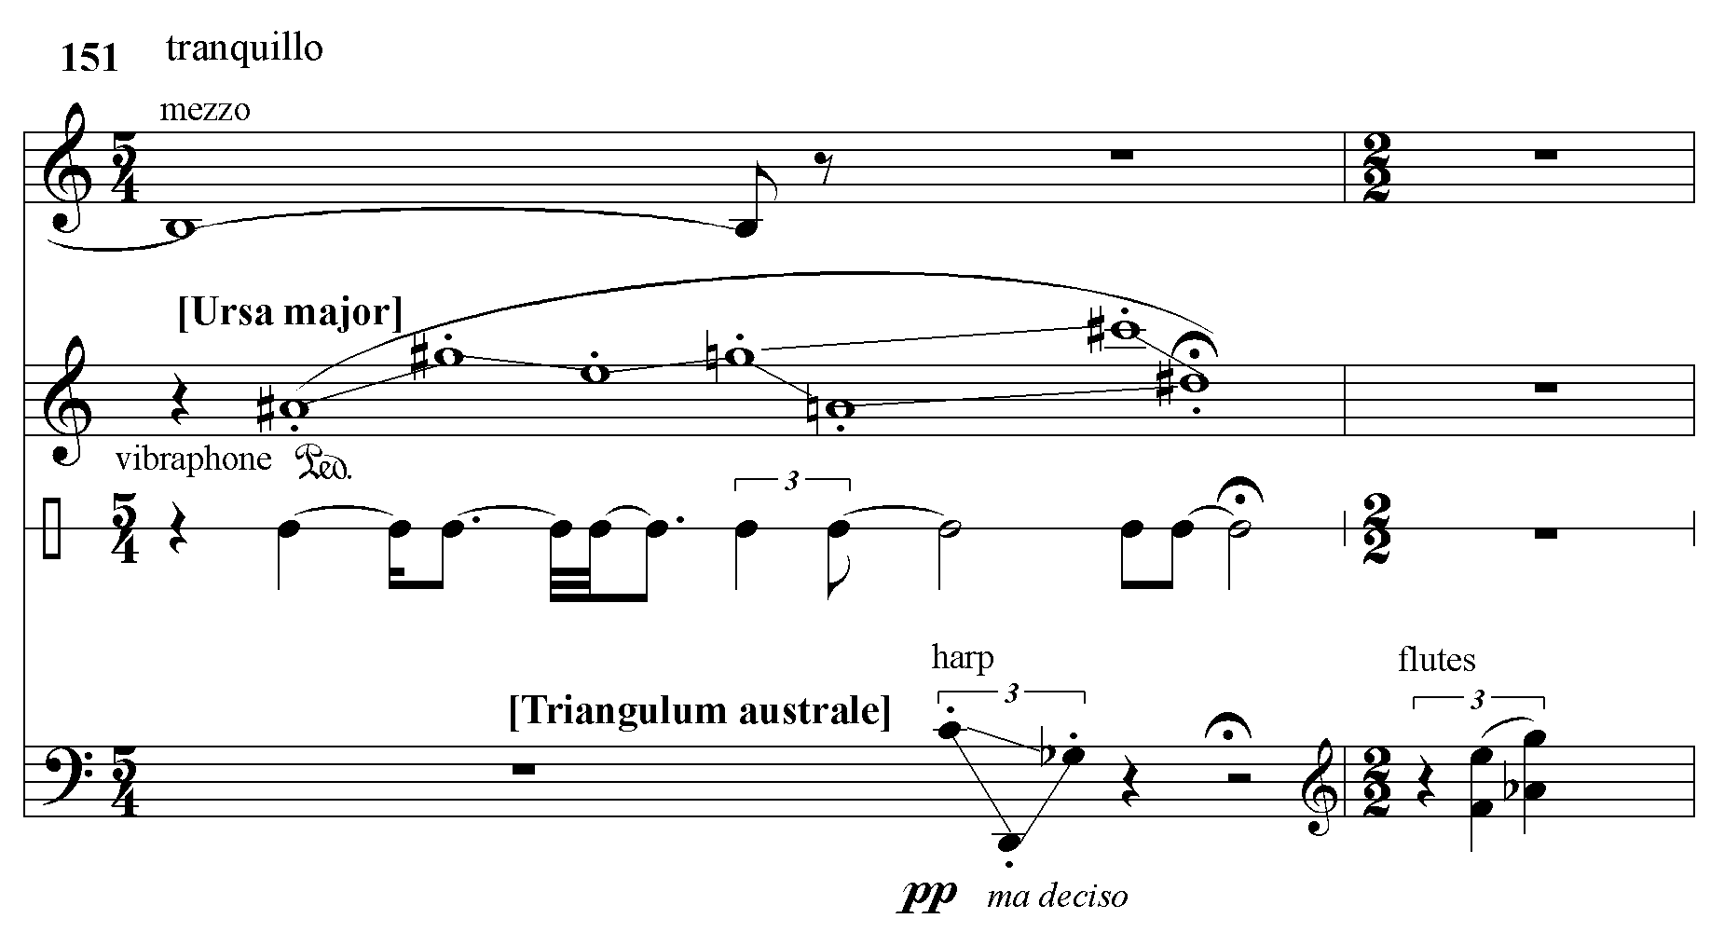
Given the apparent decay of tonal analogue and linear structure beginning with Preghiere (1962), it could be argued that the strong row level structures of Parole di San Paolo (1964) and Tempus Destruendi (1971) are better interpreted as text-setting artifacts than as organic compositional procedures. The return of the ‘charity chords’ in Parole di San Paolo, for instance, could owe its existence more to the parallel structure of the text than to the compositional design. In the case of Tempus Destruendi, the striking architectonic confluence of tonal analogue, linear structure, octatonic structure, texture blocks and dynamic organization could be interpreted as an enormous text-painting device depicting the destruction and reconstruction of the Temple. Although those text-painting interpretations are certainly valid, it would be more correct to say that, on the whole, Dallapiccola’s architectonic sensibility existed prior to text or music, and embraced both. For example, the ‘pillars of P₀’ in the purely instrumental work, Dialoghi (1960), perform a function similar to that of the ‘charity chords’ in the vocal work, Parole di San Paolo (1964). It seems likely that Dallapiccola chose the texts under consideration precisely because they offered him an opportunity to create a highly structured musical design.
In his magnus opus, the opera Ulisse (1960-68), he imposed an architectonic structure on the plot that audiences initially felt was inconsistent with Homer’s dramatic narrative.
Table 6.8 episodes of Ulisse (after Dallapiccola)7

 | 7. Realm of the Cimmerians
6. Circe |  | 8. Palace of King  Alcinous
5. Lotus-eaters |  | 9. Eumaeus
4. Palace of King  Alcinous |  | 10. Palace at Ithaca
3. Nausicaa  (ball game) |  | 11. Banquet of the Suitors  (dance)
2. Poseidon  (symphonic intermezzo) |  | 12. Ulysses and Penelope  (symphonic intermezzo)
1. Calypso (alone) |  | 13. Ulysses (alone)

“The second half of the opera, therefore- scenes 7 [sic] through 13- forms a mirror image of the first half. Only the scene at the top of the arch- the Realm of the Cimmerians- is balanced by itself, for reasons that become clear as the nature of the episodic arrangement is revealed.”8 This quite different, more static and “classical” quality of Dallapiccola’s Ulisse failed to excite critics and audiences, who were expecting a dramatized version of the adventures of Homer’s Ulysses.”9

The mirror extends into the level of textual correspondence. The first words Calypso sings are “ Alone, once more alone, are your heart and the sea. Inconsolably I mourn you, Calypso, the lovelorn goddess.” (mm.11-20). The last words Ulysses sings are “Signore! [Lord] No more alone are my heart and the sea.” (mm.1025-1030). The same music is used for the words “goddess” and “Signore”. An example of purely musical correspondence is provided by the ball game of Nausicaa and the dance of Melantho at the Banquet of the Suitors; the two musical interludes develop similar interlocking motivic material.
Ulisse is an example of a text that Dallapiccola recast in his own architectonic image to create a completely new interpretation of the Odyssey as a parable of existential alienation and reconciliation.
Commiato for soprano and chamber orchestra
In Ulisse, Dallapiccola applies the principle of retrograde to the plot structure, leaving the keystone episode, the Realm of the Cimmerians, outside the retrograde scheme. In his final work, Commiato (1972), he applies a musical retrograde over the
outer movements of the five-movement span, leaving the central movement out of the scheme. The fifth movement is an exact retrograde of the first movement; in both movements, the soprano vocalises on “Ah”. The fourth movement is a modified retrograde of the second movement, omitting the flute solos and several other passages. Both of these movements are purely instrumental while the third movement is a through-composed setting of a lauda attributed to Brunetto Latini. Dallapiccola had previously employed a five-movement form alternating between vocal and instrumental movements in the Concerto per la notte di Natale dell’anno 1956 (1957) and Requiescant (1958). Already present in An Mathilde, Dialoghi and Preghiere, in Commiato, the musical principle of a structural retrograde over a large area is expanded to degree unprecedented in Dallapiccola’s music.
It is possible that again Dallapiccola chose a text, the expression of which would be consistent with a vast retrograde, the ascent of the soul being the reverse of the fall of the body. The poem and its translation appear below.

Commiato
O fratel nostro, che se’ morto e sepolto,
nelle sue braccia Iddio t’abbia raccolto.

O fratel nostro, la cui fratellanza
perduta abbiam, chè morte l’ha partite,
Dio ti dia pace e vera perdonanza
di ciò l’offendesti in questa vita:
l’anima salga, se non è salita,
dove si vede il Salvatore in volto.

Farewell
O our brother, who art dead and buried,
may God have received you in his arms.

O our brother, whose brotherhood
we have lost because death has taken it,
may God give you peace and true
forgiveness
for what you did in this life that
offended him:
may your soul ascend, if it has not
ascended,
where the Savior’s face can be seen.

The first and last movements have no row per se. Their linear and vertical material is generated by various aggregational permutations of the [0,1,6] and [0,1,2] trichords. All of the vertical material is organized into paired, inversionally related [0,1,2,3,6,7] hexachords, which can be constructed by combining the abovementioned trichords. In the case of the first chord in the example below, the trichords are {Eb, A, Bb} and {E, F, F#}.
Ex. 6.25 Commiato I: paired inversionally related chords, mm. 2-3

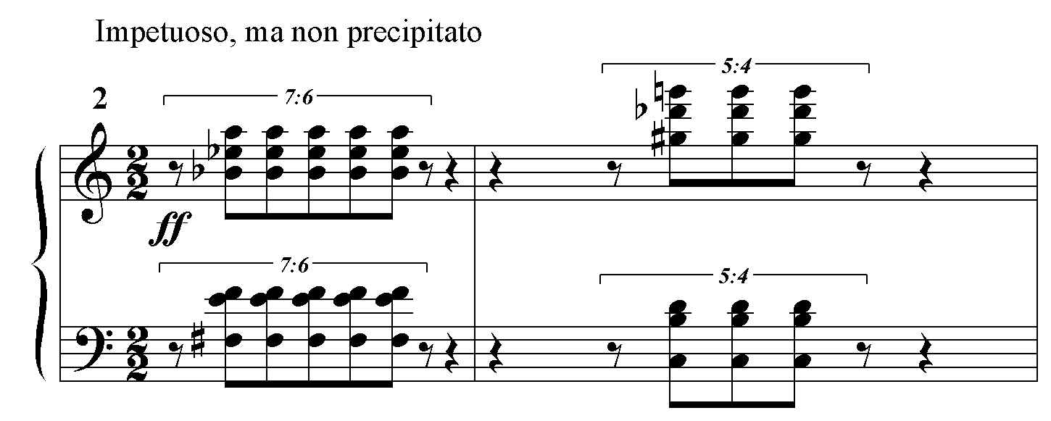
Even without a row, given the hexachordal homogeneity of the orchestral accompaniment, it is conceivable that a structure of hexachordal levels might be present. Taking the paired hexachords of Ex. 6.25 as the 0 level of the first movement, the pattern of hexachordal levels is 0, e, 4, 9, 3, 2, 1. Clearly, Dallapiccola is intent on avoiding tonicizing any particular level.
The second and fourth movements do exhibit a discernible row, a succession of two octatonic hexachords. Derived rows simply reorder the octatonic collections within each hexachord so that all the rows express the octatonic [0,1,3,6,7,9] hexachordal set. (Compare P₀ and DR [second hexachord] in Ex. 6.26.)
Ex. 6.26 Commiato II: hexachords: octatonic and set structure

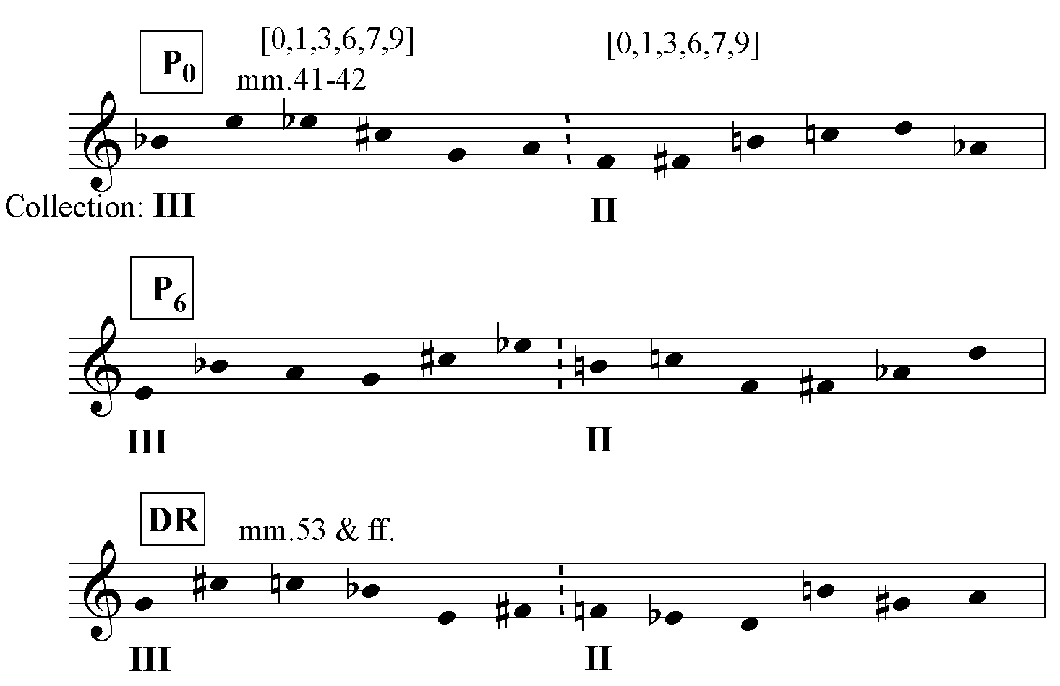

As illustrated by a comparison of P₀ and P₆ in the example above, hexachordal content is replicated at the tritone transposition. As a result, there are only six prime-retrograde levels. Nevertheless, as in the first movement, there is no obvious pattern of row or hexachordal levels. However, Table 6.9 on the following page reveals that the third movement does exhibit a tonal analogue. One surmises that Dallapiccola deemed the global retrogrades in the outer movements formally sufficient but felt the necessity for a higher degree of interior architecture for the keystone movement, which stands outside the retrograde order.
The row of the third movement, shown in Ex. 6.27, differs from both the
aggregates of the first movement and the row of the second movement.

Ex. 6.27 Commiato III: row

Table 6.9 Commiato III: tonal analogue

meas. | 93 94 96 98 100 | 102 104 106 113-114
row | P₀ D[016] I₈ I_{e} D[016]  a b c b | H[013,016] D[013,026,016] D[016,026,012] D[036,016]

meas. | 115 117 118 122 | 125 126 128 130 133 134-36
row | P₀ D[016,012] ? D[0126,0123] | P₀ D[016] I₈ I_{e} D[016] D[013,026,016]  a b c b

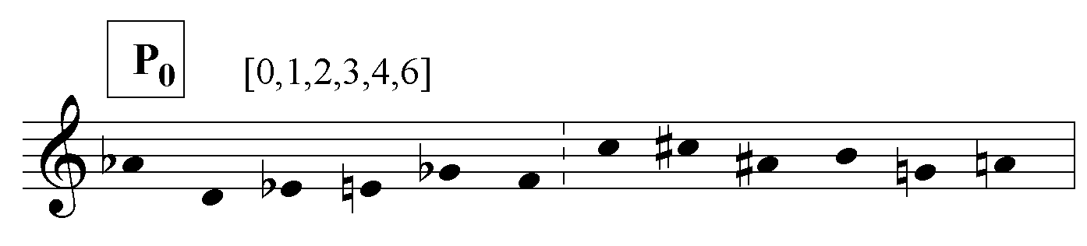
D stands for derived row; H stands for hexachord. At m. 115, the song is divided into two equal halves of 22 measures by the introduction of a new line of text after a rest in all parts. Each section is further subdivided into subsections, by the beginning of the second stanza after a long vocal rest at m.102, and by a fermata at the end of mm.124 preceding a repeat of the opening couplet. Although it is impossible to characterize one row or group of rows as a ‘tonic’, there obviously has been some attempt to anchor the listener’s harmonic perception in some repeated configurations. Three of the four subsections begin with P₀ in the voice. The music of the first subsection is repeated completely in the last subsection. Within that subsection the instances of DR [0,1,6] are harmonically identical, creating the form abcb as shown. The end is formally ambiguous; it is not quite clear why mm.134-136 should be a repetition of mm.104-5 transposed up a whole step.
Dallapiccola seems to have relied very heavily on the large scale retrograde to produce a cogent form in this work; the tonal analogue is rather weak, and there is no convincing linear structure that I could discover.
One might expect that the second movement, whose octatonic hexachords are presented as a series of verticals, would exhibit a great deal of octatonic harmony. Dallapiccola avoids this, for the most part, by consistently adding one non-octatonic pitch to the hexachords. Occasionally, however, some pure small-scale octatonic structures shine through, as in the example below. (See Ex. 6.26 for the row.)
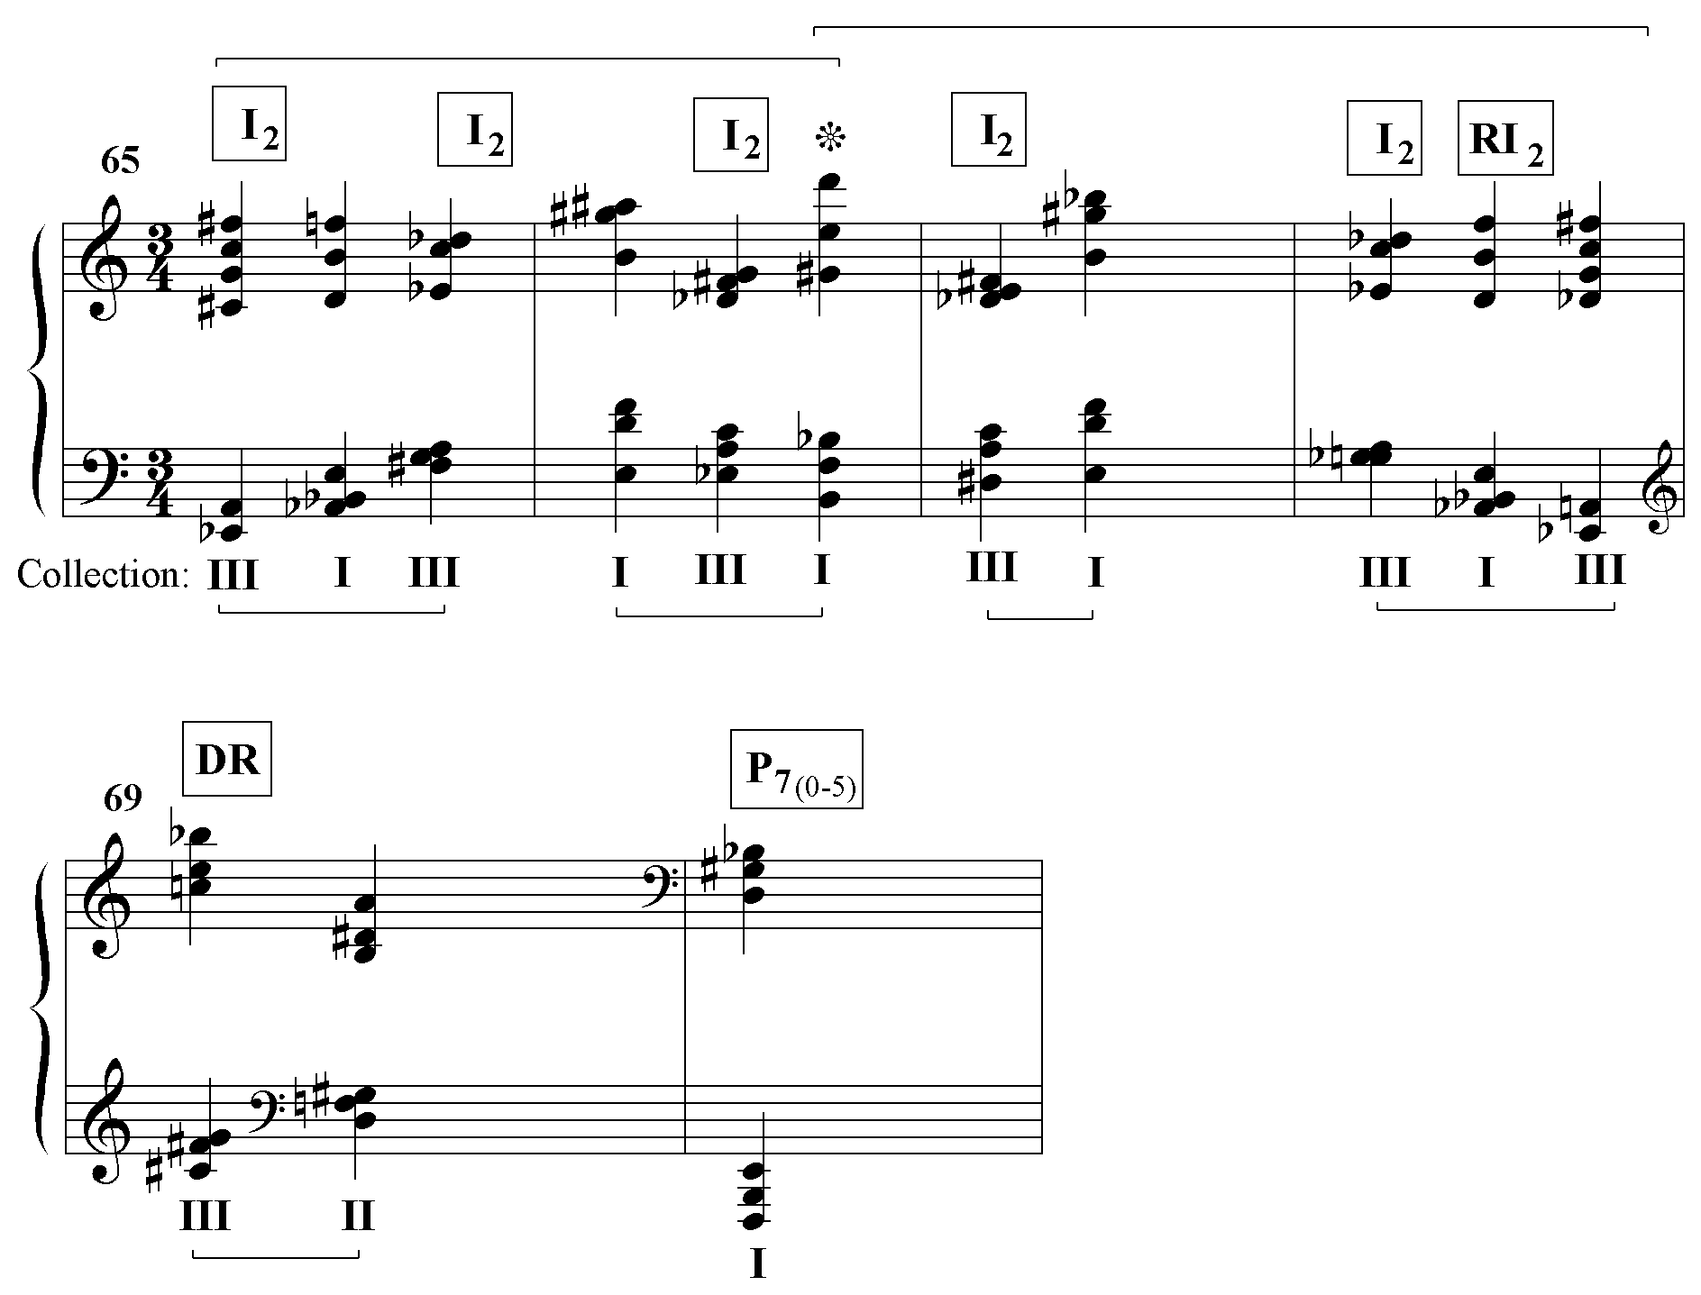
Ex. 6.28 Commiato II: octatonic structure mm. 65-70 (schematic)
The top brackets mark off the retrograde in mm.65-68 that revolves around the third chord of m.66. This small retrograde octatonic structure is reminiscent of the larger one in An Mathilde discussed on pages 25-26. The bottom brackets indicate the phrase groupings according to rhythmic considerations. Measures 65-68 vacillate between an emphasis on Collections III and I before settling on Collection I in m.70.
Conclusion
Piccola Musica Notturna (1954) was the turning point in Dallapiccola’s use of tonal allusion. It is present in every work before 1954 and absent from every work after that point (except for the expressedly tonal Tartiniana Seconda (1956), and instances of symbolic self-quotation such as the fleeting B major triad in Ulisse at the word “stars” that harks back to the B major triad in Volo di Notte (1937) when the hero flies toward the stars.)
Tonal analogue is present as a strong formal element as late as his penultimate work, Tempus Destruendi/Tempus Aedificandi (1971), but beginning with Preghiere (1962) it is increasingly absent. Sicut Umbra (1970) and Commiato (1972) suggest that Dallapiccola may have been moving toward replacing the row with a succession of trichord-generated aggregates. One can only speculate on whether he would have tried to ‘tonicize’ certain hexachordal or tetrachordal levels, or whether, as in Preghiere, the harmonic vocabulary would have remained unstructured.
The linear structure, which in Ciaccona (1946) and Quaderno Musicale di Annalibera (1952) mimicked tonal clichés, already by Rencesvals (1946) had begun to evolve to the point where each work expressed its own idiosyncratic line (when one was present), a situation that obtained without exception from Piccola musica notturna (1954) onward.
However, after An Mathilde, linear structure, too, becomes less strongly felt. Like tonal analogue, it is also essentially absent from works such as Preghiere, Sicut Umbra and Commiato, suggesting that the two formal devices are linked. Nevertheless, one should keep in mind that his penultimate work, Tempus Destruendi/Tempus Aedificandi, which displays him at the height of his powers, is probably the most organized piece he ever wrote in terms of its linear and octatonic structures; its second movement, Exhortatio also exhibits a strong tonal analogue. Although the presence of tonal analogue and linear structure show a statistical decline in the last decade of his compositional activity, they remained a potent force.
Octatonic harmony was a lifelong habit of Dallapiccola’s, ready to be expressed at any time. Although the incidence of octatonic rows declines in his later period, the incidence of octatonic harmony is fairly constant.
There has been quite a bit of row analysis in this paper. Nevertheless, it is necessary in order to understand the structure of Dallapiccola’s musical thought. It seems clear that Dallapiccola’s formal habits were tonal habits that were adapted to a new harmonic language. The drama of departure and return, which in tonal music is expressed in terms of keys, is realized with rows.
Beginning with Ritmi from the Quaderno Musicale di Annalibera, Dallapiccola was increasingly fascinated by the use of texture as a formal building block, a procedure that reached its apogee in Tempus Destruendi/Tempus Aedificandi. Of course, throughout history composers have employed texture as a formal element. In Dallapiccola’s oeuvre, however, it appears to take on a heightened importance as a result of the balanced patterns in which the textures of a work are organized. Ploratus and Exhortatio from Tempus Destruendi/Tempus Aedificandi are prime examples. As is evident from Tables 5.1 and 5.2, the return of texture blocks sometimes coincides with the return of row levels, but not always. Therefore, to a certain extent, texture can be heard as an independent formal element.
In the field of harmony, Dallapiccola began with, and then abandoned the harmonic detritus of tonality, bits and pieces of triads and seventh chords. However, his lifelong fascination with octatonic harmony suggests that he never abandoned his interest in a transcendent harmonic system, although his music never achieves complete coherence in this regard.
From my perspective as composer, the enduring interest of Dallapiccola’s music lies in his attempt to achieve the formal cogency of the finest works of the tonal period with contemporary harmonic means. In works such as Piccola Musica Notturna, Quaderno Musicale di Annalibera and Tempus Destruendi/Tempus Aedificandi, he most successfully creates a new and convincing harmonic language based on tonal analogue and/or octatonic harmony. Clear fundamental linear patterns, return of the tonic row level at important formal junctures, and the balanced organization of texture blocks combine to produce a strong, perceptible musical architecture.

Bibliography

Baker, James. “Schenkerian Analysis and Post-Tonal Music.” In Aspects of
Schenkerian Theory, edited by David Beach, 153-86. New Haven: Yale University Press. 1983.

Biondi, Michael. Compositional Process in Dallapiccola’s “Ulisse”. Ph.D. diss. City
University of New York, 1994.

Brindle, Reginald Smith. “Current Chronicle: Italy.” The Musical Quarterly 43
(1957): 240-245.

Brown, Rosemary. “Dallapiccola’s Use of Symbolic Self-Quotation.” Studi Musicali 4
(1975): 277-304.

Dallapiccola, Luigi. Dallapiccola on Opera. Tr. Rudy Shackleford. London. 1987.

_____. “Luigi Dallapiccola: Fragments from Conversations.” Presented by
Hans Nathan. The Music Review 27 (1966): 294-312.

_____. “Luigi Dallapiccola on Arnold Schoenberg.” Translated by Michael Eckert. Journal of the Arnold Schoenberg Institute 7 (1983): 93-101.

_____. “My Choral Music.” in The Composer’s Point of View: Essays on Twentieth Century Choral Music by Those Who Wrote It, edited by Robert Stephan Hines, 151-177. Norman: University of Oklahoma Press, 1963.

Dapogny, James. Style and Method in Three Compositions of Luigi Dallapiccola.
D.M.A diss. University of Illinois at Urbana-Champaign, 1971.

Dwelley, Robert. An Analysis of Luigi Dallapiccola’s “Piccola Musica Notturna”.
Ph.D. diss. University of Rochester, Eastman School of Music, 1985.

Eckert, Michael. “Octatonic Elements in the Music of Luigi Dallapiccola.” The Music
Review 46 (1985): 35-48.

Gerhard, Roberto. “Apropos Mr. Stadlen.” The Score (July 1958): 50-57.

Hill, Richard. “Schoenberg’s Tone-Rows and the Tonal System of the Future.” The
Musical Quarterly 22 (1936): 14-37.

Hyde, Martha.” The Telltale Sketches: Harmonic Structure In Schoenberg’s Twelve-
Tone Method.” The Musical Quarterly 66 (1980): 560-80.

Krumhansl, Carol. Cognitive Foundations of Musical Pitch. NY: Oxford University
Press. 1990.

Lang, Paul Henry. “Choral Music in the Twentieth Century.” American Choral
Review 21/2 (1977): 12-13.

Lewin, David. “A Study of Hexachordal Levels in Schoenberg’s Violin Fantasy.”
Perspectives of New Music 6 (1968): 18-32.

MacDonald, Calum, “LUIGI DALLAPICCOLA The Complete Works.” Tempo
116: 2-19.

Mancini, David. “Twelve-tone Polarity in Late Works of L.D.” Journal of Music
Theory 30/2 (1986): 203-224.

Mead, Andrew. “ ‘Tonal’ Forms in Arnold Schoenberg’s Twelve-Tone Music.” Music
Theory Spectrum 9 (1987): 67-92.

Merrill, Thomas Glen. Luigi Dallapiccola’s Use of Serial Technique in Four Choral
Works. DMA diss., University of Cincinnati, 1995.

Michel, Pierre. Luigi Dallapiccola. Genève: Éditions Contrechamps, 1996.

Murray, Edward Michael. New Approaches to the Analysis of Webern. Ph.D. diss.
Yale University, 1979.

Nathan, Hans. “On Dallapiccola’s Working Methods.” Perspectives of New Music 15
(1975): 34-57.

_____. “Review of Records.” The Musical Quarterly 64 (1978):

Owen, D.D.R., trans. The Song of Roland. Wolfeboro, New Hampshire: The Boydell
Press, 1990.

Parks, Richard. “Tonal Analogues as Atonal Resources and Their Relation to Form in
Debussy’s Chromatic Etude.” Journal of Music Theory. 29/1 (1985): 33-60.

Perle, George. “Scriabin’s Self-Analyses.” Music Analysis 3/2 (1984): 101-22.

Piston, Walter. “More Views on Serialism.” The Score (July 1958): 46-49.

Qualliotine, Armand Guy. “Extended Set Procedures in Two Compositions of Luigi Dallapiccola.” Ph.D. diss., Brandeis University, 1986.

Schoenberg, Arnold. “Composition with Twelve Tones (1)” in Style and Idea, edited
by Leo Stein, 214-244. Translated by Leo Black. Berkeley: University of California Press, 1975.

Salzer, Felix. Structural Hearing: Tonal Coherence in Music. 2cnd ed. New York:
Dover, 1962.

Sessions, Roger. “To the Editor.” The Score (July 1958): 58-64.

Stadlen, Peter. “Serialism Reconsidered.” The Score (Feb 1958): 12-27.

Straus, Joseph. “The Problem of Prolongation in Post-tonal Music.” Journal of Music
Theory 31 (1987): 1-21.

Sturzbacher, Ursula. Entretiens d’atelier avec des compositeurs. Munich, 1973.

Thomas, Jason. “An Analysis with Performance Notes of Luigi Dallapiccola’s
Dialoghi.” DMA diss., University of Wisconsin-Madison, 1991.

Travis, Roy. “Toward a New Concept of Tonality?” Journal of Music Theory 3
(1959): 257-84.

van den Toorn, Pieter. “Some Characteristics of Stravinsky’s Diatonic Music I.”
Perspectives of New Music 14 (1976): 104-138.

Vlad, Roman. Luigi Dallapiccola. Translated by Cynthia Jolly. Milano: Edizioni
Suvini Zerboni, 1957.

_____. “Dallapiccola 1948-1955.” The Score 15 (1956): 39-62.

Waterhouse, John. “The Italian Avant-Garde and National Tradition.” Tempo 64
(1968): 14-25.

Wildberger, Jacques. “les grandes heures de luigi dallapiccola pour l’histoire de la
musique.” Musique en jeu 21 (1975): 67-80.

Wilson, Paul. The Music of Bela Bartok. New Haven: Yale University Press, 1992.

The dates of composition are taken from Michel, Luigi Dallapiccola, pp. 151-56.
Works that are arrangements or that spring from the same compositional impulse are not counted. Thus, the Variations, which is the orchestration of the Quaderno, and the Canti di Liberazione, which is based on the same row and compositional material as the Quaderno, are not on the list.
3 Eckert, “Octatonic Elements”, p.39.
4 Eckert, “Octatonic Elements”, p.37.
5 Dapogny, Style and Method, p.64.
6 After Dapogny, Style and Method, pp.64-69
7 Dallapiccola, Dallapiccola on Opera, p.255
8 Biondi, Compositional Process, p.10
9 Ibid. p.10n

