Chapter 5 Tempus Destruendi/Tempus Aedificandi (1971)
Dallapiccola’s penultimate work, Tempus Destruendi/Tempus Aedificandi, consists of two movements for virtuoso a cappella choir, set to Medieval Latin texts dealing with the destruction and rebuilding of the Temple at Jerusalem. (For the texts and translations, see the following page.) The two movements, Ploratus and Exhortatio, are both unified and differentiated by means of texture, derived row construction, octatonic harmony, and linear structure. In Exhortatio, reconstruction is evoked with a greater symmetry of textural blocks, a greater density of octatonic cadences, and a more stable linear structure.
The rows of Ploratus and Exhortatio are constructed from conjoined octatonic hexachords. For the first time since Piccola musica notturna (1954), octatonic harmony plays a crucial role in form creation. In fact, this work is arguably the most structurally octatonic that Dallapiccola ever wrote. Example 5.1 below indicates the octatonic nature of the two rows as well the segments used in derived row formation. The segment ‘m’ appears as an important independent motive in Ploratus.
Derived rows constructed from the replication of trichordal and tetrachordal row segments are already significantly represented in Piccola Musica Notturna (1954) and Parole di San Paolo (1964). In Tempus Destruendi/Tempus Aedificandi, their role is expanded considerably, accounting for about half of its measures. Although Ploratus and Exhortatio are each constructed from distinct rows, both rows can be segmented to produce [0,1,3] and [0,1,4] trichords as well as the [0,1,6,7] tetrachord.

Ploratus
O quae in altum extollebas verticem
quomodo jaces despecta, inutilis
pressa ruinis, nunquam reparalibis
tempus in omne!
Pro cantu tibi, cithara et organo
luctis advenit, lamentum et gemitus…

Lamentation

O you, who raised your towers to the sky
how you lie there despised,
crushed by senseless destruction,
irreparable for all time!
For you, instead of singing with organum and the kithara,
sorrow has come, lamenting and groaning...

Paulini Aquileiensis
“Versus de destructione Aquilegiae nunquam restaurande” (strophes 14-15)
- Monumenta Germaniae historica. Poetae latini aevi Carolini.
(Berlin, 1880; Vol. I; parte prima: p. 142)

Exhortatio

Exite, ut dixi, exite de Babilonia;
ite, aut redite Jerusalem:
Lapides Sanctuarii qui dispersi sunt recolligite:
Muros quos destruxit Nabuzardan,
princeps militiae Babylonis,
.
Exhortation

Go out, as I have said, go out of Babylonia;
Go, and return to Jerusalem:
Gather again the jewels of the Sanctuary which were dispersed:
Rebuild the walls destroyed by Nabuzadan,
commander of the Babylonian army.

restruite.

Deramti cujusdam Hiberniensis proficiscentis Jerusalem itineraria seu exhortatoria (circa 1095)
-Patrologiae cursus completus accurante J.P. Migne.
(Tomus CLV: Godefridi Bullonii…..Epistolae et diplomata.
Accedunt appendices amplissimae monumenta perplurima de bello sacro complectentes…..
(Paris, 1854, Col. 488- Sec. )

translations by Maria Rose

Ex. 5.1 Tempus Destruendi/Tempus Aedificandi: the rows and their segments
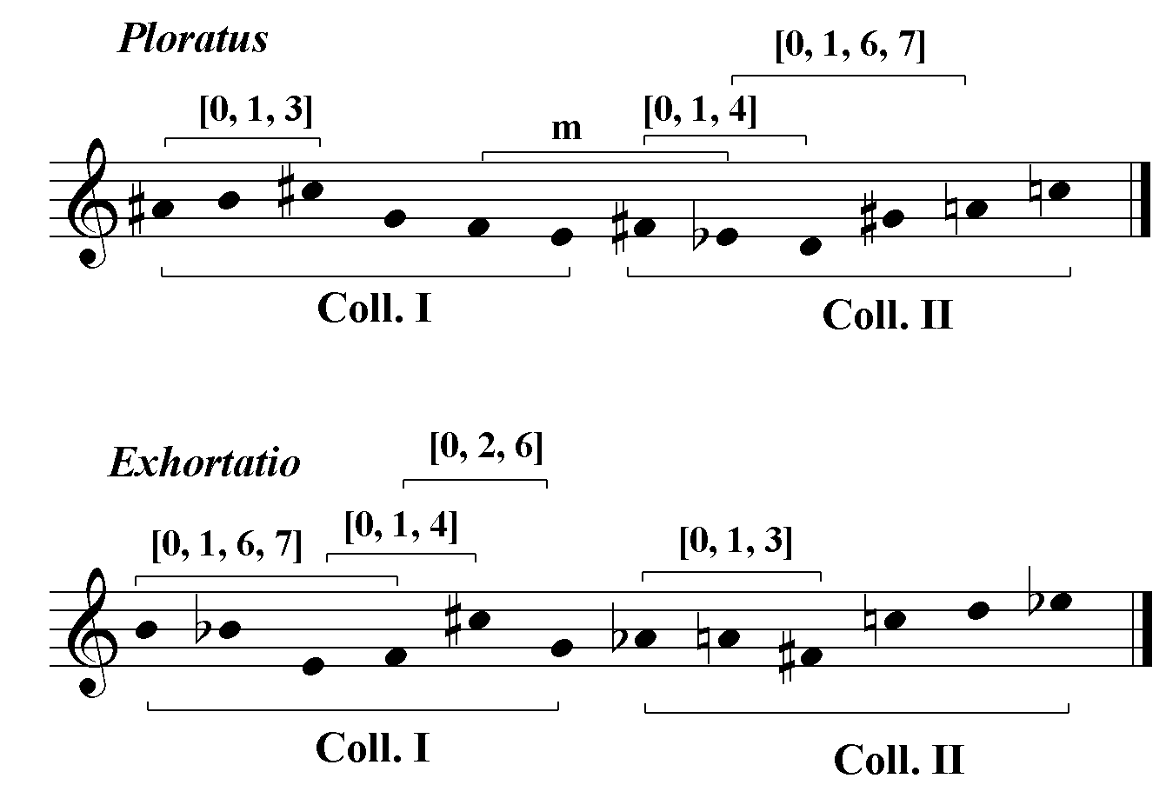
While these segments are exploited in both movements, derived row construction by replication of the [0,1,3] trichord is more prevalent in Ploratus whereas the [0,1,6] trichord and [0,1,6,7] tetrachord are found more commonly in Exhortatio. With the exception of eight measures of Ploratus that appear transposed in Exhortatio, the two movements do not share any derived rows despite the fact that these rows are sometimes constructed from the same segmental building blocks.
Both movements are characterized by blocks of very angular dyadal, trichordal and tetrachordal motives. These are segments of the primary rows that are replicated to create derived rows. The measures below, in which four [014] trichords are used to construct a derived row, are representative.
The motivic overlap, analogous to the overlap of masonry, is a principle of architectonic construction that, in this piece, extends to higher levels of formal organization as well.
Ex. 5.2 Ploratus: mm. 29-31, derived row construction with the [014]
building block
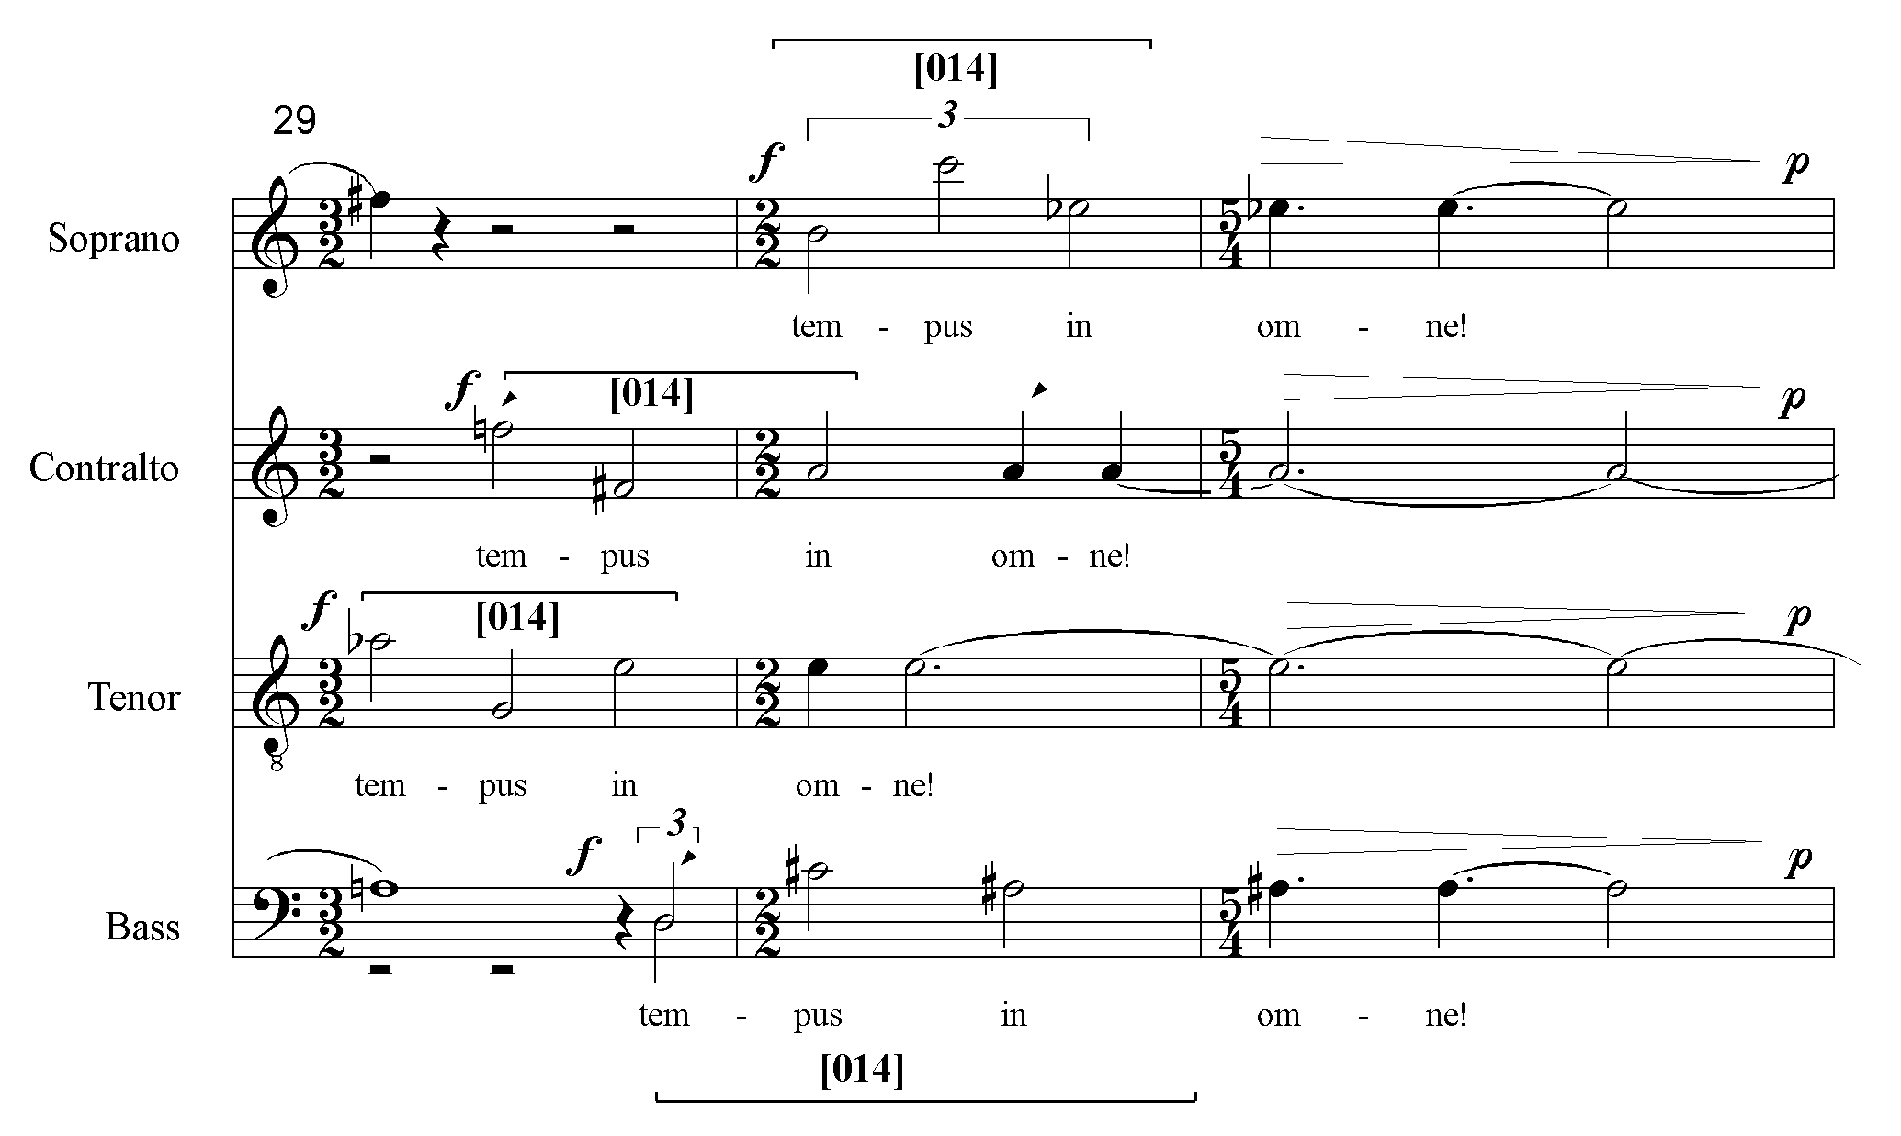
Before going on to discuss the larger blocks of texture, it will be instructive to finish the investigation into the raw material of the row. The extent of derived row formation is illustrated by the complete row analysis of Tempus Destruendi/Tempus Aedificandi that appears in Ex. 5.3. Derived rows are labeled DR and are followed by the set designation of their replicated segment. The numbers that appear next indicate the measures during which the rows are in force.

Ex. 5.3 TD/TF row analysis
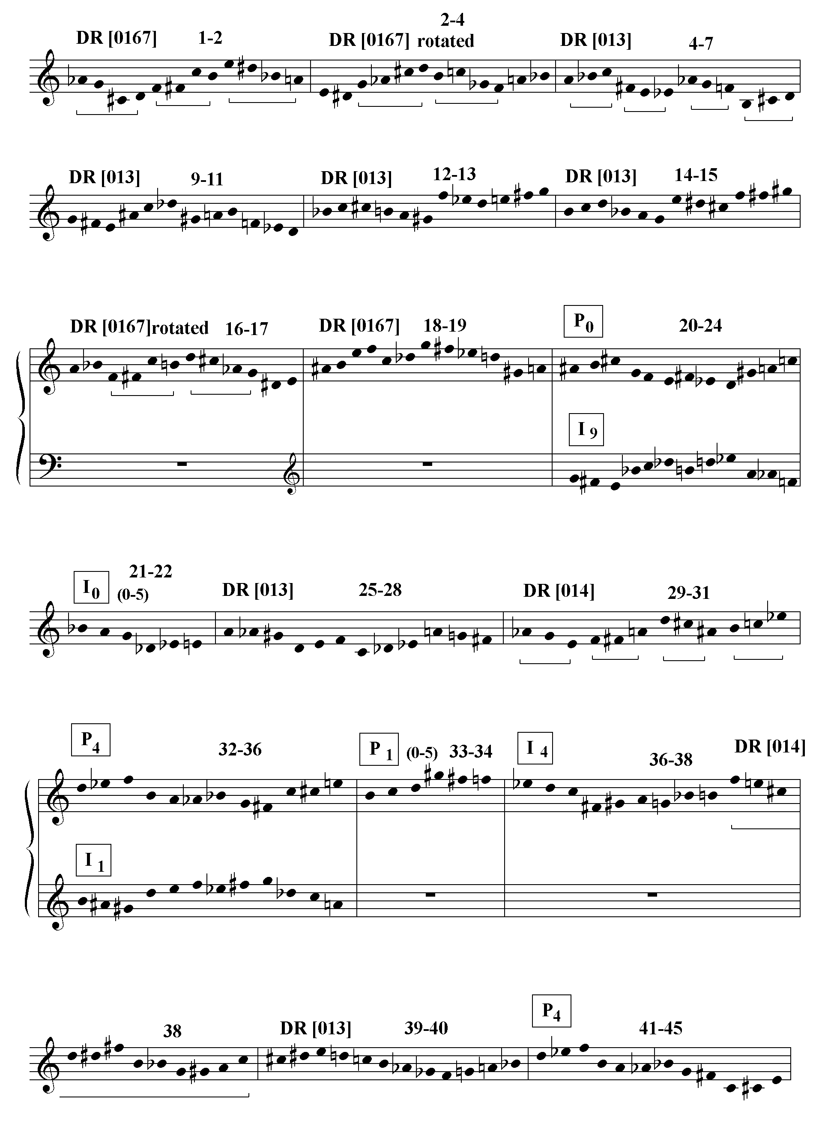
Ploratus: row analysis
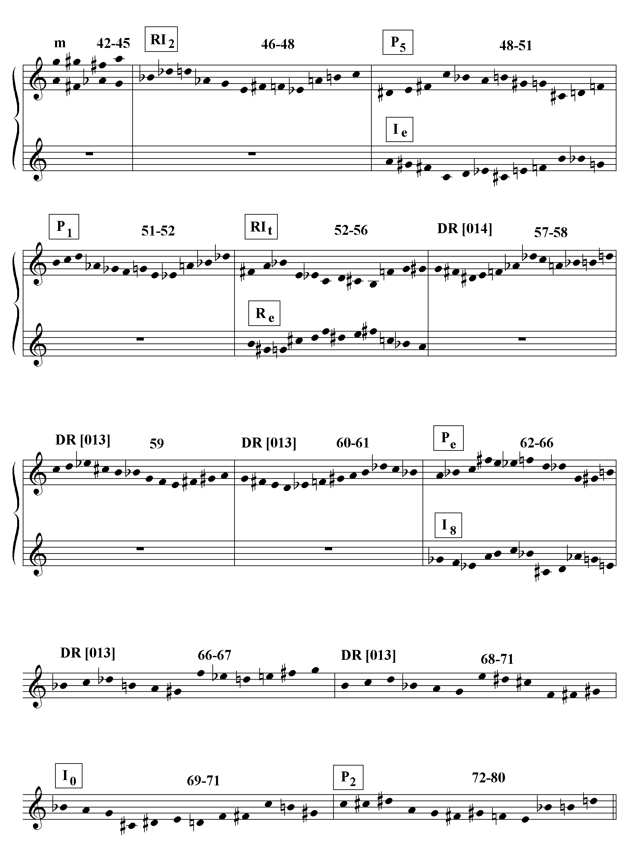
Exhortatio: row analysis
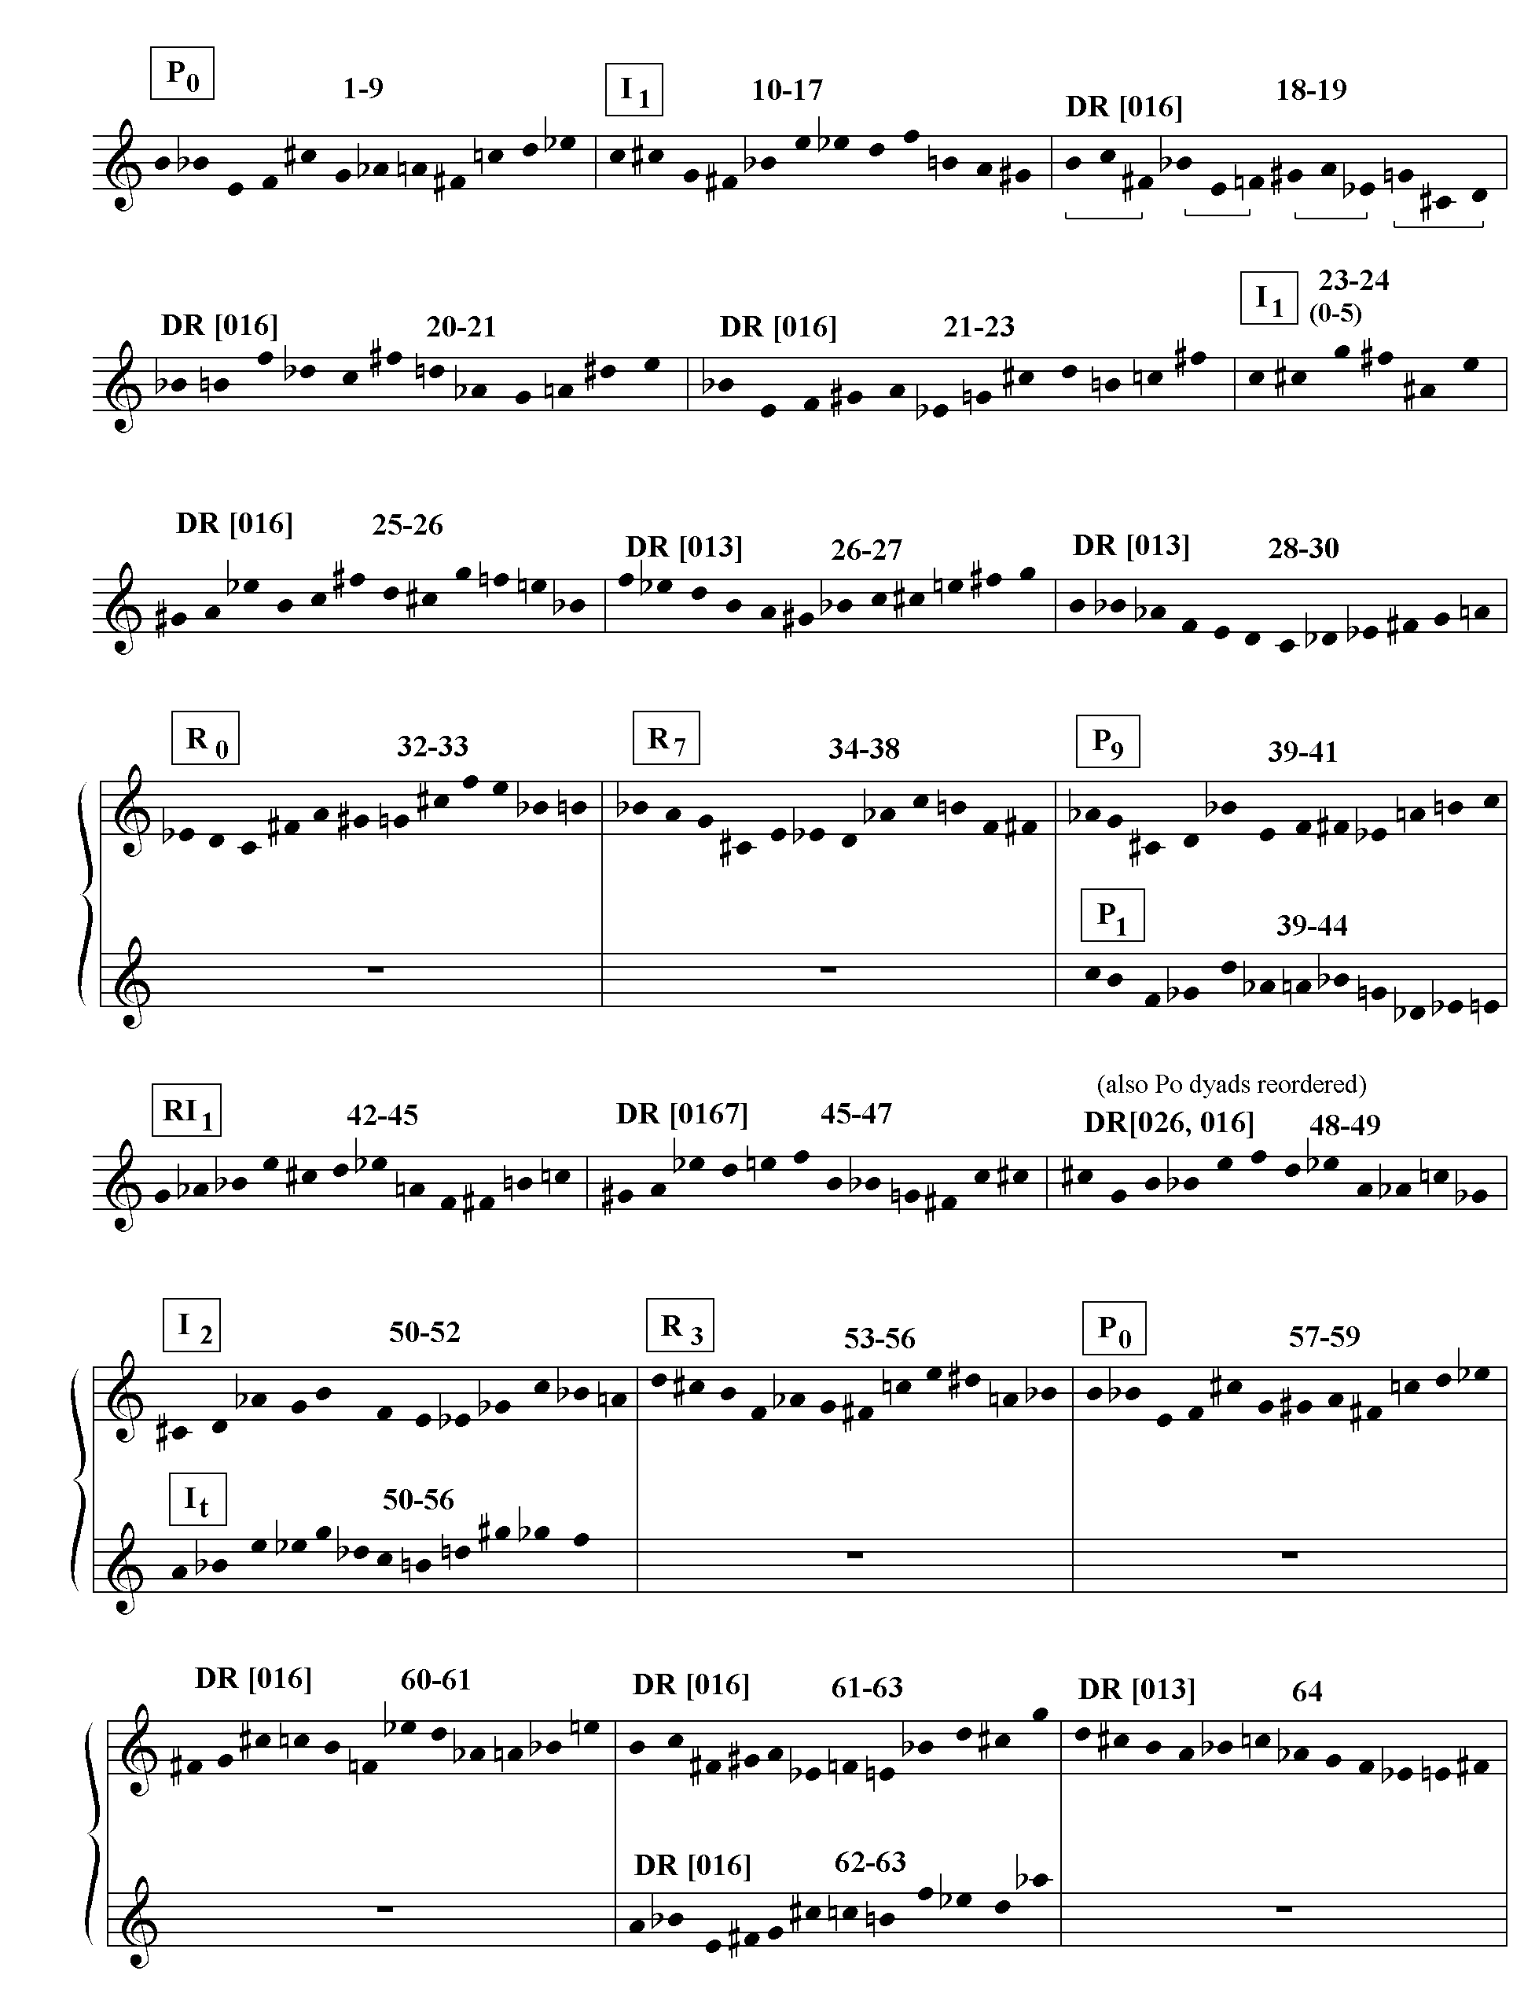
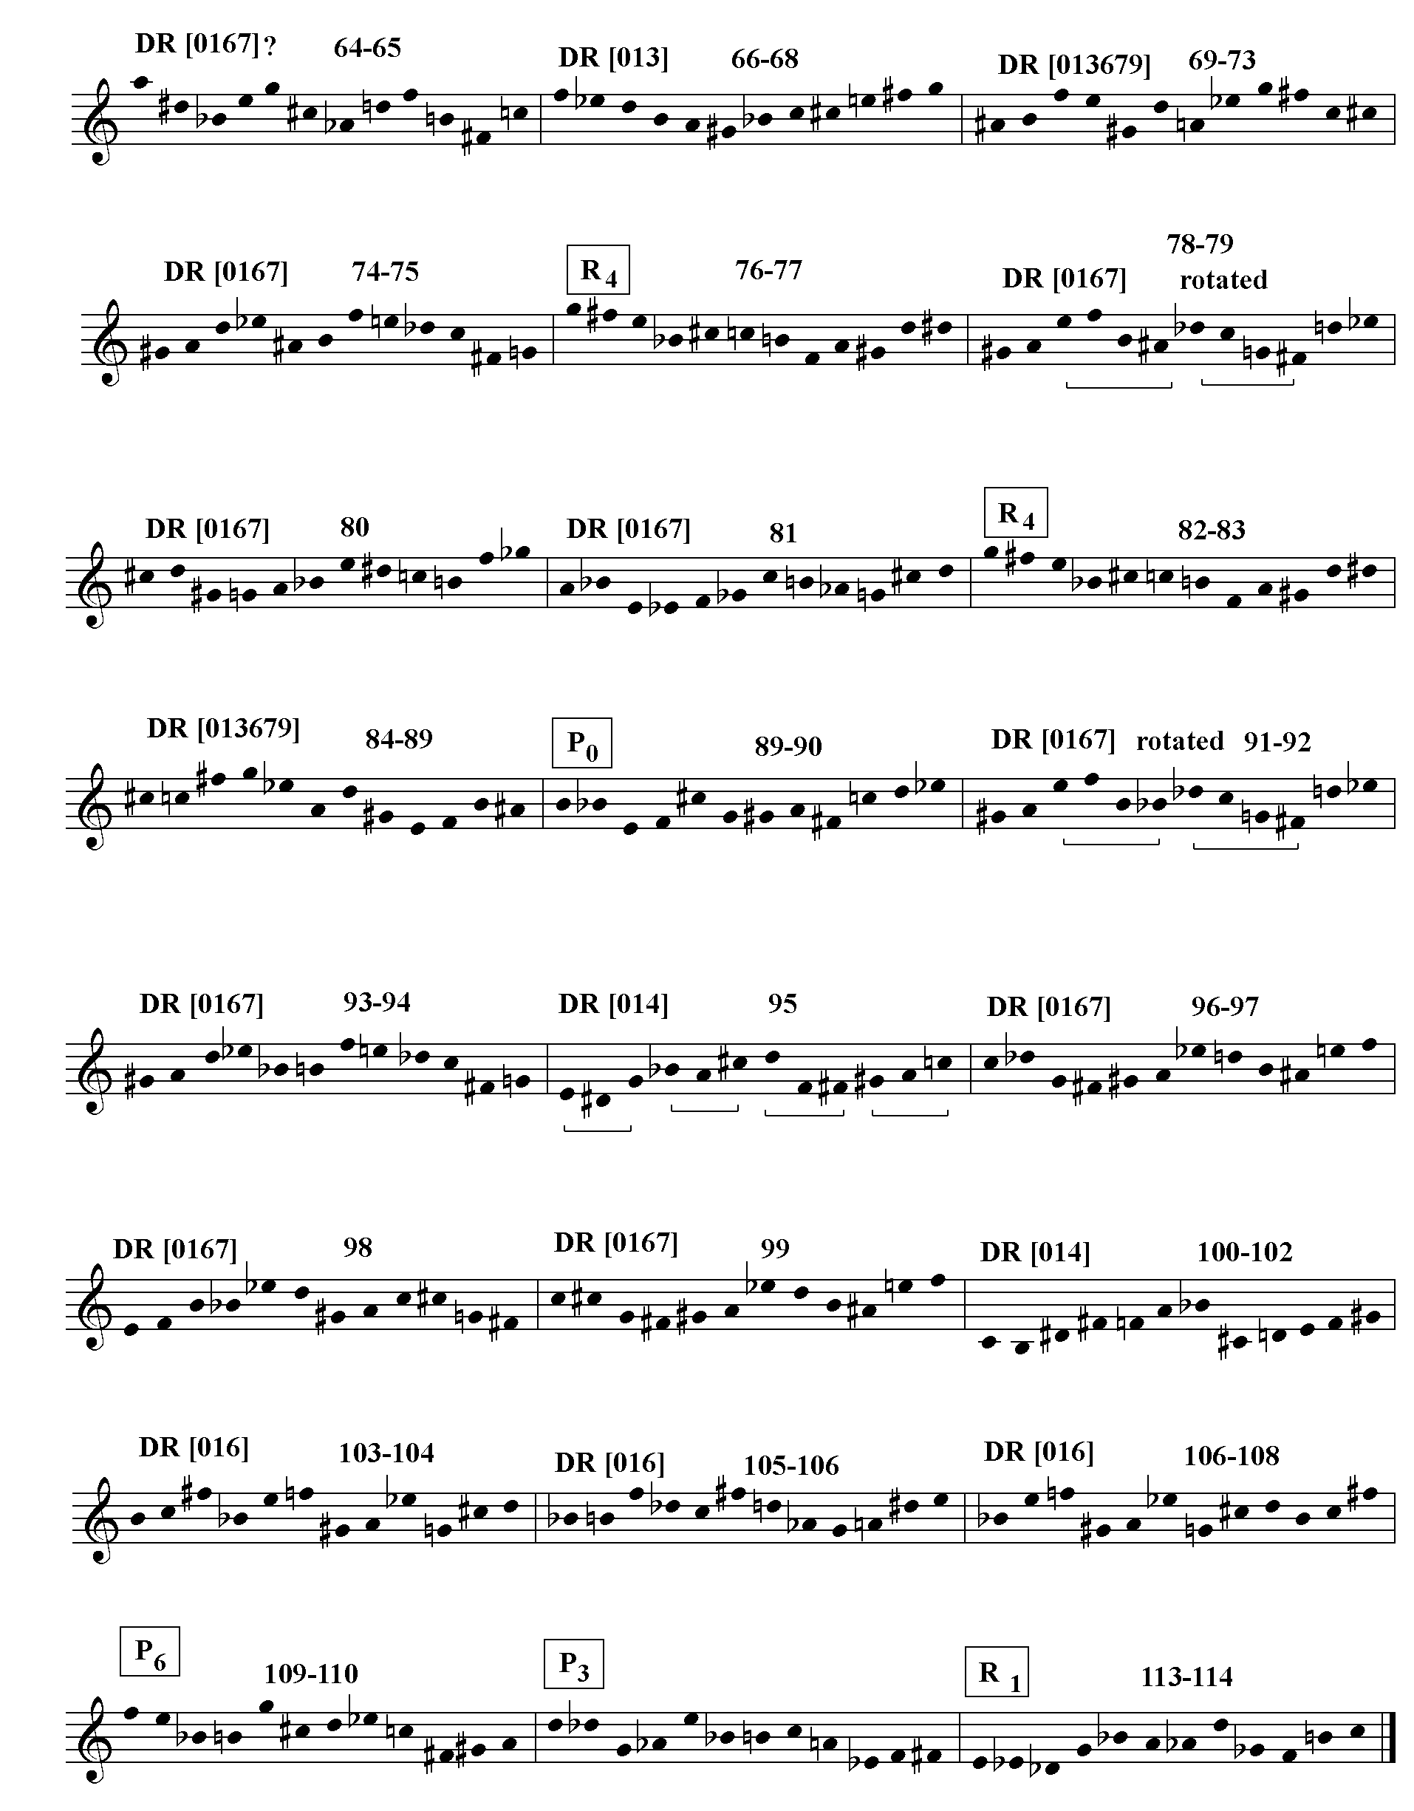

Tempus Destruendi/Tempus Aedificandi is organized into a more or less symmetrical series of texture blocks, most of which cadence on a harmonically significant octatonic chord. It is probably no coincidence that, given the subject matter, this is the most architectonic of Dallapiccola’s compositions.
Table 5.1 (see link) shows how Ploratus consists of three parts. Part A is exclusively choral; Part B begins with an introductory soprano solo. The soprano solo proper begins at m. 46, and is taken up again in part C. C consists of the transposed and reordered return of previous material, and repeats the words “lamentum et gemitus” as a kind of textual coda.
Dallapiccola produces an overlap at the highest formal level in the following way. Taking A and B together, the dynamic level moves from ff to ppp without any intermediate crescendos interrupting the descent. C then recapitulates the dynamic descent, ff to ppp. Alternatively, the end of section B+C (mm.74-80) transposes its beginning (mm.42-45) down a whole step. The dynamics create an A+B/C structure while the motives, texture and harmonies create an A/B+C structure.
The shaded areas of Table 5.1 show how the textural architecture works on a more local level. Part A is divided into two main sections, marked by the diamond. The first section is framed by the [01] dyad leaps setting “Ah”. (The [01] dyads can be combined into the [0167] tetrachordal row segment, which is how I surmise that Dallapiccola justified this material in terms of his serial technique.) The second
section is in turn divided into the following textural succession: canon/chords/ imitative trichords. This succession is then repeated, beginning at a tempo change. B is divided into the introductory soprano solo, repeating “tempus in omne” on the “m” motive while accompanied by the held chords, and the soprano solo proper, accompanied by dyad leaps. Again, there is a tempo change at the beginning of the second section, although I don’t consider the difference between quarter note equals 52 and quarter note equals 50 terribly significant. C divides at the point where the imitative trichords return, which is followed shortly by the reintroduction of the soprano solo.
Example 5.4 on the following page is an analysis of the succession of row forms and the pattern of octatonic harmony in Ploratus as they relate to the textural architecture displayed in Table 5.1. The example conforms as much as possible to the layout of the table. The first two systems correspond to part A with the break between them occurring at the point indicated by the diamond in the table. Systems B and C correspond to parts B and C. Furthermore, each bar of the example is equivalent to a texture block in the table. Measure numbers and row forms are shown above the systems while the collections of octatonic harmonies in each texture block are show below. Octatonic collections that conclude texture blocks are boxed. An “N” indicates the presence of a non-octatonic harmony.
It is immediately evident that, unlike the most of previous works analyzed (and the Exhortatio to follow), there is no tonal analogue. Neither P₀ nor any other row form attains referential status. Rather than a row form, it is an octatonic collection that
Ex. 5.4 Ploratus: Harmonic Structure
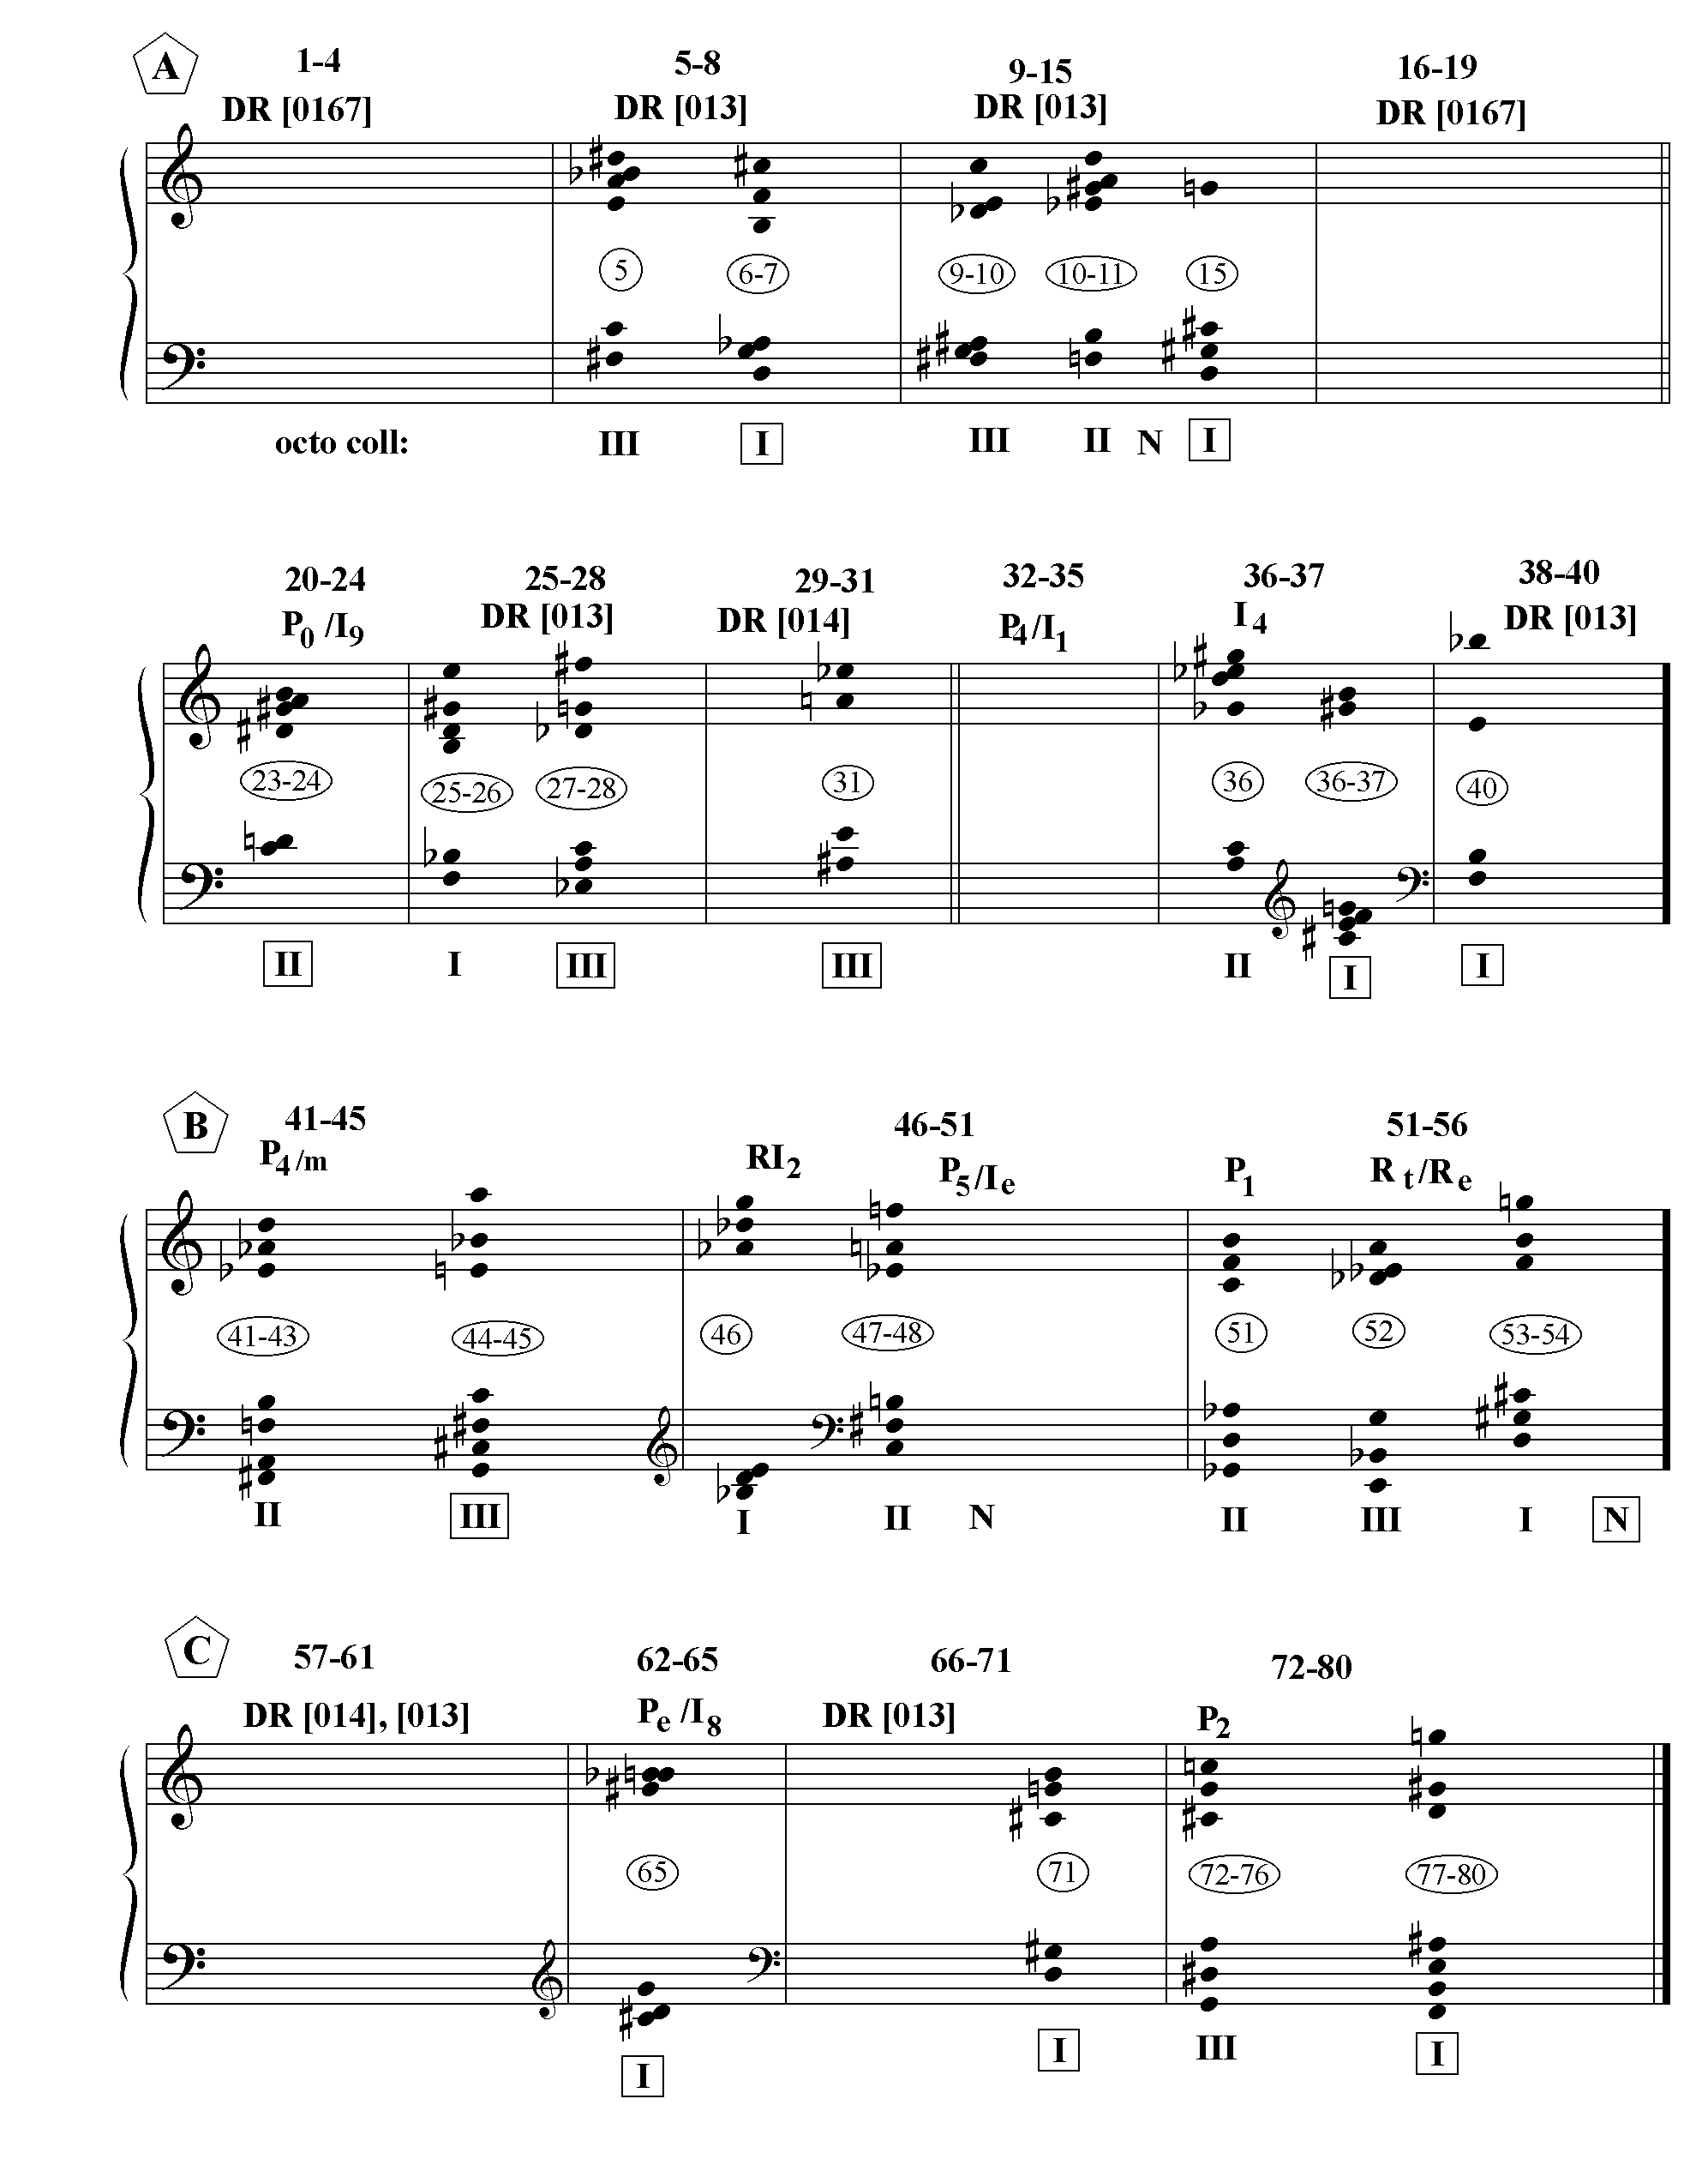

assumes the function of a tonic. Part A asserts collection I as a tonic. That collection concludes more blocks than the other collections, as well as ending part A. Part B is less octatonically structured as two of its three sections end on non-octatonic formations, after which C reaffirms collection I, as three out of four of its sections, including the last one, end on that collection. Example 5.5 on the next page illustrates how the harmonies that end parts A and C are structurally connected by their common participation in collection I. Note that the pc content of m. 40 is a subset of the chord at m.80. (See also Ex. 5.4, the end of the second and fourth systems.)
The textural architecture and harmonic structure of Exhortatio provide points of similarity and contrast to the preceding analysis of Ploratus. The sequence of textures in Exhortatio is even more organized than it is in Ploratus. One might consider the blocks of texture illustrated in Table 5.2 as a metaphor for the stone blocks of the reconstructed Temple. The form can again be organized into three parts. In A, the long held chords frame the imitative trichords and shorter held chords. In B, the soprano and contralto solos interlock with the imitative trichords and, in C, the sections beginning with dyads and ending with held chords are juxtaposed, after which the imitative tetrachords-held chord sections are also juxtaposed. A and B have similar dynamic arches, p-ff-p, and pp-quasi f-p-ff-pp, the difference being that B repeats the contour of A. C provides a contrast, ff throughout.
Although the textural architecture and dynamic contour support a tripartite organization, the tempi and tonal analogue could imply a bipartite structure. At m.57, the midpoint of the measure count, there is a tempo change, which is maintained for the rest of the piece in contrast to the four different tempi in force before that point. This coincides with the return of P₀. One observes a similarity to Parole di San Paolo where an articulation at the midpoint of the measure count also creates superimposed forms, in that case simultaneous four- and five-part forms. The difference is that the measure rest in Parole di San Paolo created the dominant four-part form whereas the formal juncture at m.57 of Exhortatio is not as strong as the breaks at m.38 and m.73.
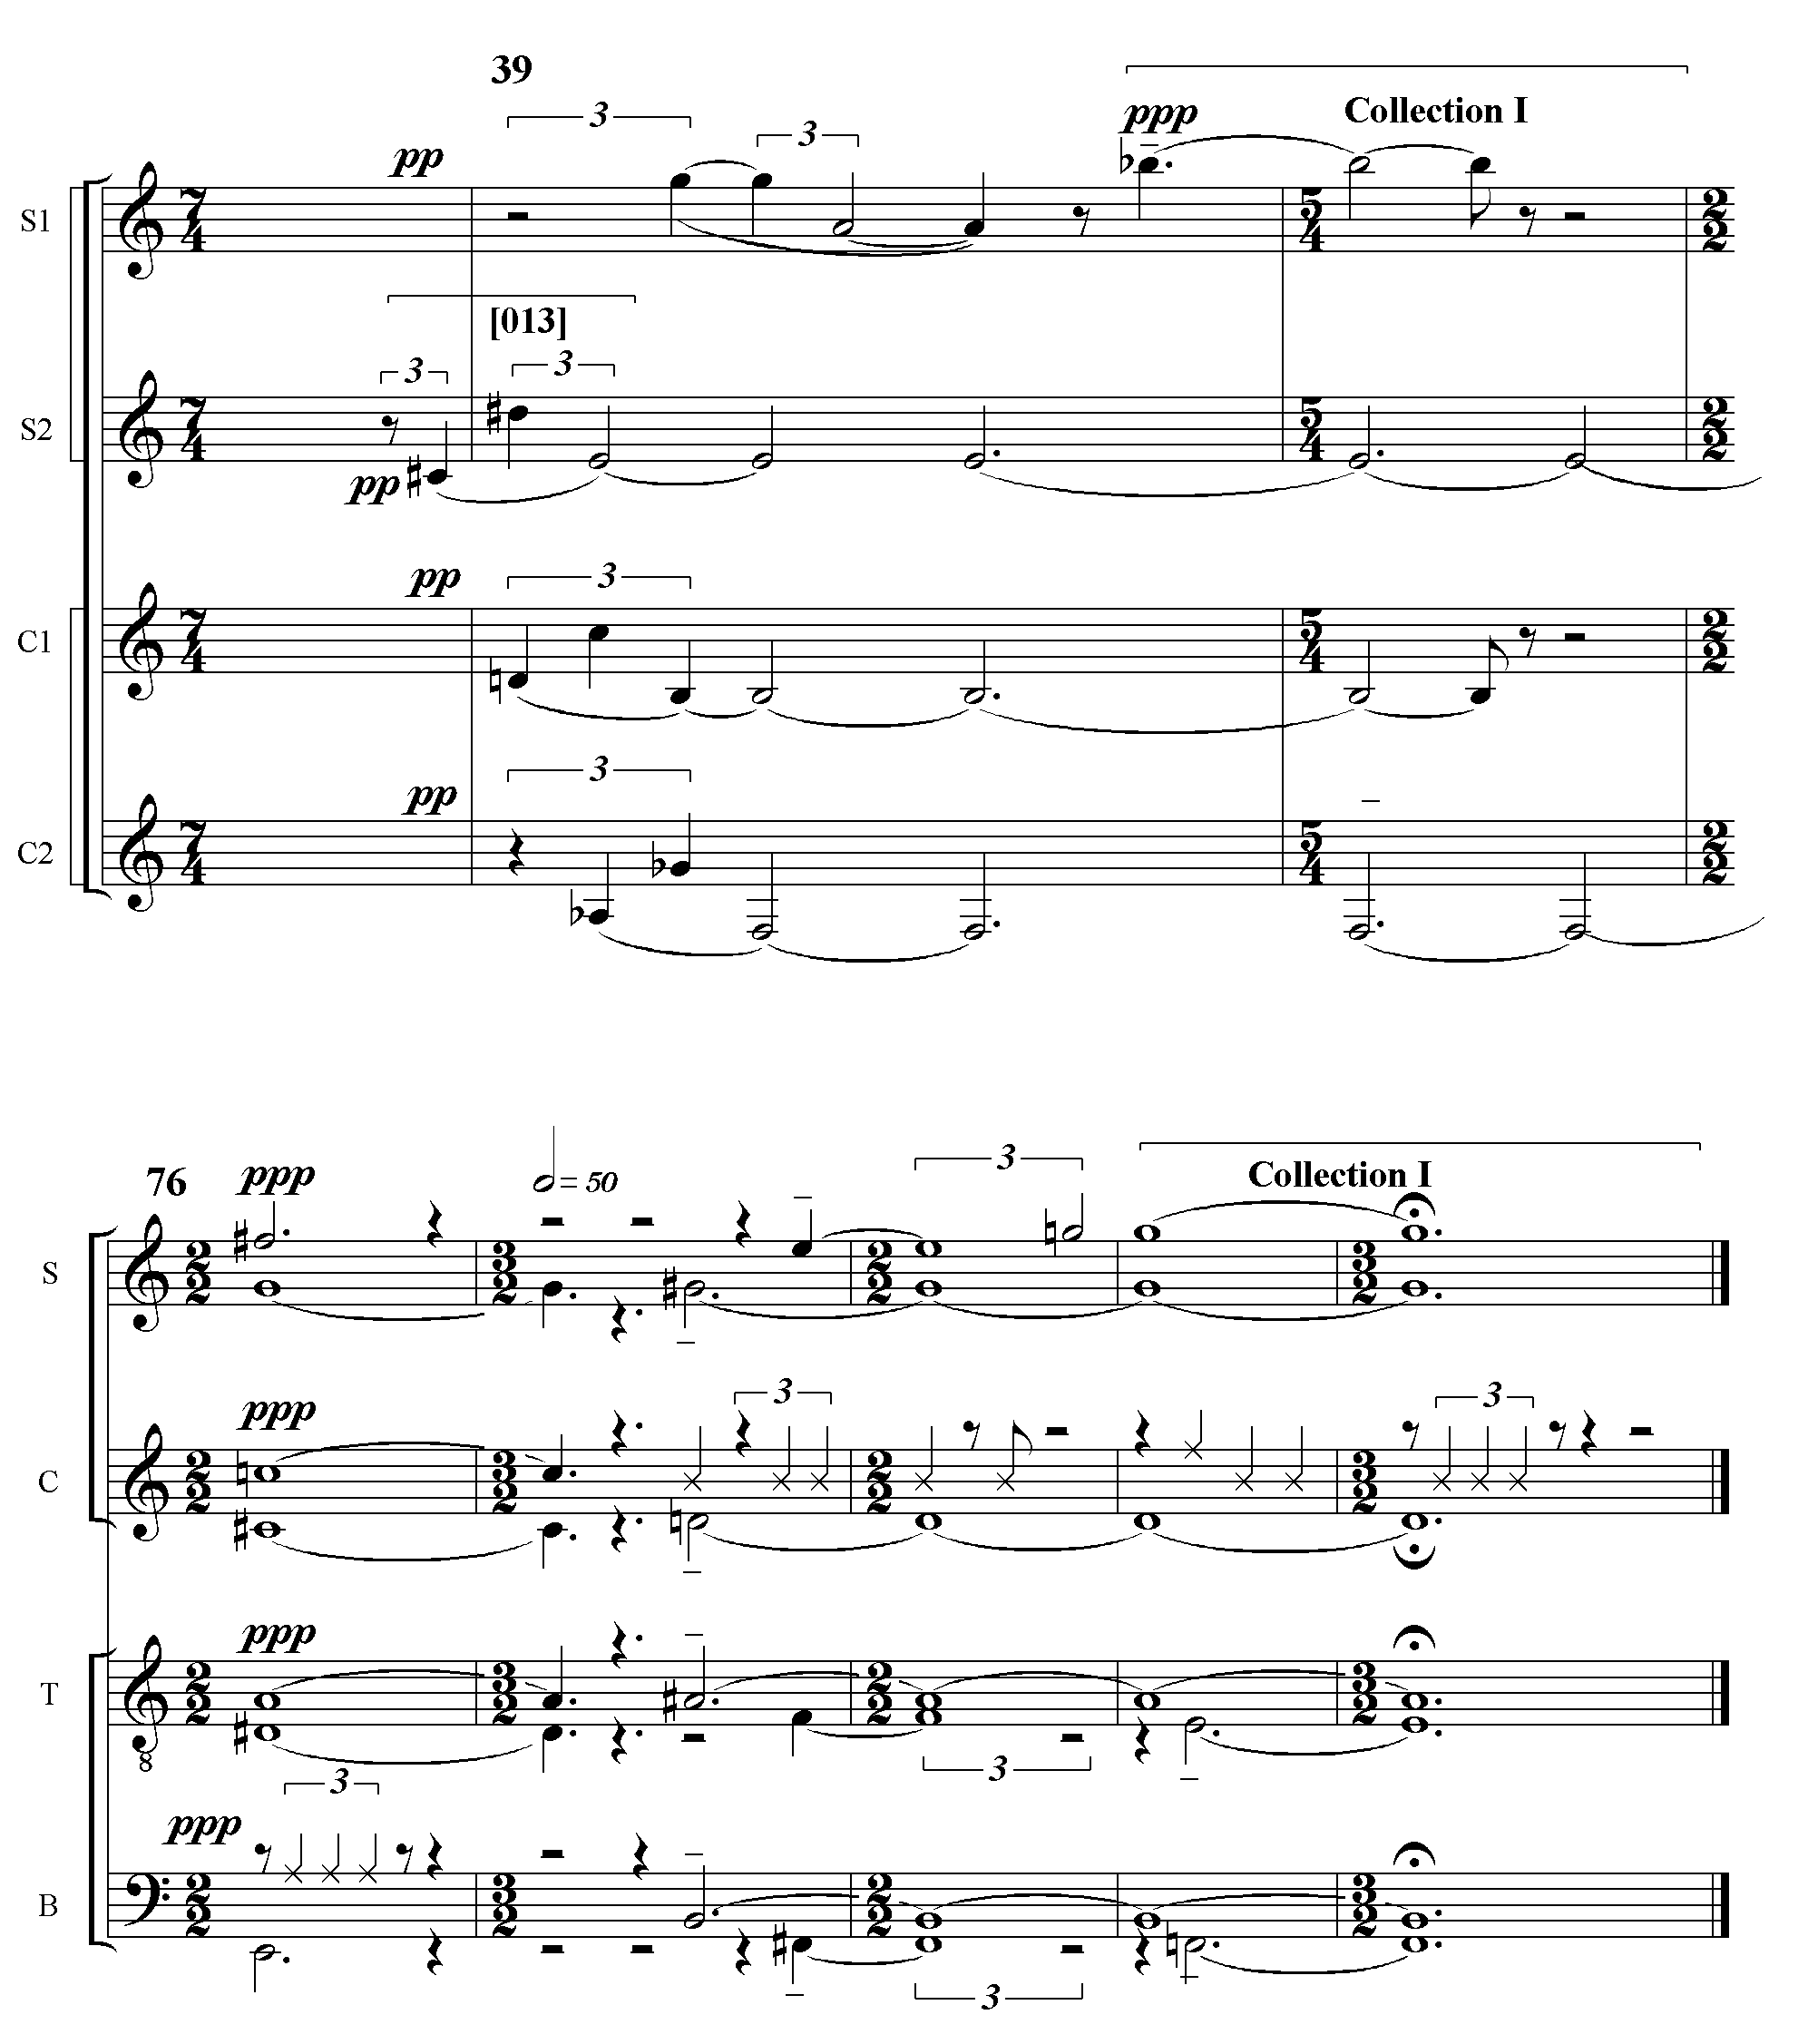
Ex. 5.5 Ploratus: octatonic structure, mm. 38-40 and 76-80
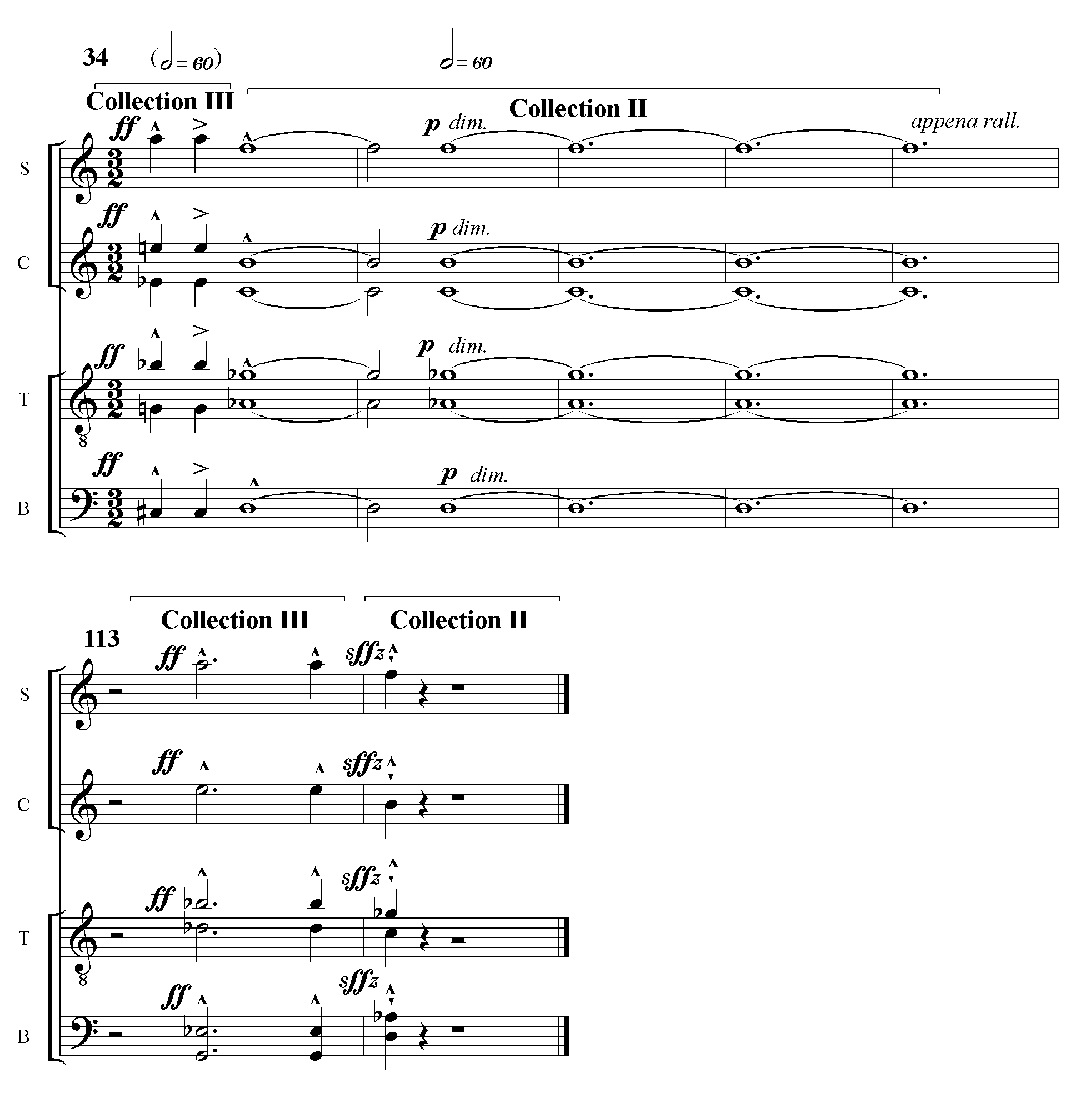
Examination of the harmonic structure of Exhortatio shown in Ex. 5.7 on the following page reveals that a tonal analogue is coordinated with an octatonic tonic. It is clear that P₀ occurs at the beginning, the midpoint (m.57) and at the midpoint of C (mm.89-90). Before one can say anything further about the tonal analogue, one must look at the octatonic structure. Like Ploratus, Exhortatio is harmonically organized around an octatonic collection, this time collection II. However, the organization is much stronger. Only three of the texture blocks end on a non-octatonic formation. All in all, ten out of the sixteen blocks end on a collection II harmony, including the last two blocks of A and every block of C. Example 5.6 below demonstrates the relationship between the octatonic cadences that conclude parts A and C.

Ex. 5.6 Exhortatio: octatonic cadences ending parts A and C

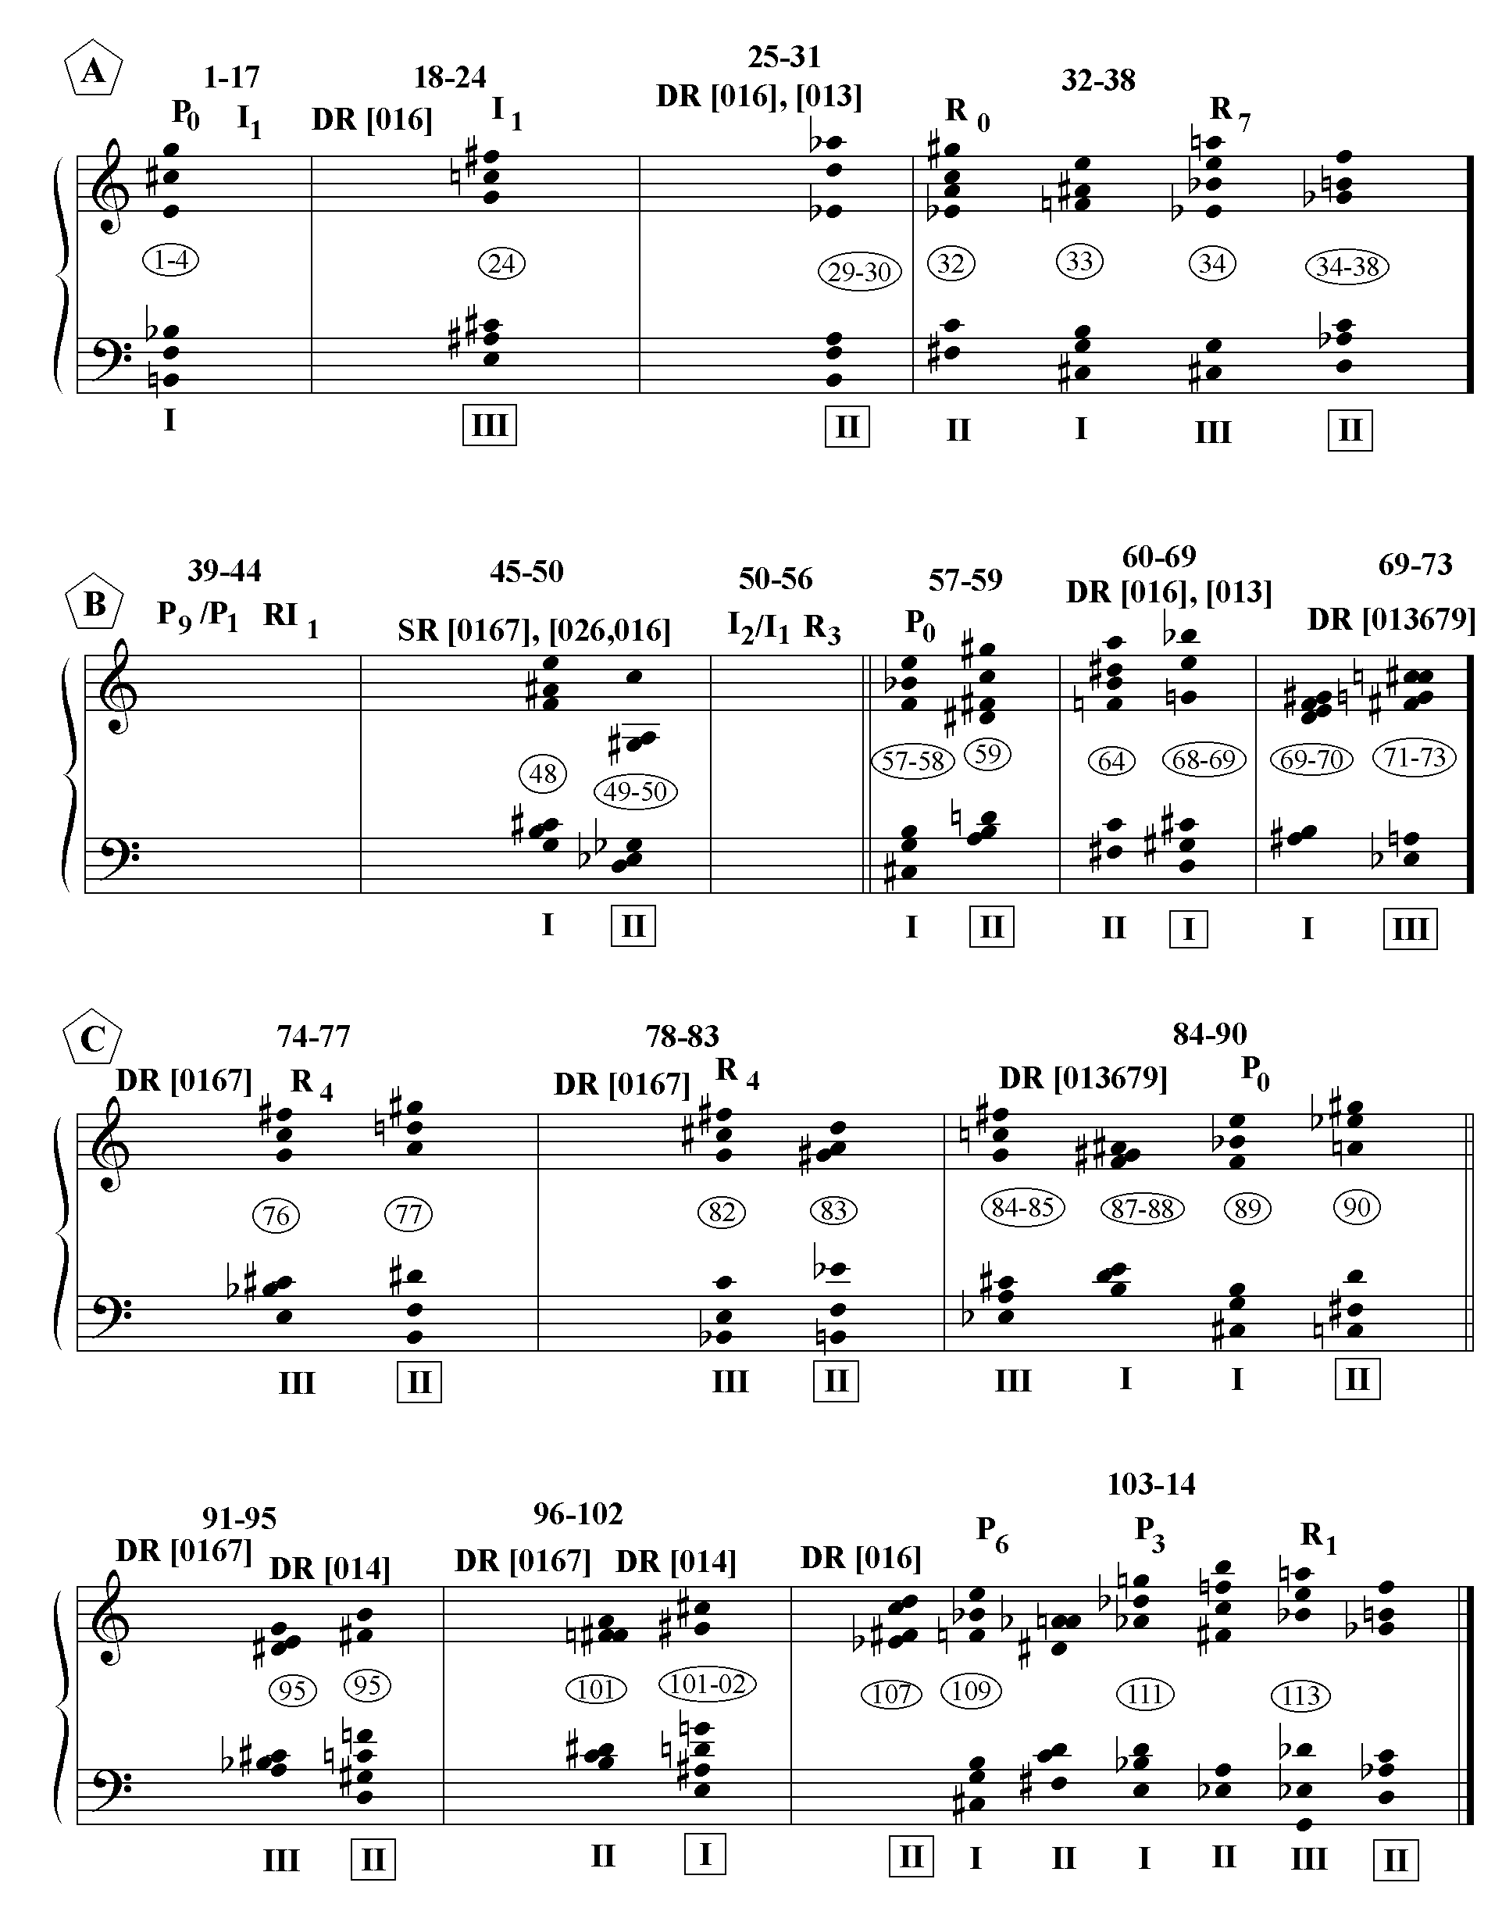
Ex. 5.7 Exhortatio: Harmonic Structure

The answer to the question of how the tonal analogue and harmonic structure are related lies in the structure of the row. At significant formal points the row is divided into two six-note chords each of which belongs to a different octatonic collection, so that a true sense of harmonic progression is created. Because octatonic collections transposed by a minor third are equivalent, the succession of octatonic collections in the hexachordal progressions remains constant for cycle-3 related rows. For example, the octatonic progression, collection I→ collection II, will occur whenever rows P₀, P₃, P₆ or P₉ are divided into two six-note chords. In Ex. 5.7, a comparison of P₀, P₃ and P₆ in blocks 84-90 and 103-114 makes this evident. A comparison of blocks 32-38, 74-77 and 103-114 demonstrates the octatonic equivalence of R₇, R₄ and R₁ (III→II).
Furthermore, because tritone related rows such as P₀ and P_{6,} or R₇ and R₁ have identical hexachordal content, their six-note chord progressions not only express the same octatonic succession, they are identical. (See ex. 5.8)
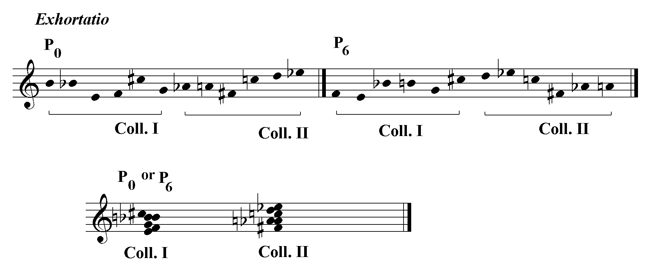Ex. 5.8 hexachordal equivalence in Exhortatio

It is clear from Ex. 5.5 that P₀, P₃, P₆, R₇, R₄ and R₁ all cadence on collection II when divided into two six-note chords. Dallapiccola exploits this interaction between the row and the octatonic collections to construct a stable harmonic structure. On the highest level, part A cadences on collection II, B moves away to cadence on III and C reaffirms II. (See ex. 5.6 and 5.7)
Since the hexachordal content of the tritonally related R₇ and R₁ is identical, both A and C conclude with same chord progression. In fact, the last chords of each section are the same. In addition, the first two blocks of C cadence on the octatonically equivalent R₄, so that the last part begins and ends with the same harmonic progression, providing a strong tonal analogue.
Concurrently, there is an octatonic structure involving P₀, P₃ and P_{6.} (To follow the ensuing discussion, please refer to Ex. 5.7, p.121.) The movement opens with P₀; however, owing to the held Bb, the second chord (B, Bb, A, G#, C, F#, Eb, D) in mm. 6-9 is not octatonic. At the beginning of B, P₉ is prevented from expressing its octatonic affinity with P₀ by contrapuntal simultaneity with P₁. P₀ appears full strength at the movement’s midpoint (m.57-59) and reoccurs at the midpoint of C (mm. 89-90). Its hexachordally identical relative P₆ begins the final cadential motion (mm.109-110). It is succeeded in turn by the octatonically equivalent P₃ before the final cadence on R₁. The identity of P₀ and P₆ suggest a recurrence of Dallapiccola’s habit of establishing P₀ as the “tonic” row and returning to it near the end of a piece just before ending on some other row level, a habit already observed in Rencesvals, Piccola musica notturna and Parole di San Paolo.
However, the fact that both the R forms and P forms in the octatonic constellation under discussion end on collection II ties them all together into one structure asserting and reaffirming its primacy.
The relationship between the octatonic and linear structures of Tempus Destruendi/Tempus Aedificandi is illustrated in ex. 5.9 on the following page. Before looking into this relationship, it will be instructive to compare the linear structures of Ploratus and Exhortatio. In Ploratus, the long-range bass motion, D-G-F (mm. 15, 35 & 40) in part A is repeated in C (mm.71, 72, 77). Furthermore, the passage at the beginning of B involving voice exchange between the “m” motives and cadencing on G in the bass (m.45) is presented a whole step lower at the end of the piece where it cadences on F in the bass (m.77). Thereby, the relatively local bass motion, G-F, appearing at the close of both parts A and C (mm. 45 and 40 & mm. 72 and 77) is expanded to the long-range bass motion G-F between part B and the end of part C. (mm.45 and 80). There is also a mid-range G-F motion between mm. 45 and the beginning of C, m.61. Thus, as in the case of Rencesvals, one observes the falling whole step or “sigh” operating on more than one level.
Whereas Ploratus’ bass line begins on D and, after a significant articulation on G, ends on F, Exhortatio’s bass line rests solidly on D: D-Eb/D-Eb-D. The linear structure both unifies and differentiates the two movements; the entire work begins and ends on D, but the D is more stable in Exhortatio, evoking the solidity of the
imagined temple rebuilt.
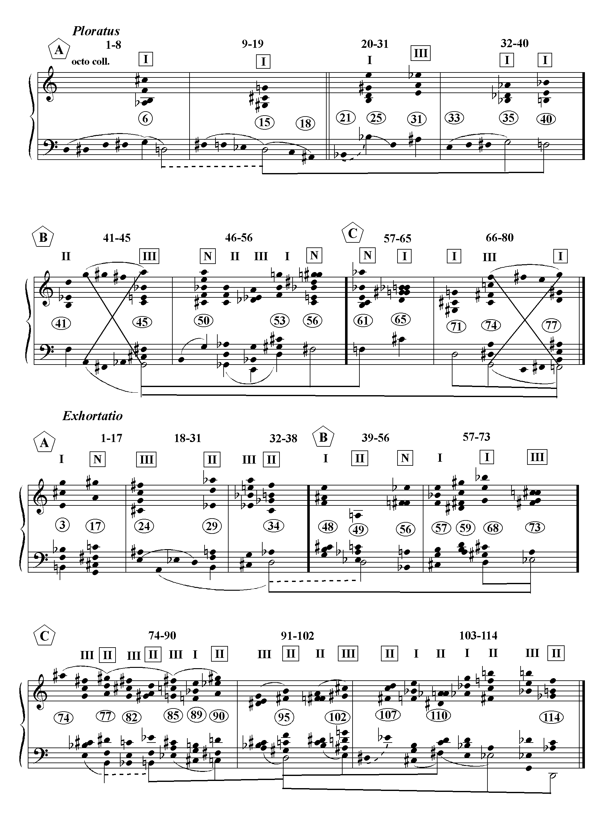
Ex. 5.9 Tempus Destruendi/Tempus Aedificandi: Linear Structure

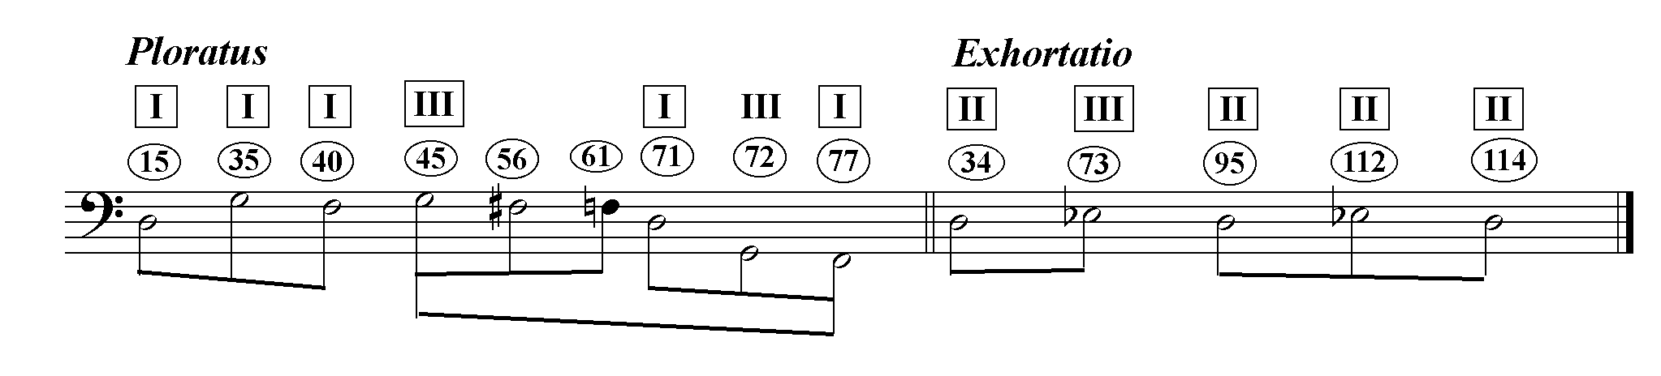The sketch below clarifies the long-range linear structure delineated on the previous page in Ex. 5.9
Ex. 5.10 TD/TA: long-range linear structure

It is interesting to note that although octatonic collection and linear structure are very positively correlated within each movement- the structural D’s of Ploratus are all collection I and the structural D’s of Exhortatio are all collection II- they are negatively correlated between movements. Over the course of the entire piece, then, the constant D supports an octatonic motion from collection I to II.
Dallapiccola was not content to evoke the difference between the Temple destroyed and the Temple rebuilt by means of global techniques such as the relative symmetry of textural blocks, the density of octatonic fundamental harmonies, or the relative stability of the linear skeleton. On a smaller scale in Exhortatio, he employs a refined formal device to express the difference between the phrases “muros quos destruxit” (walls destroyed) and “muros restruite” (walls rebuilt). The settings to these phrases are the only ones in Exhortatio that are taken from Ploratus. At “muros quos destruxit…muros” (mm.74-79 of Exhortatio), measures 16-19 of Ploratus appear as two transposed two-measure fragments, in reverse order, and separated by a two-measure octatonic cadence on “quos destruxit”, a metaphorical deconstruction appropriate to the evocation of the Temple destroyed. (See Ex. 5.11 below.)
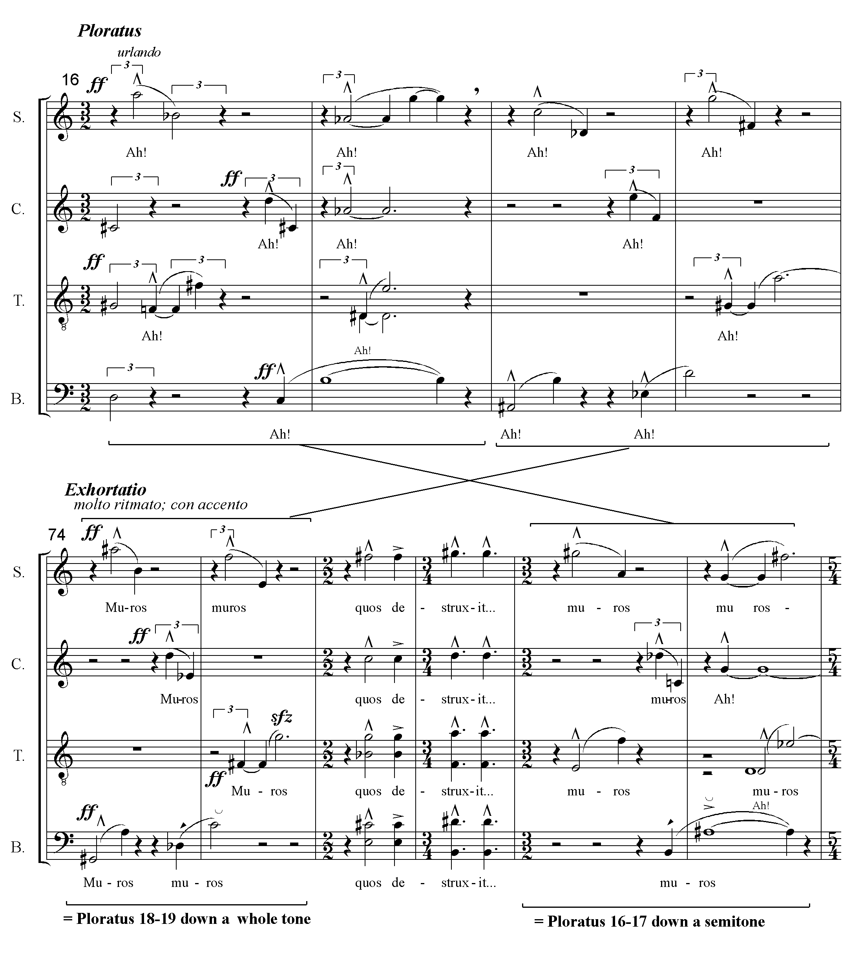
Ex. 5.11 Ploratus mm.16-19 broken and reordered in Exhortatio mm.74-79

Then, in mm. 91-94 of Exhortatio, setting “muros restruite”, the two two-measure fragments are reordered and joined so that they correspond to the original phrase in mm. 16-19 of Ploratus. Hence, one observes the original phrase of Ploratus, fragmented at “muros destruxit”, being rebuilt at “muros restruite”. Because Exhortatio was composed before Ploratus, Dallapiccola would have had to work backward to achieve the effect. It then becomes evident that mm.16-19 of Ploratus were transposed, perhaps to create the linear bass descent, D-C-A#. (The entire four-measure segment is not transposed at the same level; mm.91-2 are a semitone lower than mm.16-17 and mm.93-4 are a whole tone lower than mm.18-19. See ex. 5.12)
Ex. 5.12 “reconstruction” of Ploratus, mm.16-19 at Exhortatio, mm.91-95.
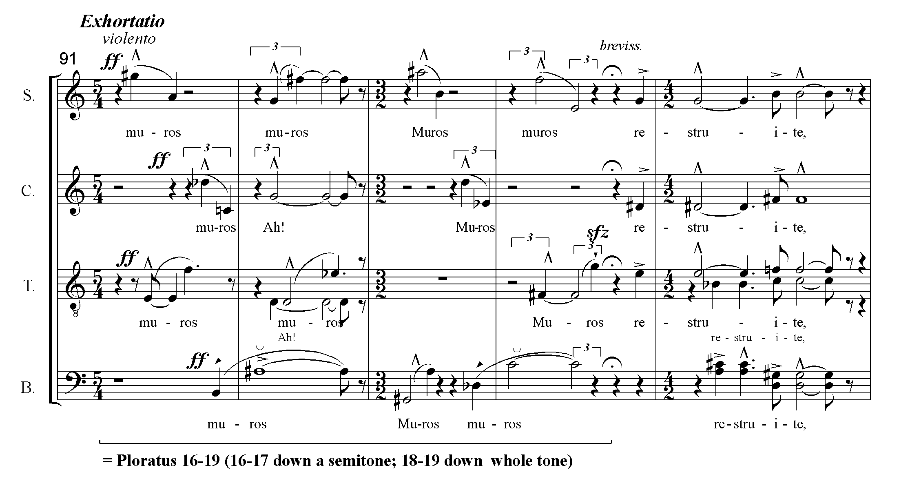

The re-ordering of these sections of music as a text-setting device is a small-scale illustration of the extent to which form and expression interpenetrate in Dallapiccola’s work. On the largest possible scale, the presence of a tonal analogue in Exhortatio after its absence in Ploratus, and the much stronger linear-octatonic structure in Exhortatio are formal differences that arguably express the difference between destruction and reconstruction. Here, too, form and expression, are aspects of a unitary process.

The text suggests that part B begins at m. 46 rather than at m. 41. However, m. 41 is the point of greatest harmonic articulation.
Nathan, “Review of Records.” p.550.

