Chapter 4 Parole di San Paolo (1964)

Parole di San Paolo is a work for mezzo-soprano and a small chamber orchestra of 11 instruments, the text of which is drawn from Paul’s first letter to the Corinthians on the subject of charity. It projects two formal designs concurrently: a two-part form that is divided at the exact midpoint by a grand pause and further subdivided into four sections delineated by the appearance of leitmotival ‘charity chords’, and a five-part arch form that corresponds to the five verses of Dallapiccola’s text. The verse sections will be referred to as I, II, III, IV, and V. Because the sections of the ‘charity form’ sometimes begin in the middle of the verse sections, each of which breaks down into two parts, the verse sections will be further divided into Ia, Ib, IIa, IIb and so on. Dallapiccola’s Latin text and the corresponding verses from the King James Version appear on the following page with section headings and measure numbers in boldface at right. The Roman numerals indicate the junctures of the arch form while the capital letters at far right indicate the sections of the ‘charity form’. The table below shows how Dallapiccola extracted his text.
Table 4.1 verses from Corinthians 1 in Parole di San Paolo
Dallapiccola’s verses | 1 | 2 | 3 | 4 | 5
Biblical verses | 1 | 2 | 3 | 4, 6, 7 (fragments) | 13

instrumental introduction Ia (1-8) A
(1) Si linguis hominum loquar et angelorum, caritatem autem non habeam, Ib (7-20)
factus sum velut aes sonans, aut cymbalum tinniens.

(2) Et si habuero prophetiam, et noverim mysteria omnia, IIa (21-31)
et omnem scientiam:
et si habuero omnem fidem ita ut montes transferam, IIb (32-39) B
caritatem autem non habuero, nihil sum.

(3) Et si distribuero in cibos pauperum omnes facultates meas, IIIa (39-50)
et si tradidero corpus meum ita ut ardeam,
caritatem autem non habuero, nihil mihi prodest. IIIb (51-57) C

(4) Caritas patiens est, benigna est:….. IVa (58-66)
(6) Non gaudet super iniquitate, congaudet autem veritati:…..
(7) Omnia suffert, omina credit, omnia sperat, omnia sustinet. IVb (67-77)

instrumental introduction Va (78-91) D
(13) Nunc autem manent fides, spes caritas, tria haec:
instrumental interlude Vb (92-100)
major autem horum est caritas.

instrumental introduction
(1) Though I speak with the tongues of men and of angels and have not charity,
I am become as sounding brass, or tinkling cymbal.

(2) And though I have the gift of prophecy and understand all mysteries,
and all knowledge:
and though I have all faith so that I could remove mountains,
and have not charity, I am nothing.

(3) And though I bestow all my goods to fed the poor,
and though I give my body to be burned,
and have not charity, it profiteth me nothing.

(4) Charity suffereth long and is kind:…..
(6) rejoiceth not in iniquity but rejoiceth in the truth:…..
(7) Beareth all things, believeth all things, endureth all things.

instrumental introduction
(13) And now abideth faith, hope, and charity, these three:
instrumental interlude
but the greatest of these is charity.

Parole’s row matrix will assist in the analysis of its form.
Table 4.2 Parole di San Paolo: row matrix

P→→ | I₀ | I₈ | I₉ | I_{T} | I₄ | I₃ | I₆ | I₇ | I₅ | I_{E} | I₂ | I₁ | I↓
P₀ | Bb | F# | G | G# | D | C# | E | F | Eb | A | C | B | R₀
P₄ | D | Bb | B | C | F# | F | G# | A | G | C# | E | D# | R₄
P₃ | C# | A | Bb | B | F | E | G | G# | F# | C | Eb | D | R₃
P₂ | C | G# | A | Bb | E | Eb | F# | G | F | B | D | C# | R₂
P₈ | F# | D | Eb | E | Bb | A | C | C# | B | F | Ab | G | R₈
P₉ | G | D# | E | F | B | Bb | C# | D | C | F# | A | G# | R₉
P₆ | E | C | C# | D | G# | G | Bb | B | A | Eb | Gb | F | R₆
P₅ | Eb | B | C | C# | G | F# | A | Bb | Ab | D | F | E | R₅
P₇ | F | C# | D | D# | A | G# | B | C | Bb | E | G | F# | R₇
P₁ | B | G | G# | A | Eb | D | F | F# | E | Bb | Db | C | R₁
P_{T} | G# | E | F | F# | C | B | D | D# | C# | G | Bb | A | R_{T}
P_{E} | A | F | F# | G | C# | C | D# | E | D | Ab | B | Bb | R_{E}
RI↑↑ | RI₀ | RI₈ | RI₉ | RI_{T} | RI₄ | RI₃ | RI₆ | RI₇ | RI₅ | RI_{E} | RI₂ | RI₁ | ←R

In the arch form, sections I and V, and II and IV are related; III stands alone. Sections I and V begin with the row-forms P₀, I₃ and RI₇. In section I they are realized as chords; in section V they appear as lines. (See Ex. 4.1a and 4.1b on pp. 92-93.) Both chordal and linear manifestations play important roles. The chords at level P₀ are consistently associated with the word “caritas” (charity). (These chords occur in mm. 1, 32, and 51.) The chordal and linear presentations of P₀ are composed in a way that maximizes the ability of the listener to identify them as such. Because the first entrance of the linear P₀ in the voice is accompanied only by a held F, it is not difficult to hear it as an arpeggiation of the charity chords. (See Ex. 4.1a) Later, in section V, when P₀ appears as part of a two-voiced canon, it can be associated with the vocal line beginning at m. 7, and by extension, with the charity chords. (See Ex. 4.1b)
Ex. 4.1a Parole di San Paolo: row levels, mm. 1-11

As he does in Rencesvals III and Piccola Musica Notturna, Dallapiccola returns to the ‘tonic’ row level near the end of the piece, just before ending on some other row level. The vocal P₀ of section I returns as R₀, concluding the vocal part near the end of section V before the instrumental coda ends on R₄. (See Ex. 4.7 on p. 101.)

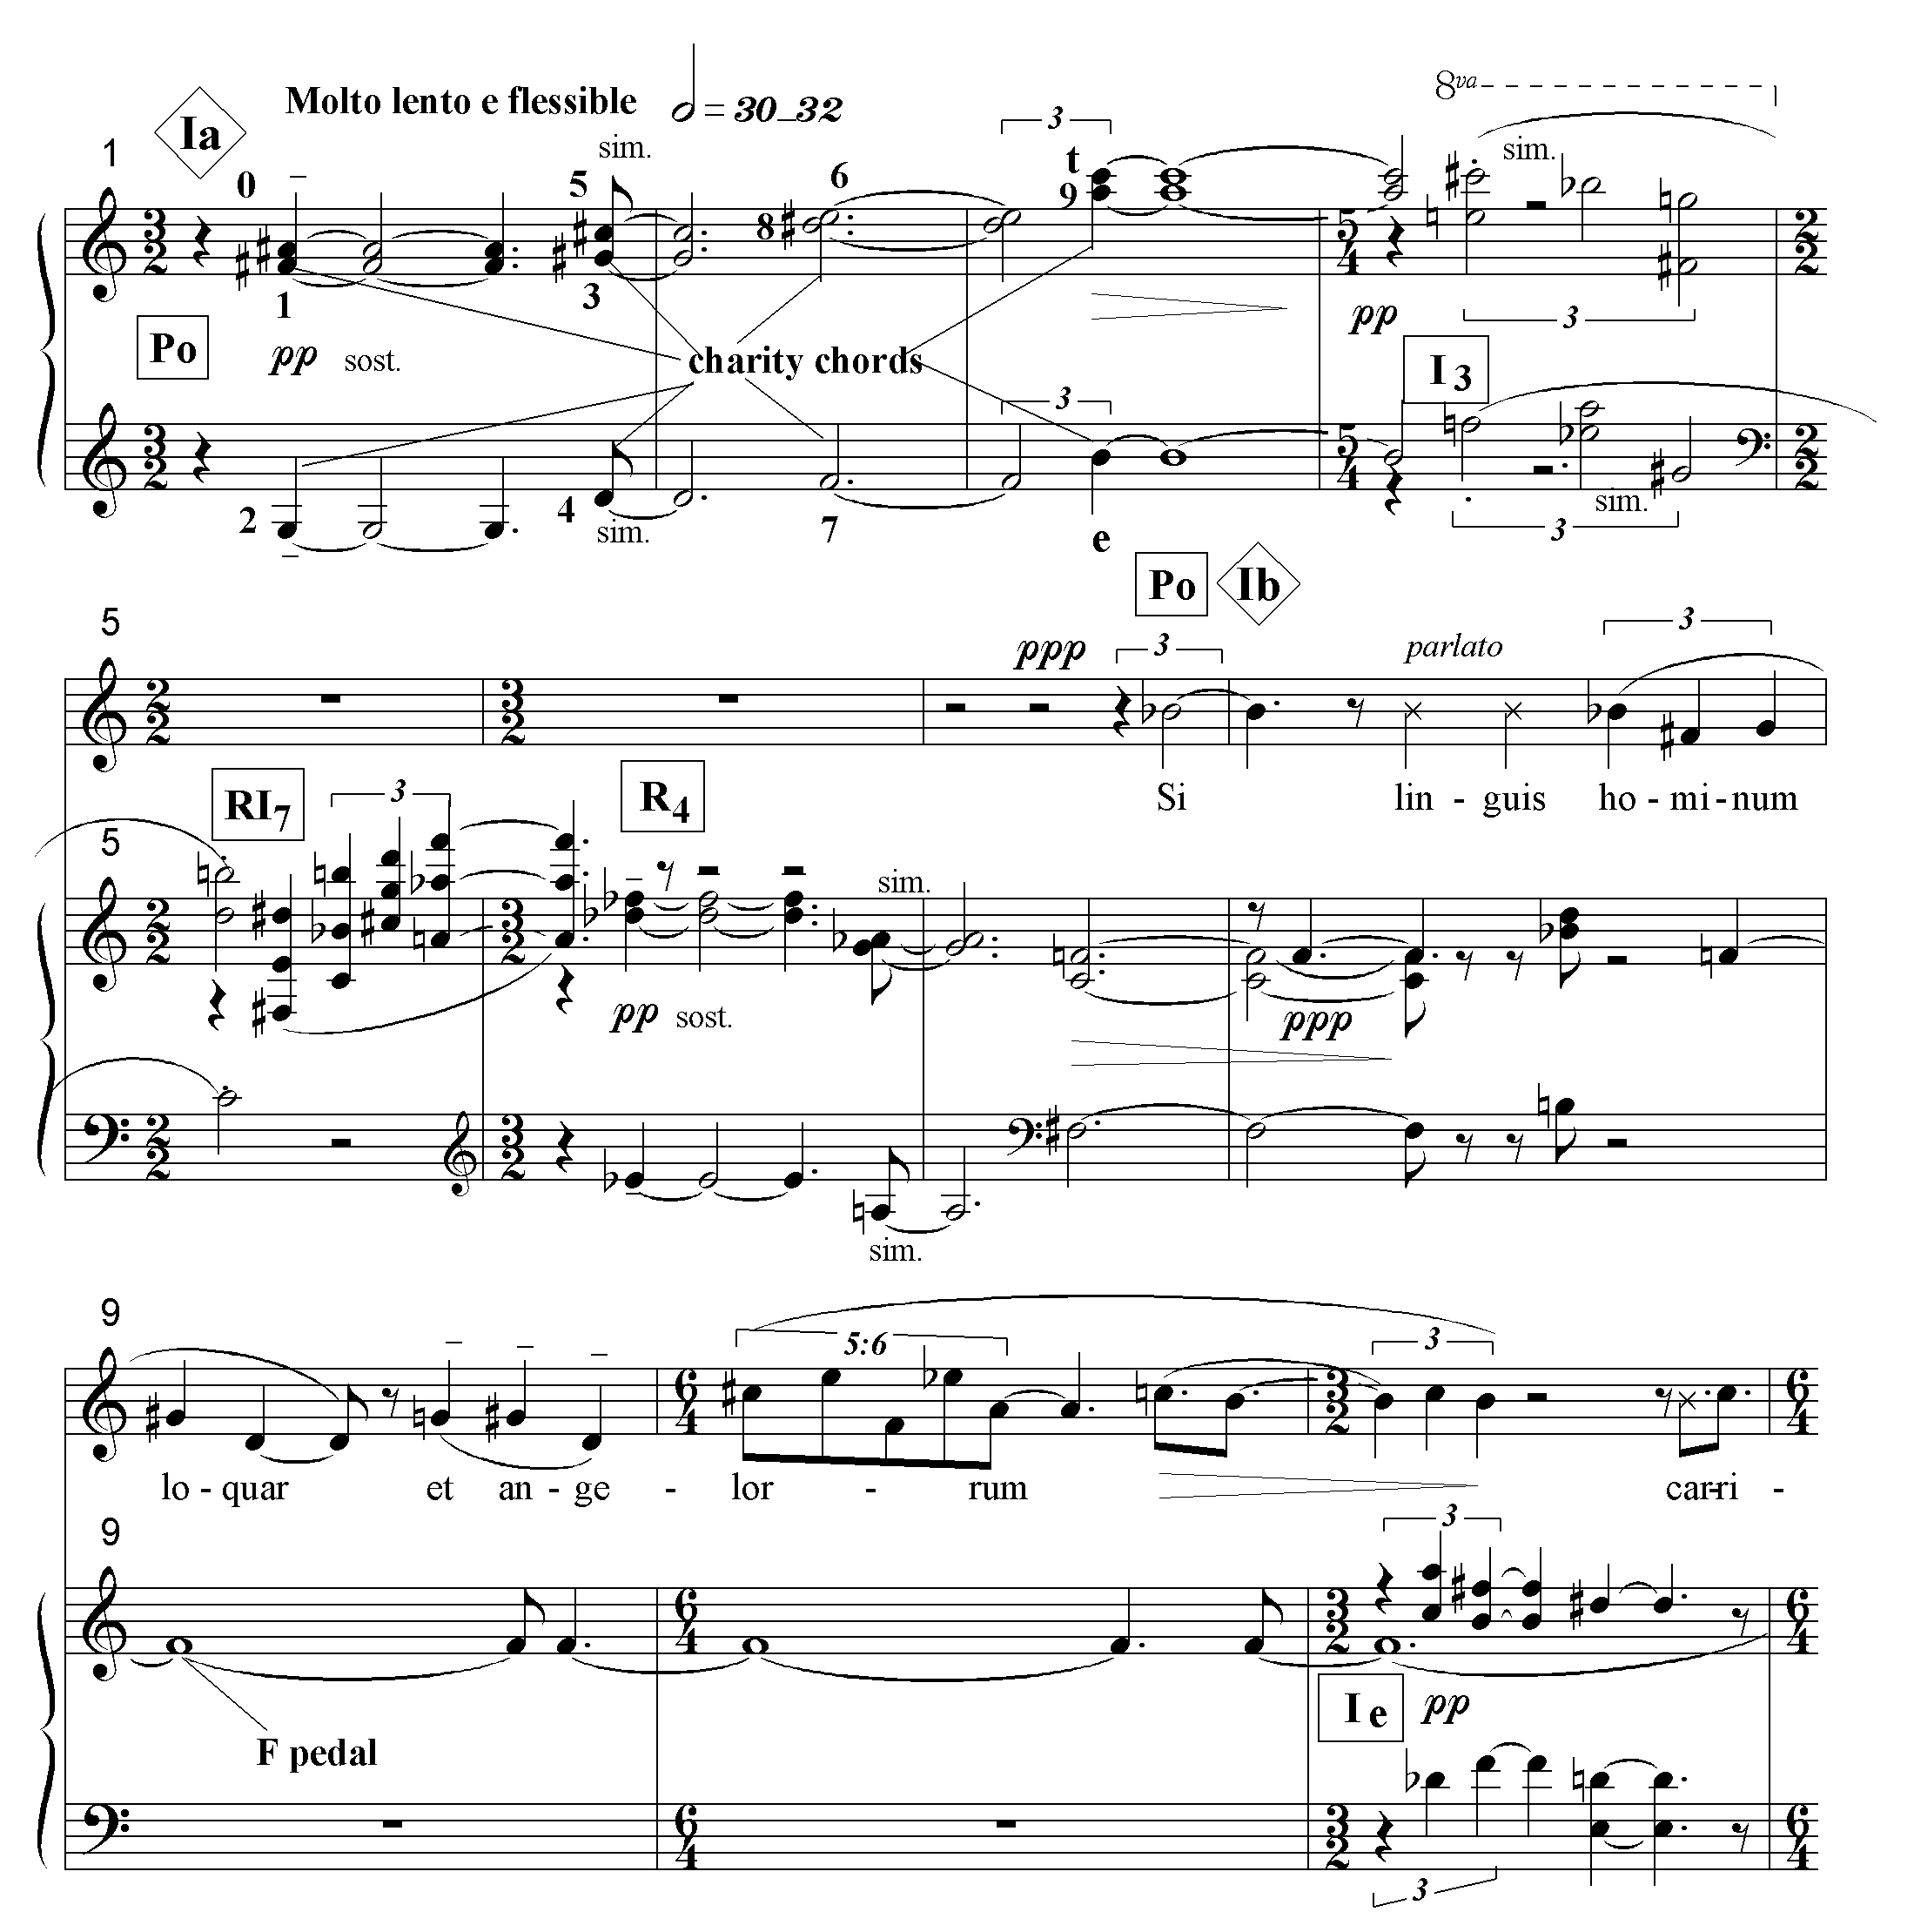

Ex. 4.1b Parole di San Paolo: row levels, mm. 78-83.

Sections I and V are further related by the F pedal tone common to both of them whereas E and F# are the most important bass tones in sections II and IV.
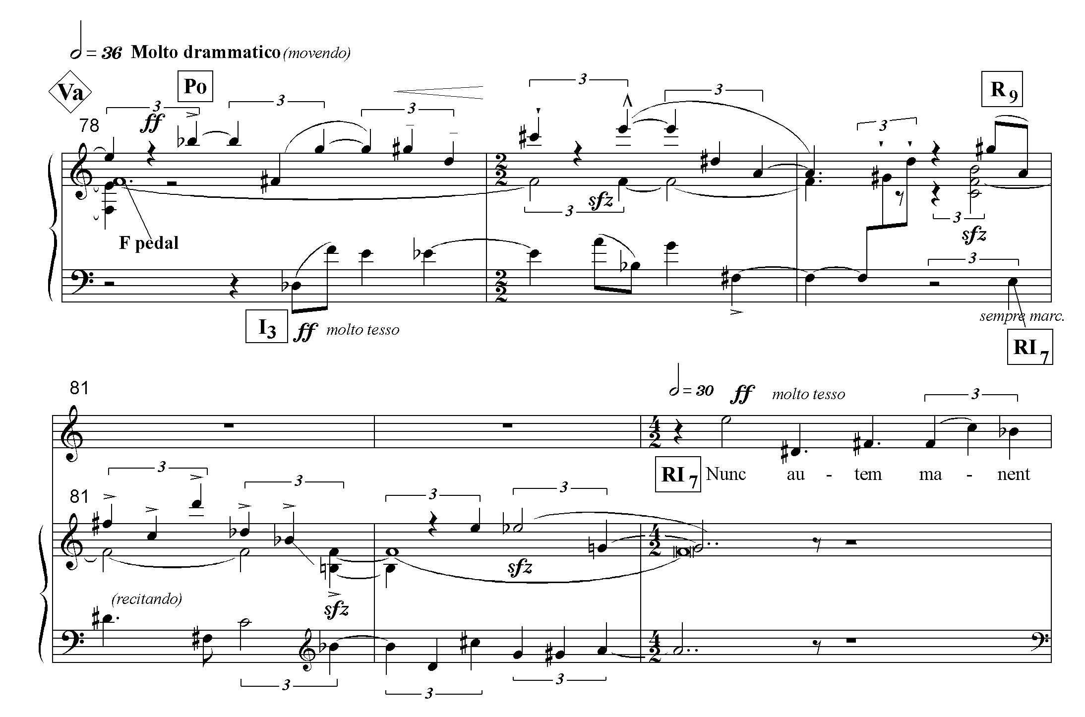
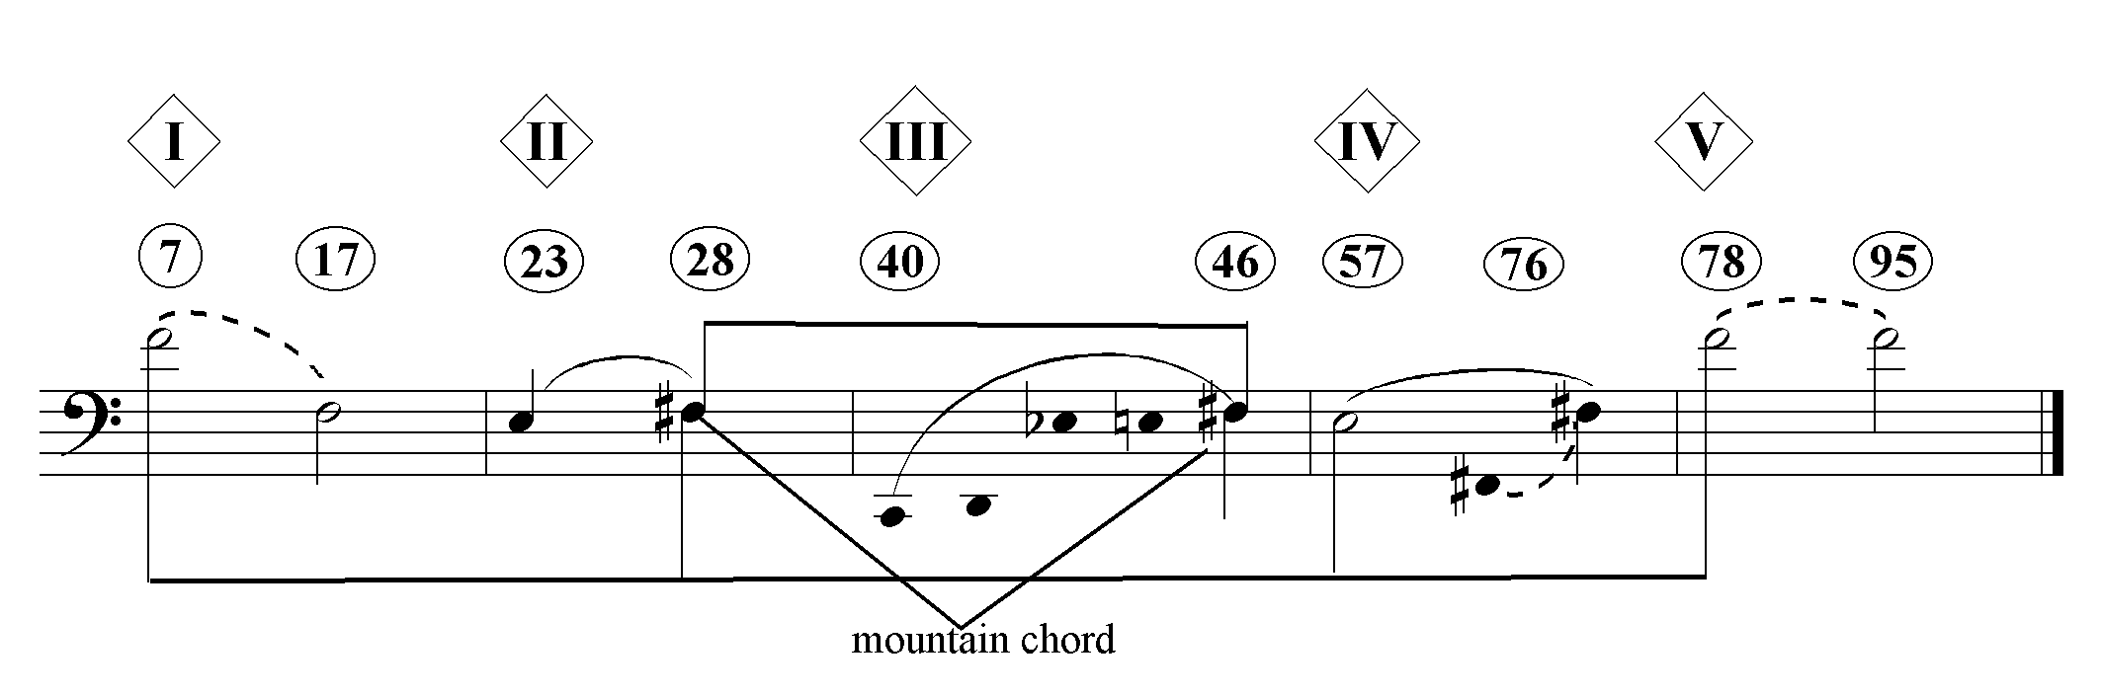Ex. 4.2 Parole di San Paolo: pedal tones
Sections II and IV both open with the voice beginning I₉, accompanied by linear presentations of P and I. In section II, only the first pitch of I₉ is taken by the voice; the row continues in the harp and then bass clarinet. (Compare Ex. 4.3a and 4.3b).

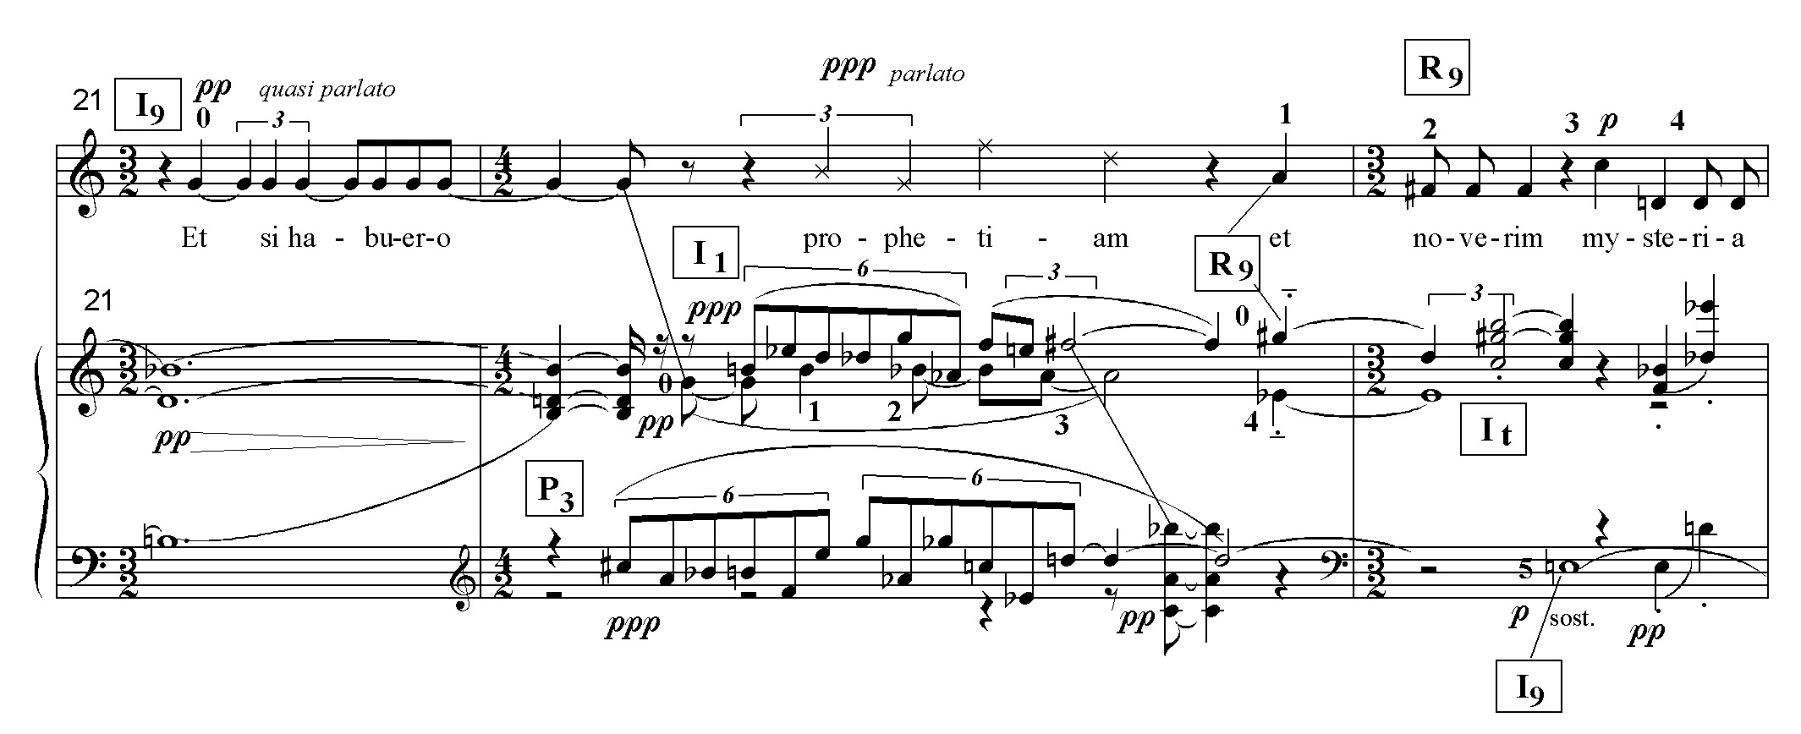
Ex. 4.3a Section II: row levels, mm. 21-23

Ex. 4.3b section IV: row levels, mm. 58-60
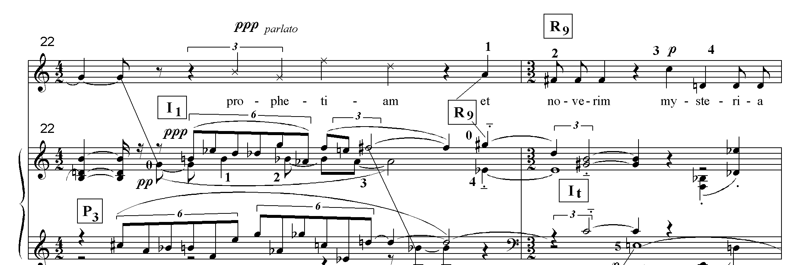

The arch, then, consists of five sections, each approximately 20 measures in length. The ‘charity form’, arising from the appearance of the word ‘charity’, with its accompanying chords, in the middle of verses two and three, is superimposed on the arch and, in fact, dominates it. This means that the formal junctures at IIb and IIIb are much more salient those at IIa and IIIa. Shortly before IIb and IIIb, the “mountain” chord (discussed at the end of the chapter) is attacked ff. This is then followed by a general pause that precedes a return of the charity chords first heard at mm.1-3.
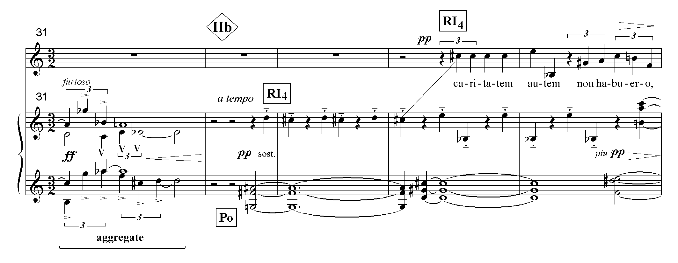Ex. 4.4a Parole di San Paolo, section IIb: return of charity chords

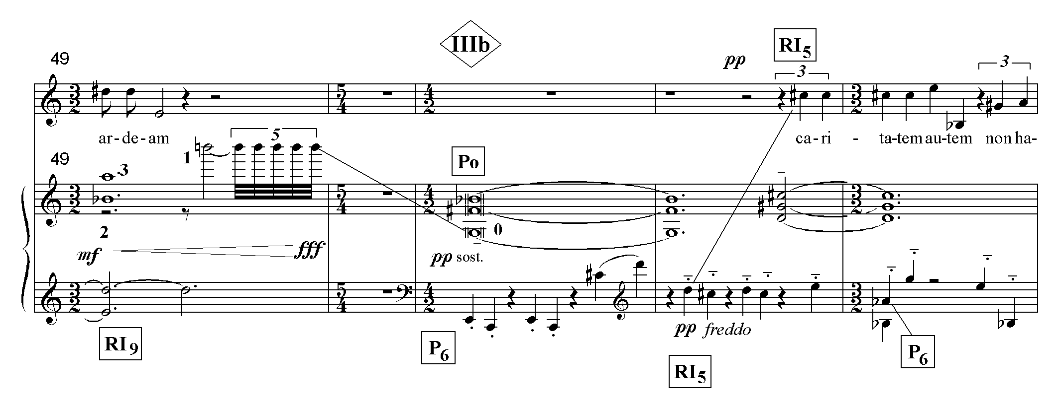Ex. 4.4b: section IIIb, return of charity chords

The decision as to where the next formal juncture lies is not so clear-cut. P₀ returns at IVb as the top voice of a compound canon, moving in parallel minor sevenths with P₂. I₇ and I₉ enter a measure later, also in parallel minor sevenths. The minor- seventh saturation creates a voluptuous harmonic environment that is easily distinguishable from the ethereal character of the rest of the piece. The sevenths occasionally come together, hinting at dominant seventh chords in a rare suggestion of tonal allusion. The unique harmonic environment reflects the special nature of the text. Only here does the poet list the positive attributes of charity; the rest of the text describes the barren aspects of a life without charity.
Nevertheless, I hear the beginning of section V as making the stronger formal articulation. It, too, presents P₀ linearly but, in this case, the dynamic contrast between the end of IV (ppp) and its beginning (ff) is decisive. On the other hand, the dynamic contrast at IVb is limited to the difference between ppp and p. In summary, the charity form is articulated as follows: mm.1-31/ 32-50/ 51-77/ 78-11//. Table 4.3 on the following page illustrates the superimposition of the arch and charity forms in greater detail.
One can only speculate why Dallapiccola projected two conflicting musical designs. Perhaps this was his way of expressing the overwhelming importance of charity, the chords of which break through the more conventional arch to create their own form. The question of whether Dallapiccola’s formal devices are truly formal or epiphenomena of text expression is explored at greater length in chapter 6. I think that the evidence shows that Dallapiccola’s architectonic sensibility predisposed him to choose texts for their formal attributes so that it is really not possible to distinguish between form and expression. In this case, the idea of a musical design in conflict with itself may also provide the formal analogue to the contradictory grammatical construction of the verses.
The tension between the superimposed forms corresponds to the tension implicit in the rhetorical conceit “though I do such and such, my true being is not at all that which my actions would lead one to believe.” (See verses 1-3.)
Table 4.3 Parole di San Paolo: form

meas. | 1-8 | 8-20 | 21-31 | 32-38 | 39-50
voice  instr. | P₀ I₃ RI₇ R₄ | P₀ RI₃ I₈  I_{e} P₆ RI₇ ag | I₉ R₉ RI₇  P₃  I₁ I_{t}  I₉ RI₉ ag | RI₄  RI₄  R₁  P₀ I_{t} P₄ ag | I₁ P_{e} I₁ P_{e} I₇  P_{t} P₀  I₀ I₂  RI₃ R₇ RI₉
pedal |  | F | E-F# |  | F#
tex-ture | chords |  | lines & chords,  trichord mosaic | chords  tri/mos | intercut row segs  rarefied chord  silence (m.50)
arch | Ia | Ib | IIa | IIb | IIIa
 | A (charity chords) |  |  | B (charity chords)

51-57 | 58-66 | 67-77 | 78-91 | 92-100
RI₅  P₀ R₁  P₆ I_{t} P₄ RI₇ | I₉ R₅  I₈  P₅ ag | trichord ag  P₀ P₄  P₂ P₆  I₇ I_{e}  I₉ I₁ | RI₇ I_{t}  P₀ R₉ P₁ R₄  I₃ RI₇ I₃ RI₆  P₈ R_{e}  I_{t} RI₁ | R₀  R₄ P₁ P₅ R₄  I₇ RI_{t}
E | E | F# | F | F
2-note motives, chords | lines,  tri/mos | compound canon | canon,  compound canon,  intercut row segs | chords
IIIb | IVa | IVb | Va | Vb
C (charity chords) |  |  | D

After having delineated the large-scale form, one can begin to discuss the relationship between the phrases and their linear structure. At the beginning of the work (mm.1-8), one observes the juxtaposition of the charity chords and their transformations to create antecedent-consequent phrases and a linear hierarchy around B. Referring to Ex. 4.1a, one observes that each of the first four row forms constitutes one phrase. The rising chords of phrases one and three are answered by the descending chords of phrases two and four. As Ex. 4.5 demonstrates, the final trichords of P₀ (phrase one) and I₃ (phrase two) are linearly associated by their boundary pitches, B-C and C-B. More importantly, the lowest and highest pitches of the simultaneity formed by the last trichord of R₄ and the first pitch of P₀ in the soprano are B-Bb (phrase four).
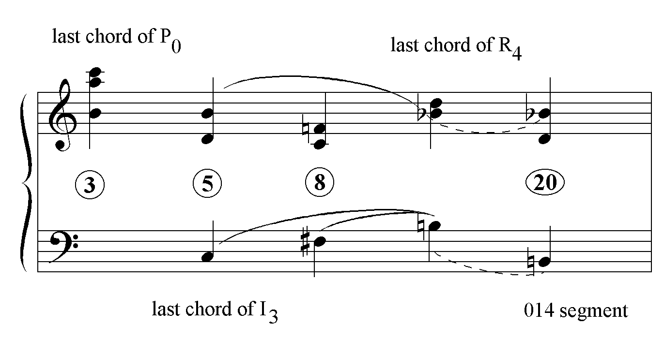Ex. 4.5 Parole di San Paolo: harmonic hierarchy, section I

The B-Bb in m. 8 is heard as a structural semitonal descent from the C-B in m. 5. Coupled with the F#-B motion in the bass, the semitonal descent invests the B-Bb with the character of a ‘tonic substitute.’ (Coincidentally, the pitches B-Bb of the last trichord of R₄ are also the first and last pcs of P_{0.}) A comparison of the pedal tone hierarchy in Ex. 4.2 and the hierarchy created by the ‘tonic’ substitute in Ex. 4.5 indicates that the former is centered around F while the latter is centered around B. Thus, one senses parallel competing hierarchies. The following analysis traces the relative strength of B and F in the rest of the piece during which B emerges as somewhat more important.
When P₀ makes a melodic appearance with the vocal entrance in m. 7, it is not difficult to hear it as an arpeggiation of the charity chords (mm. 1-3) owing to its very sparse accompaniment, limited to a held F. Although tonal allusion and octatonic harmony have been burnt and purged away in the fires of Dallapiccola’s increasingly sophisticated twelve-tone technique, he has not lost his fondness for the ‘tonic’ row level. At the end of the first verse, the texture breaks up into [014] trichordal motives drawn from ops 0-2 of the row. The motival aggregates evidently depict the ‘tinkling cymbals’. This brief instrumental interlude between sections I and II (mm.18-20) comes to rest on the trichord B-D-Bb, the tonic substitute of m.8. That Dallapiccola derived the same tonic substitute in two different ways in mm.8 and 20 suggests that his serial manipulations served a predetermined harmonic goal. Note that the pedal tone, F, while present, plays a subsidiary role in the pitch hierarchy of section I.
In sections II through IV, B disappears as a significant pitch center, only to return in section V, along with the pedal tone, F, which plays a more prominent role there. However, owing to the differences in text-setting between sections I and V, the strength of the pc, B, is also realized differently.
The clear cut chordal texture and architectonic phrase structure of the introduction to the first section is a musical comment on the power of charity. With the vocal entrance, comes doubt. One surmises that the word “linguis” is spoken, rather than sung, to demonstrate the insufficiency of eloquence without charity (m.8). The instrumental accompaniment is reduced to a single pitch, presumably to illustrate the inconsequence of anything in the face of charity. When the four-chord units do reappear (mm.11 & ff.), in each case, a rest is inserted between the third and fourth chords, indicating uncertainty. Nevertheless, as noted before, section I does reaffirm the confidence of the introduction by ending on the tonic substitute, B-D-Bb.
Like the first section, section V begins with an instrumental introduction, but it is canonic, not chordal. (See Ex. 4.1b, mm-78-82.) When the voice enters, it is accompanied by rows coupled in minor sevenths in the manner of IVb. (See the score, mm.84-86.) However, here the minor sevenths are not present canonically, but simultaneously, as four-voiced chords. Their solidity depicts the three virtues, faith, hope and charity. Dallapiccola apparently treated ‘tria haec’ (these three) as emblematic of multiplicity because these words are accompanied by intercut row segments. At the midpoint of m.87, the music which accompanies the text “fides, spes, caritas, tria haec:” (mm.84-87), is now presented retrograde at a row level a minor third higher and accompanies the text “tria haec, fides, spes, caritas.”
Significantly, the end of the vocal subsection on caritas (m.91) is supported by a chord built on B: B-A-E-D. (See Ex. 4.6) The B owes its importance to its formal placement and its duration. In section V, only the low D in mm. 85-86 lasts as long. The B-F duality is underscored in mm.94-95 where the held F of the last chord of P₅ is heard against the opening B of R_{0.} (See Ex. 4.7 below.)

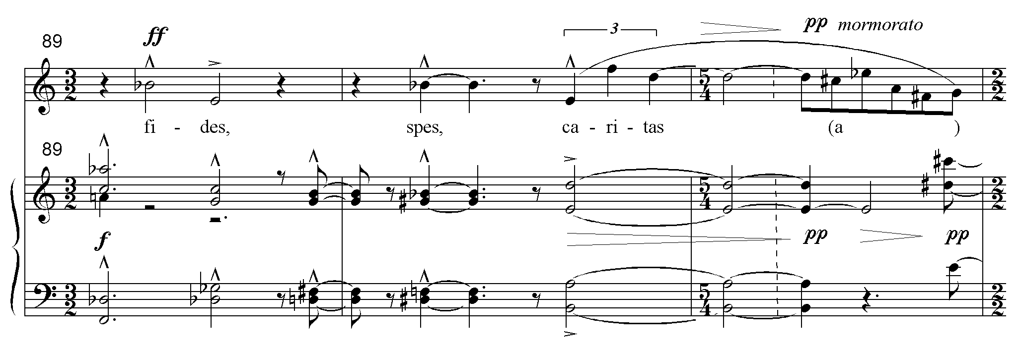
Ex. 4.6 Parole di San Paolo: mm. 89-91

The work ends with the row level P₄. Recall that, in the opening introduction, the last chord of R₄, B-Bb-D, was heard as a tonic substitute. Now the chord initiates the final phrase that ends on D#-C#-E. Whereas R₄ rounded off the introduction with an air of finality, P₄ has the effect of ending the piece on a questioning note.
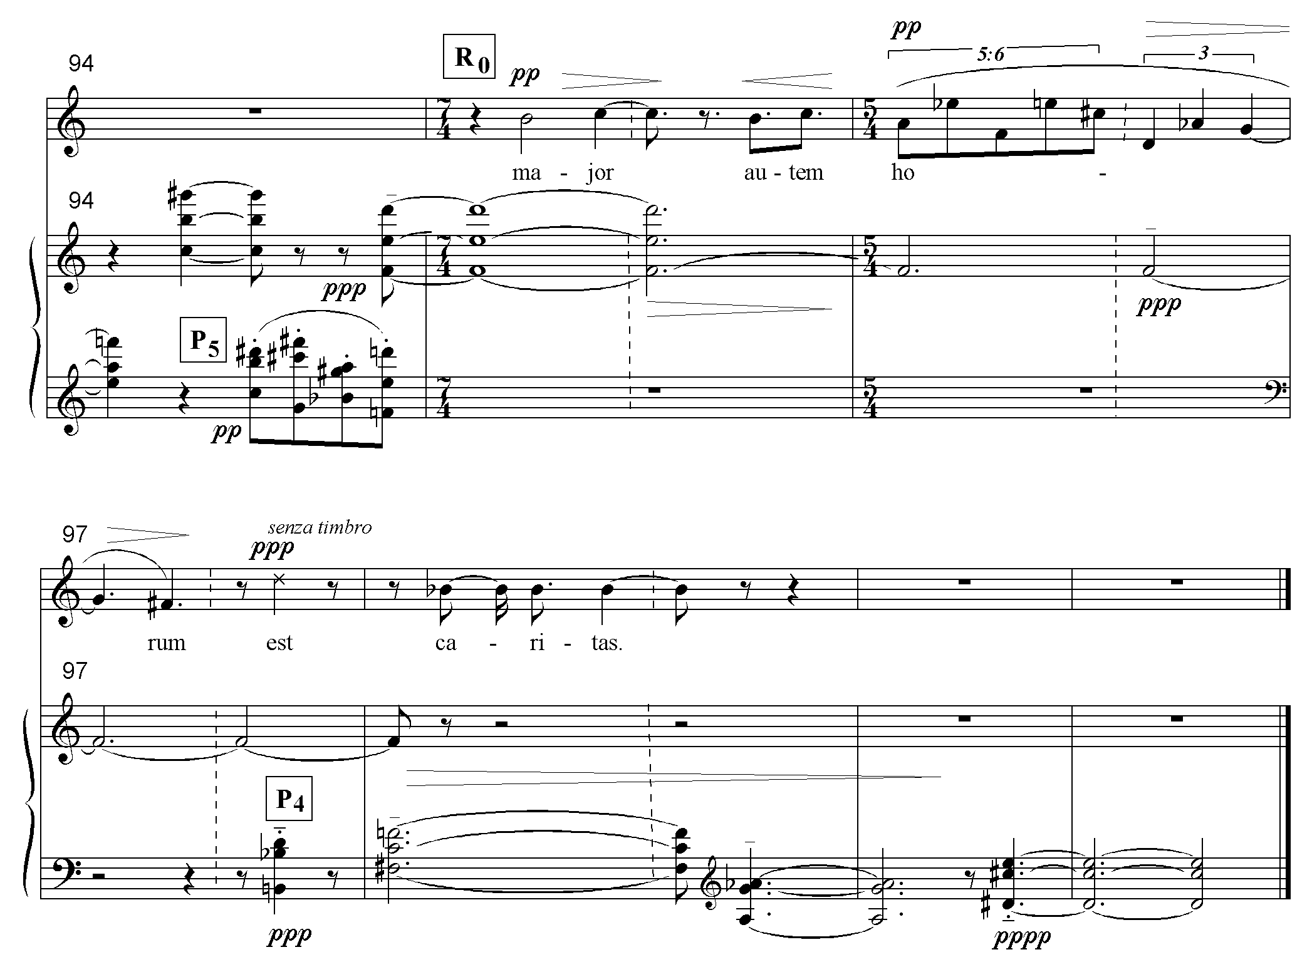
Ex. 4.7 Parole di San Paolo: mm. 94-100.
One speculates that the existential uncertainty which prompted the condemned prisoner at the close of Il Prigionero (1948) to stutter “And liberty?” has not been resolved in Parole di San Paolo (1964). Perhaps it is this stance that consistently leads Dallapiccola to return to the ‘tonic’ row level at the end of a particular piece just before he ends on some other row level. Parole di San Paolo is a complex example of that because the ultimate level P₄ (which follows the tonic level R₀) is the same as R_{4,} which contained the ‘tonic’ chord in the opening of the piece. Since Dallapiccola preserves the precise pitches in their original registral locations, the reversal of chord order creates a mirror image. Thus the chords that descended at m. 8 ascend at the end, evoking uncertainty.
It is in section III, the keystone of the arch, one finds one of the most stunning examples of Dallapiccola’s text-painting, but to fully understand it, one must start in the previous section. Toward the end of IIa, the word ‘montes’ (mountains) is accompanied by the held chord, F#-D-F-Ab-C#, which I designate the ‘mountain chord’. Tripled by strings, harp and winds, repeated, and played fortissimo, the first four pitches constitute an isolated segment of RI₉, ops e-8. (The C# doubles the vocal line’s op 4 of RI₇.) (See Ex. 4.8 on the following page.)
The solidity of the chord, evoked by its scoring and repetition, expresses the massiveness of the mountain, while the absence of the succeeding pcs of RI₉ may symbolize its removal (“and though I have all faith so that I could remove mountains”).

Ex. 4.8 the “mountain” chord
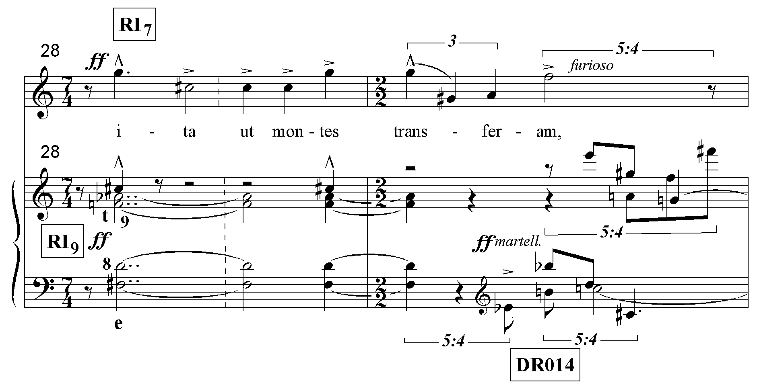

Proceeding to section III, the mountain chord reappears at m. 46, this time representing a burning body (‘si tradidero corpus meum ita ut ardeam’). Like the earlier mountain chord in IIa, it is presented twice, tripled in strings, harp and winds, played fortissimo and accompanies the vocal pitches G and C#. This time, however, RI₉ is completed in the following measures in a manner that suggests the rarefaction of a solid body turning to smoke. After the four-voiced segment (ops e-8), the next six ops are divided into ascending dyads, culminating in the extremely high single op 1 (B). In the following measure the texture is further rarefied by a full five beats of nothing (m.50). Op 0 then appears in the first of the charity chords in m. 51. (See Ex. 4.9 on the next page.)
A poetic link exists between the mountain that is being removed in mm.28-29 and the body that is turning to smoke in mm.46-49. (According to an alternative interpretation the rising dyads represent the increasing agony of the condemned choked off by the high B scream; there is no incompatibility between the two interpretations.)
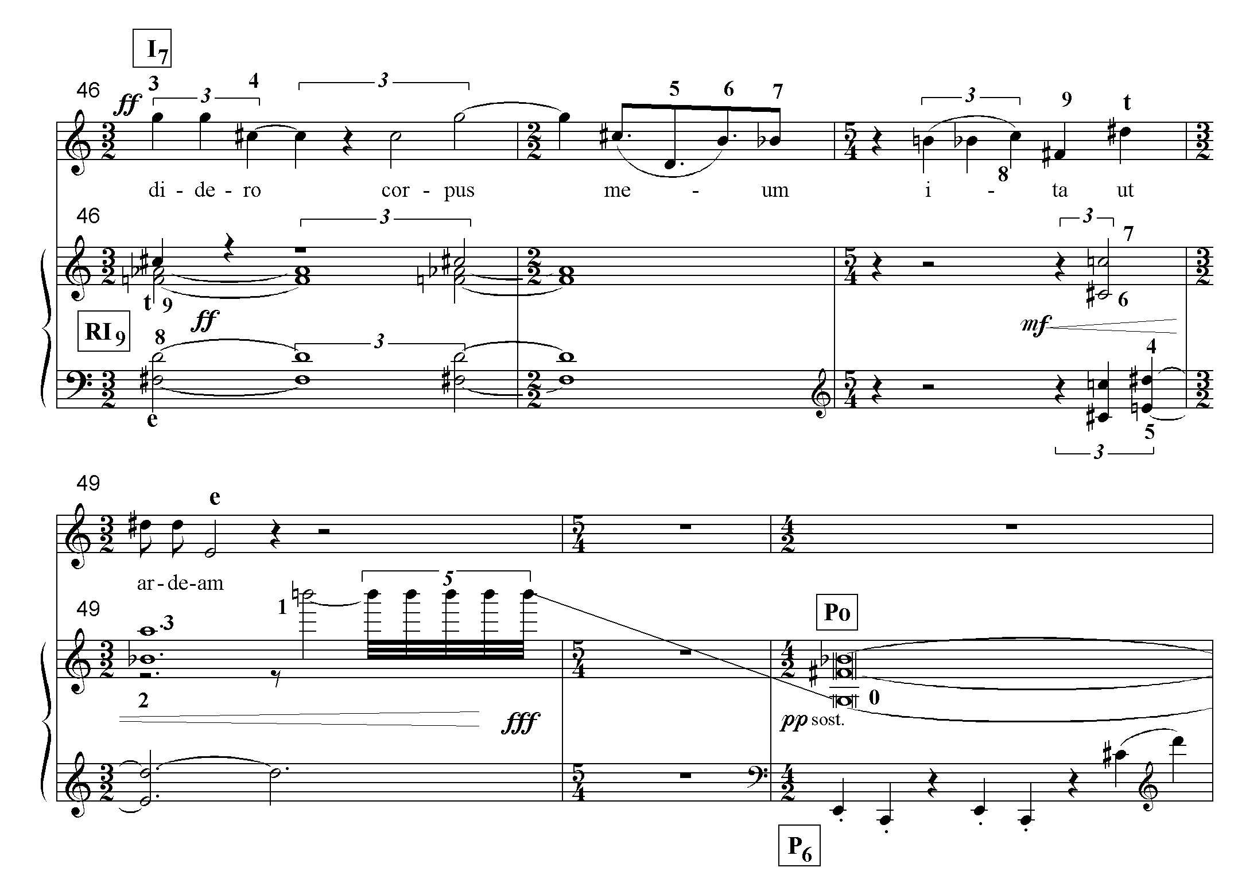Ex. 4.9 Parole di San Paolo: rarefaction of the mountain chord, mm. 46-51.

As noted earlier, these ‘mountain chords’ occur before the repetition of the “charity’ chords. Thus, they also assist in formal articulation while expressing the text. One concludes that Parole di San Paolo’s architectonic form and its text-expression are part of one formal/expressive concept that cannot be divided. The superimposed formal structures express the grammatical structures of the text; the repeated textual items create the form. Even the graphic manipulations of the mountain chord reinforce the “charity form.”

