Chapter 3 Piccola musica notturna (1954)

Piccola musica notturna (1954) is an orchestral work that was rescored in 1961 for a chamber ensemble of eight players. With the exception of inevitable changes in timbre, Dallapiccola scarcely altered the work in the chamber version. He clarified the role of dynamics in formal articulation, omitted a few notes, and transposed a few others by octave. None of these alterations critically affects the analytical conclusions.
In the eight years between Rencesvals and Piccola musica notturna, Dallapiccola’s technique developed significantly. He abandoned the idea of deriving a row from a modular chord progression and no longer treated chords as independent serial units. Rather, he segmented the row into trichords that he later recombined into derived rows. Dynamics and range transcend their incidental text-setting function and become part of the long-range compositional design. The use of pedal tones as a structural device, already in evidence in Rencesvals, becomes more elaborate.
Piccola musica notturna is characterized by a languid indulgence in sonority that one associates with Debussy.
Successively longer row segments are repeated over spans of three or four measures, allowing the listener plenty of time to luxuriate in each harmony. (See mm.1-3 or mm. 6-11.) The dynamic level varies between p and ppp; fortissimos are reserved for articulating the end of sections. The motivically transparent textures evoke stillness; there are none of the monolithic harmonies so evident in the action-packed Rencesvals.
Prefaced by Antonio Machado’s poem Noche de Verano (Summer Night), Piccola Musica Notturna is much more than a “…subjective portrayal of the poem’s general mood.” I believe that its five sections correspond to the five sentences of the poem. Each musical section expresses its corresponding text by means of row technique, range, and its position in the tonal-atonal spectrum. In Dallapiccola’s work, Machado’s lines “I walk through this old town/ alone, like a phantom” become a metaphor for his valediction to the ‘deserted’ world of tonality. The piece begins with striking allusions to tonality, after which each section becomes progressively less tonal. When Dallapiccola revisits the tonally allusive material in the last section of the piece, he revisits the “old town.” Linear and dynamic organization create an expectation for the confirmation of a pitch center and a dynamic that, in the end, are denied. That pitch and that dynamic, implied but not stated, are the musical counterparts to the poetic “phantom.”
The poem and its translation, with the measure numbers and section letters in boldface indicating the correspondence between music and text, appear on the next page.
Noche de Verano
Es una hermosa noche de verano. 1-13 [A1]
Tienen las altas casas 14-21 [A2]
abiertos los balcones
del viejo pueblo a la anchurosa plaza.
En el amplio rectangula desierto, 22-33 [A3]
bancos de piedra, evonimos y acacias
simietricos dibujan
sus negras sombras en la arena blanca.
En el cenit, la luna, ye en la torre 34-44 [B]
la esfera del reloj iluminada.
Yo en este viejo pueblo paseando 45-68 [A4]
solo, como un fantasma.

Summer Night

It is a beautiful summer night. 1-13 [A1]
The tall houses have their balconies open 14-21 [A2]
to the spacious square of the old town.
In the wide, deserted rectangle, 22-33 [A3]
stone benches, hedges and acacias
delineate symmetrically
their black shadows on the white sand.
In the zenith, the moon, and in the tower, 34-44 [B]
the sphere of the illuminated clock.
I walk through this old town 45-68 [A4]
alone, like a phantom.

The form, [A1, A2, A3, B, A4], is articulated according to row choice and technique, pitch centers, range, dynamics and, to a certain extent, texture. One might call it a theme and variations plus development. Just as each variation of a theme and variations traditionally begins in the tonic, each variation in Piccola musica notturna begins with P₀. In three of the four “A” sections (A1, A3 and A4), I₆ follows P₀, creating an analogue to the similarity of harmonic structure in each variation of a theme and variation. In section B, the row is fragmented into its trichordal constituents, which are reconstituted as derived rows (in this case, trichordal aggregates). This procedure is analogous to thematic fragmentation in classical development sections.
Parallel to the tonal analogue, a drama of “vanishing tonality” unfolds. Each successive “A” section begins by asserting the pitch G with successively less emphasis; A1 asserts G as a tonality, A2 asserts G as a chord, in A3 it is asserted as a G⁺⁶, infiltrated by an increasingly strong E, and finally A4 asserts G rather weakly as a pitch only. The presence of a G center at the beginning of every “A” section reinforces the perception of a theme and variation structure. Nevertheless, the true pitch center drama lies in the conflict between the waning of G and the waxing of E. The row structure and tonal relationships for A1 and A2 are inscribed on the piano reduction in Ex. 3.1; the row matrix is displayed in Table 3.1.

Table 3.1 Row Matrix

P→→ | I₀ | I₉ | I₁ | I₃ | I₄ | I_{E} | I₂ | I₈ | I₇ | I₅ | I_{T} | I₆ | I↓
P₀ | Bb | G | B | C# | D | A | C | Gb | F | Eb | Ab | E
P₃ | Db | Bb | D | E | F | C | D# | A | G# | F# | B | G
P_{E} | A | Gb | Bb | C | Db | Ab | B | F | E | D | G | Eb
P₉ | G | E | Ab | Bb | Cb | Gb | A | Eb | D | C | F | Db
P₈ | Gb | Eb | G | A | Bb | F | Ab | D | C# | B | E | C
P₁ | B | Ab | C | D | Eb | Bb | Db | G | F# | E | A | F
P_{T} | Ab | F | A | B | C | G | Bb | E | Eb | Db | Gb | D
P₄ | D | B | D# | E# | F# | C# | E | Bb | A | G | C | Ab
P₅ | Eb | C | E | F# | G | D | F | B | Bb | Ab | Db | A
P₇ | F | D | F# | G# | A | E | G | C# | C | Bb | Eb | B
P₂ | C | A | C# | D# | E | B | D | G# | G | F | Bb | F#
P₆ | E | C# | F | G | G# | D# | F# | C | B | A | D | A#
RI↑↑ |  |  |  |  |  |  |  |  |  |  |  |  | ←R
Ex. 3.1 Piccola musica notturna: sections A1, A2 and beginning of A3, mm. 1-23
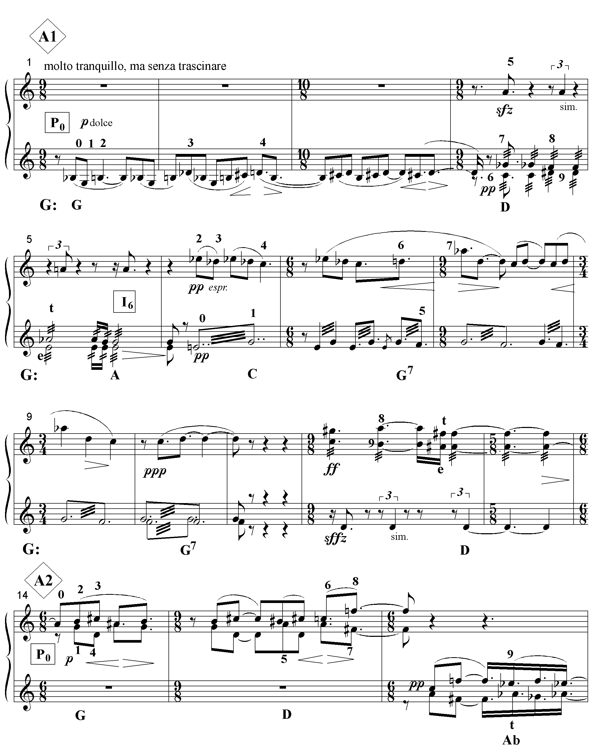

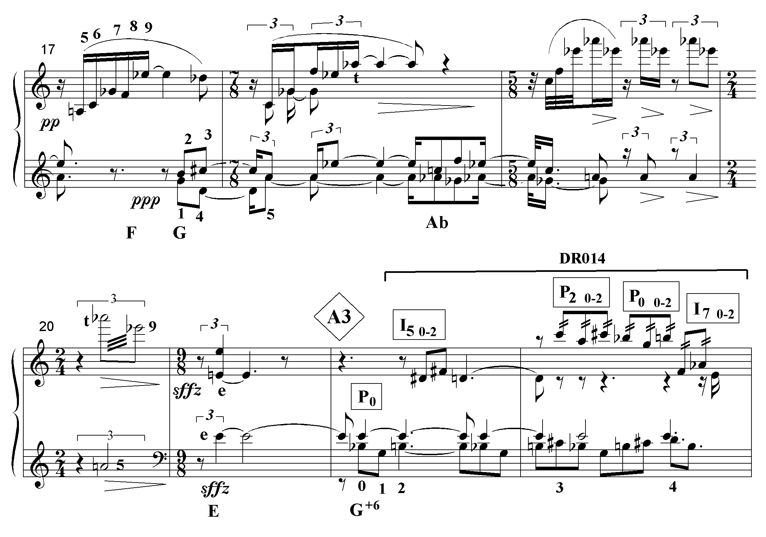
Ex. 3.1 continued

The “A” sections are marked by the letter in the diamond enclosures; the row forms appear within the rectangular enclosures, and the tonal or tonally allusive harmonies are indicated below the systems.
In the first section, mm.1-13, Dallapiccola deploys the row in ways that facilitate the perception of a G major tonality. Order positions 0-4 of P₀ unfold linearly so that the Bb and C# are heard as lower neighbors and passing tones to the B and D of a G major chord. The tendency toward languorous repetition of row fragments enhances the perception of harmonies. Dallapiccola verticalizes row segments in mm.4-5 where they form tonal sonorities. Even taking into account the octatonic flavoring of the C triad in m.6, the unresolved Ab in mm.7 and 9, and the (from a tonal point of view) arbitrary voice leading in m.12, mm.1-14 demonstrate a remarkable tonal cogency for a serially organized work. The progression mm.13-14 in particular assimilates the entire passage to G major. The D-A#-F# chord is interpreted as the dominant of G with an augmented fifth. The A# then resolves to the third of G major in the next measure, a very common progression in tonal music. Dallapiccola exploits the fact that A#, the last pc of I_{6,} is also the first pc of P_{0.} Thus, he can begin section A2 squarely on G-B, the second and third notes of the row (op 1-2).
Section A2 is articulated both in terms of its similarities and differences with section A1. Both sections present one row at a time, but in section A1 the row is presented as a line, a chord progression, and as harmony supporting a melody; in section A2, the row is divided into contrapuntal lines. Both sections begin with a statement of P₀ and a G major harmony. Already in A2, however, G begins to suffer what will become a progressive decline in its power. At first, the decline is subtle. In m.1, the unfolding G major was bounded by the interval G-D, the most stable position possible. In contrast, the G major of m.14 is bounded by D-C# which resolves to B. Then, in the ensuing measures, Dallapiccola eschews the emphasis on G major harmonies characteristic of section A1. Rather, he manipulates the diminished triad, A-C-Gb, embedded in P₀, to construct a series of interval 3 related dominant seventh chords built on D, Ab and F. (See mm. 15-20.) In. Ex.3.2, a linear analysis of mm.14-17 reveals a bass line neighbor-note motion linking the two assertions of G major. (The stemless notes represent the roots of the “dominant” chords.) Thus, the pseudo-functional G major of section A1 is replaced by a weaker neighbor note structure in mm.14-17.

Ex. 3.2 mm. 14-17, linear analysis
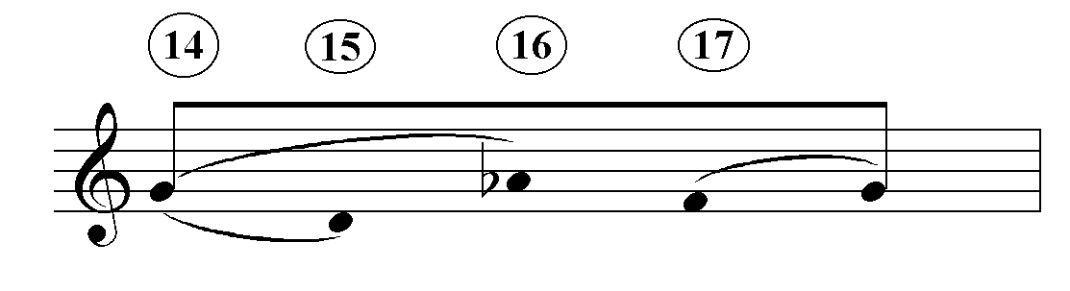
From this point onward, E gains in importance as a pitch center. The most striking assertion of any pitch in the piece occurs in m. 21 with the unison E. The short score understates its effect; in the chamber version the E is played by seven of the eight instruments, whereas in the orchestral version it is played by all the instruments except the flute, xylophone and celeste, which are silent. In m. 20, the E is preceded by the chord, A-Eb-Ab, the Eb of which produces a strong leading-tone motion to the E.
Already, then, in the first two sections, one observes that Piccola musica notturna is music about the history of music. The opening section, A1, relies on pseudo-classical functional structure whereas A2 evinces a reliance on quasi-post-romantic interval-3-related tone centers.
As shown in Ex. 3.3 on the next page, Section A3 continues the trends evident in the first two sections. E gains further strength at the expense of G; the addition of trichord aggregates to the underlying statement of P₀ and I₆ results in a reduced incidence of tonal allusion; the section as a whole is no longer structured with
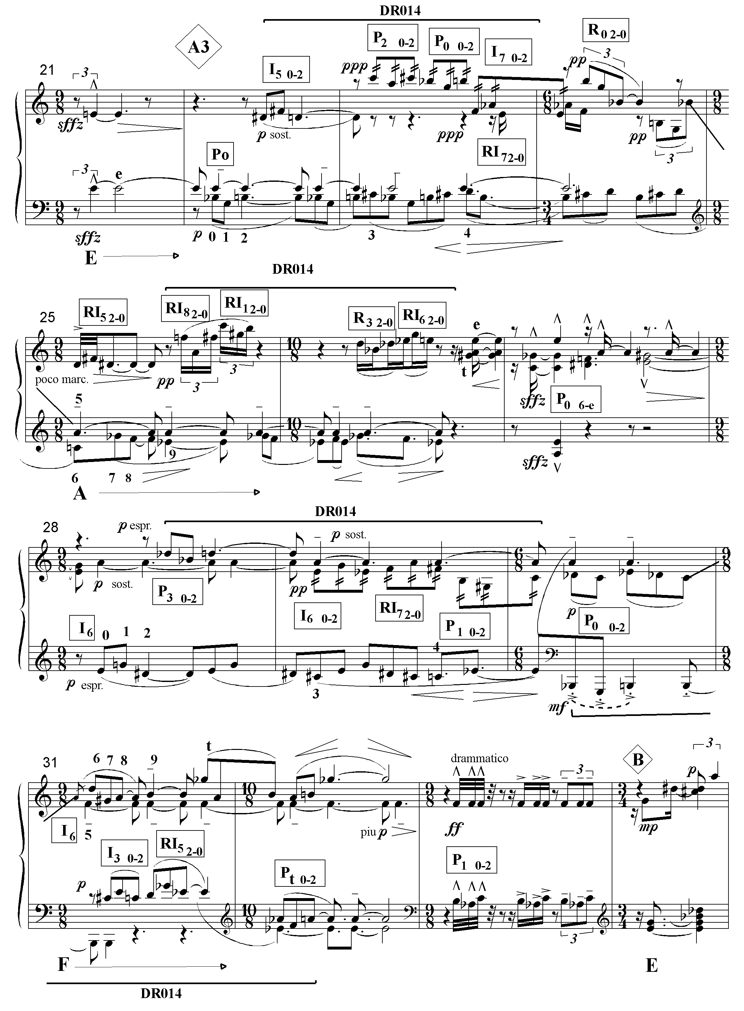
Ex. 3.3 Piccola musica notturna, section A3: row structure and pedal tones
reference to 19th-century harmonic techniques but, instead, relies on the organizing power of pedal tones. These are indicated by capital letters below the systems in Ex. 3.3.
In mm. 22-23, G and E continue to struggle for supremacy, the first as a repeated pitch in the bass voice, the second as an interior pedal. Nevertheless, the balance of power has shifted toward E owing to the frame created by the unison E’s in m. 21 and the E dominant chord at the end of m. 23. G makes a fleeting reappearance the end of m. 24 but the held G assimilates to an E half-diminished chord. The strongest tonal allusion in the remaining measures of the section occurs on the second half of m. 30 with the dominant of E. However, it is separated from the E minor third beginning Section B by three measures
Owing to the increased amount of non-tonal material separating the allusive harmonies, there is no proper tonal organization in this section but, rather, the remains or the fleeting memories of one. However, there is a linear organization to which all the various kinds of harmonic formations can be referred, whether they be tonal, octatonic or indeterminate. On the next page, Ex. 3.4 abstracts the pedal tone structure from Ex. 3.3. Each of these tones (except the last E which is not a pedal tone) is continuously present in the same register until it is succeeded by the following tone.
Whereas section A1 evokes G major by surrounding it with tertian harmonies built on its scale degrees, and section A2 affirms G major by means of neighbor-note harmonies before moving to the E unison, section A3 confirms E with a departure and return model of linear connection, reinforced by tonal allusion. Even though the pedal
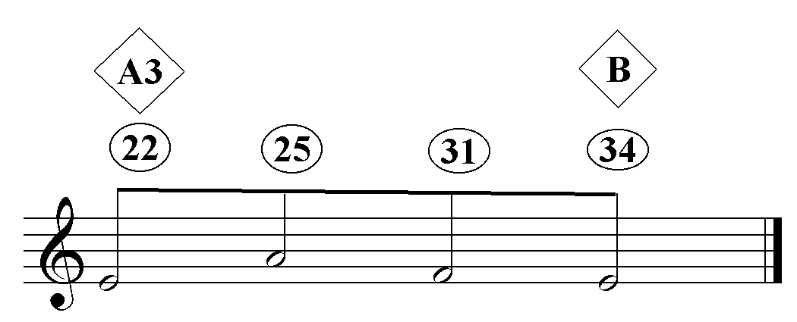
Ex. 3.4 Piccola musica notturna, mm. 22-34: pedal tones

tones of Ex. 3.4 are not always in the bass voice, they assume importance by virtue of their repetition and their identification with the roots of the tonally allusive harmonies, the E harmonies of mm. 22-23, the A harmonies of mm. 27-28, and the implied F minor triad of mm. 33.
Although it is not a continuous pedal, the obsessive appearance of Eb in the lowest voice from m. 25 on creates a feeling of stasis. Example 3.5 demonstrates how the mid-range bass motions, Eb-E from below and F-E from above, zero in on E, further enhancing its power.
Ex. 3.5 linear motion in section A3
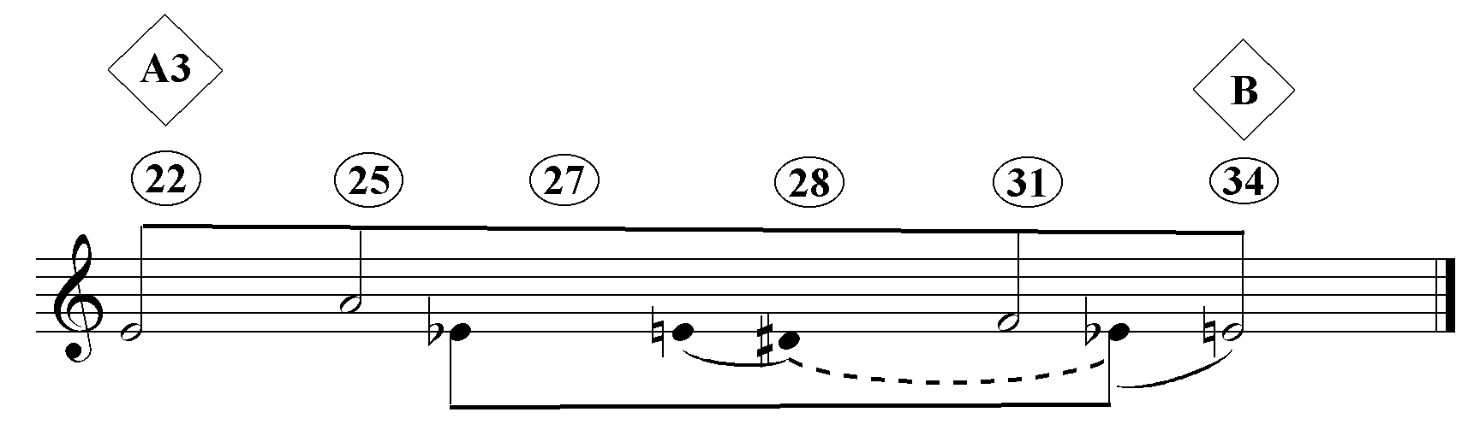

Example 3.6 summarizes the three types of linear motion in sections A1, A2, and A3. Section A1 comes the closest to the integrated linear/harmonic Schenkerian model, projecting the G triad through the dominant-tonic relationship (mm.12-14). In section A2, the tonal structure is loosened; G is asserted by means of a neighbor note motion, G-Ab-F-G, the pitches of which still function as the roots of ‘dominant’ chords. E is preceded by its leading tone, Eb, and confirmed by a powerful unison statement. The tonal allusions in section A3 reinforce a primarily linear structure that has become independent of any harmonic organization. The double bars between the sections suggest that each section projects a different mode of organization.
Ex. 3.6 Piccola musica notturna: mm.1-34, linear analysis
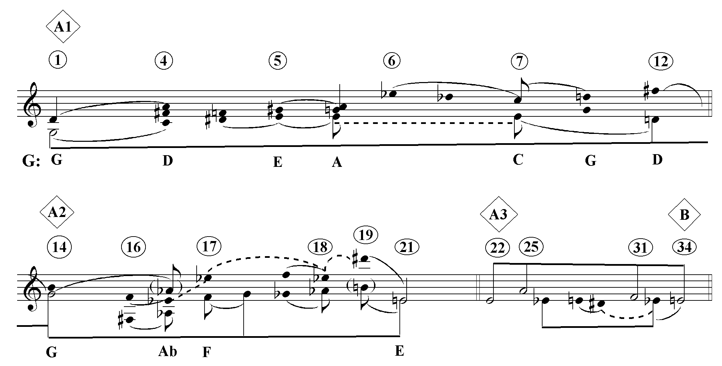
Ex. 3.6 illustrates the difficulty of applying Schenkerian principles to music where the modes of organization and, therefore, the meaning of the graphic notation changes from section to section. Section A1 is pseudo-tonal; section A2 is based on a non-functional neighbor note structure; section A3 is erected on pedal tones. However, one should not infer that the work sounds discontinuous as a result. Dallapiccola preserves a sense of stylistic unity by repeating row segments as melodic units, (the first 5 pcs of P₀ at the beginnings of sections A1 and A2, for instance), as motivic units (the various trichords in mm.22ff. that transpose, invert and retrograde the first trichord of P₀), and as harmonic units (the chords in mm. 4-5 which are repeated in mm. 27-28, for instance).
More than anything, however, Piccola musica notturna owes its distinctive sound to the octatonic character embedded in its row. The row is divided into two octatonic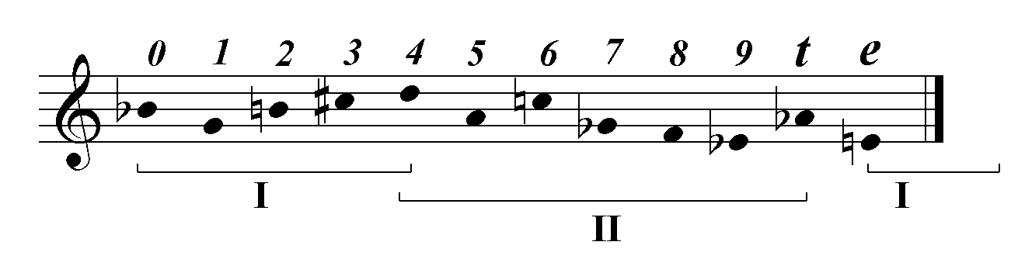 blocks.
Ex. 3.7 Piccola musica notturna: octatonic row organization

Ops 0-4 are in Collection I; ops 4-t are in Collection II, after which op e wraps around to Collection I (ops e-4). It is of some interest that the row of Rencesvals shown in Ex. 3.8 exhibits similar characteristics.
Ex. 3.8 Rencesvals: octatonic row organization
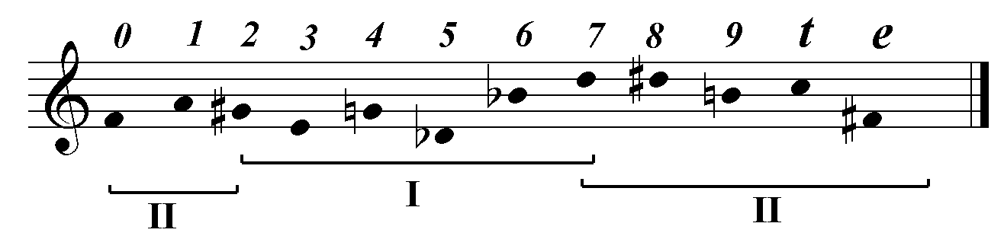
There are two facets to the octatonic character of mm.1-34: the sheer presence of octatonic sound, and its structure. Table 3.2 on the following page gives some idea of both.

Table 3.2 Piccola musica notturna: octatonic structure
Section A1
meas. | 1-4.1 | 4.2-4.9 | 5-5.5 | 5.6-7.6 | 7.7-8.4 | 8.5-11.1 | 12-12.7 | 12.8-14.1
row | P₀ |  |  | I₆
coll. | I | II | N | III | I | N | II | N

Section A2
meas. | 14.2-15.4 | 15.5-15.6 | 15.7-17.4 | 17.5-18.1 | 18.2-20.4 | 21-21.9
row | P₀
coll. | I | N | II | N | II | (I)

Section A3
meas. | 22-22.4 | 22.5-22.6 | 22.7-23.1 | 23.2-23.4 | 23.5-24.6
row | P₀ + trichord aggregates
coll. | I | N | II | III | I

Section A3 continued
meas. | 25-26.4 | 26.5-28.1 | 28.2-28.6 | 28.7-29.1 | 29.2-29.4 | 29.5-29.6
row | P₀ + trichords |  | I₆ + trichord aggregates
coll. | II | N | III | N | III | N

Section A3 continued
meas. | 29.7-30.1 | 30.2-30.3 | 30.4-31.1 | 31.2-31.3 | 31.4-33.9
row | I₆ + trichord aggregates
coll. | II | III | II | N | II

The integers after the decimal point of the measure count in the top row of the table indicate the number of eighth notes after the beginning of the measure. The borderline between shaded and unshaded areas indicates the beginning of new phrase groups. As in the previous chapter, the Roman numerals in the bottom row refer to the octatonic collections while an ‘N’ represents a non-octatonic formation.
In section A1, 68 out of 102 beats are unequivocally octatonic. The incidence of octatonic harmonies in section A2 is even higher: 49 /53 (!). In section A3, the incidence is 75/95. Altogether, 77% of the passage, A1- A3 is octatonic, quite enough to give it its characteristic “sound”.
Since each row form sequentially projects two of the three possible octatonic collections, Dallapiccola is able create a significant harmonic event by choosing a row succession in which the second row begins with a collection not present in the first. P₀ and I₆ are the only row forms that are presented completely in mm.1-34. Significantly, I₆ is one of eight row forms that begin with the collection not present in P₀, collection III. Thus, the change of row at crucial phrase junctures in sections A1 (at the end of the phrase ending in m.5) and A3 (m. 28) is synchronized with the appearance of a fresh octatonic harmony.
Ex. 3.9 change of octatonic collection at the phrase boundary in m. 5
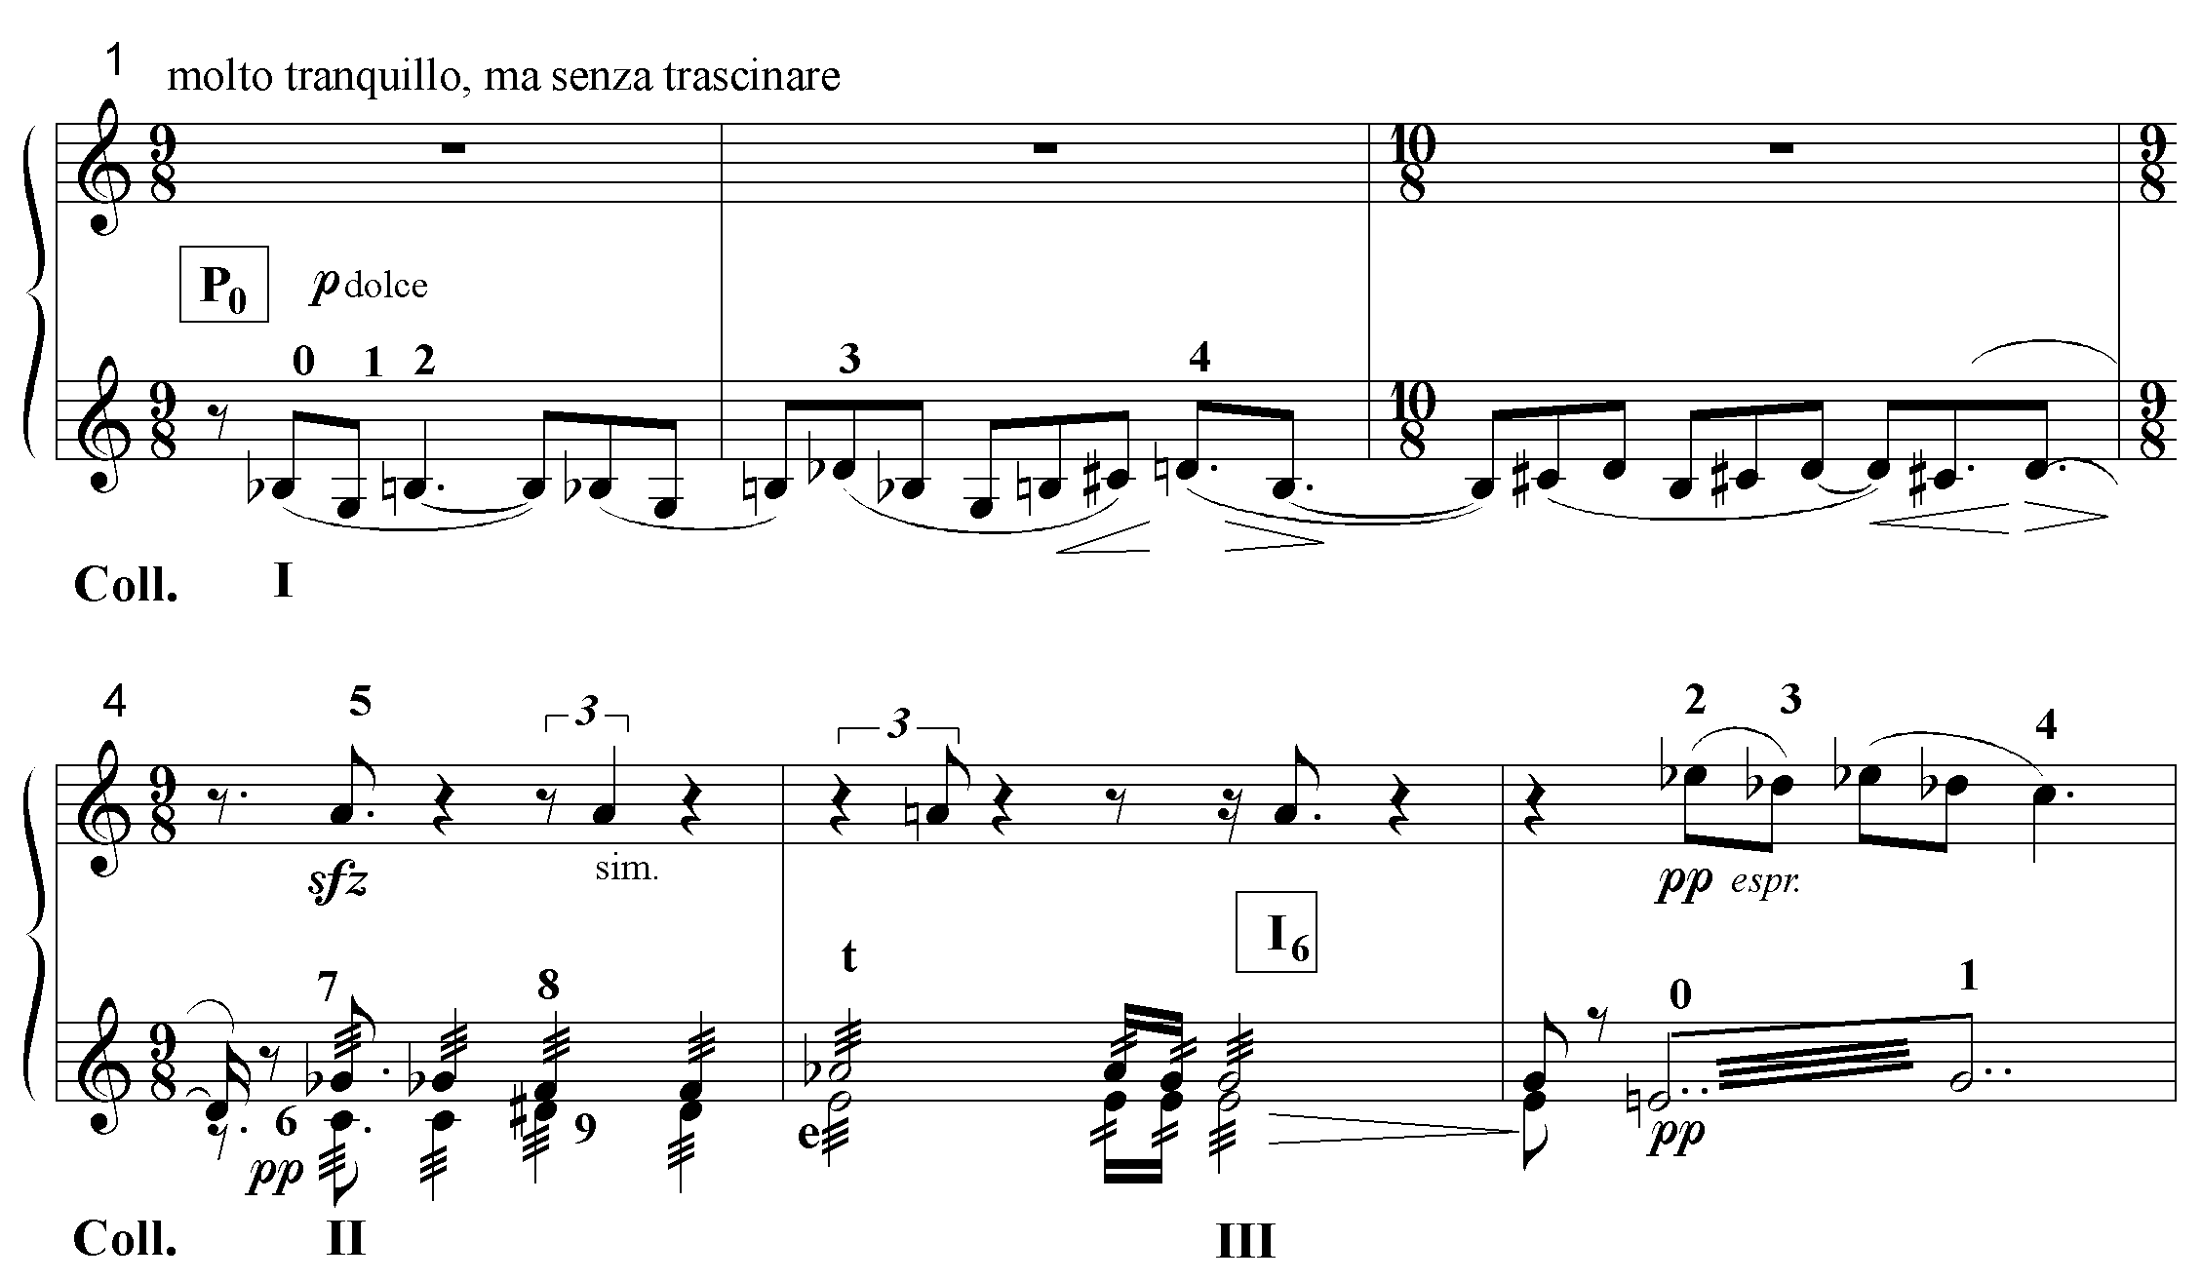
Given the decision to endow E with an increasing amount of structural force, I₆ is a logical choice to follow P₀ because E is both the first pc of the former, and the last pc of the latter. This relation also holds true for P₀ and P₆, and, as shall be shown, for R₆, which plays an important role at the end of the piece. It is also possible that the choice of P₀ and I₆ is one of Dallapiccola’s abstruse dodecaphonic metaphors. In that case, the intersection of the two row forms on the outer edges of the “magic square” (see Table 3.1) might be a reference to the “spacious square” and “deserted rectangle” of the poem. This is just the sort of formalistic text-setting that he employed again and again, as described by Rosemary Brown and James Dapogny.
The trends evident in the first three sections culminate in Section B. (See Ex. 3.10 on the next page.) The tendency toward row fragmentation reaches its apogee; whereas sections A1 and A2 present complete rows exclusively, and section A3 superimposes trichord fragments on complete rows, section B is almost completely constructed out of trichords. Only R₅ is presented nearly in its entirety in mm. 37-38. The loosening of tonal structure continues to the point where even allusions to tonal constructs become almost non-existent. Pedal tones disappear as well. The linear structure is virtually divorced from any harmonic organization. Octatonic presence, too, sinks to a low ebb. G retires as a pitch center, leaving the field to a tenuous E.

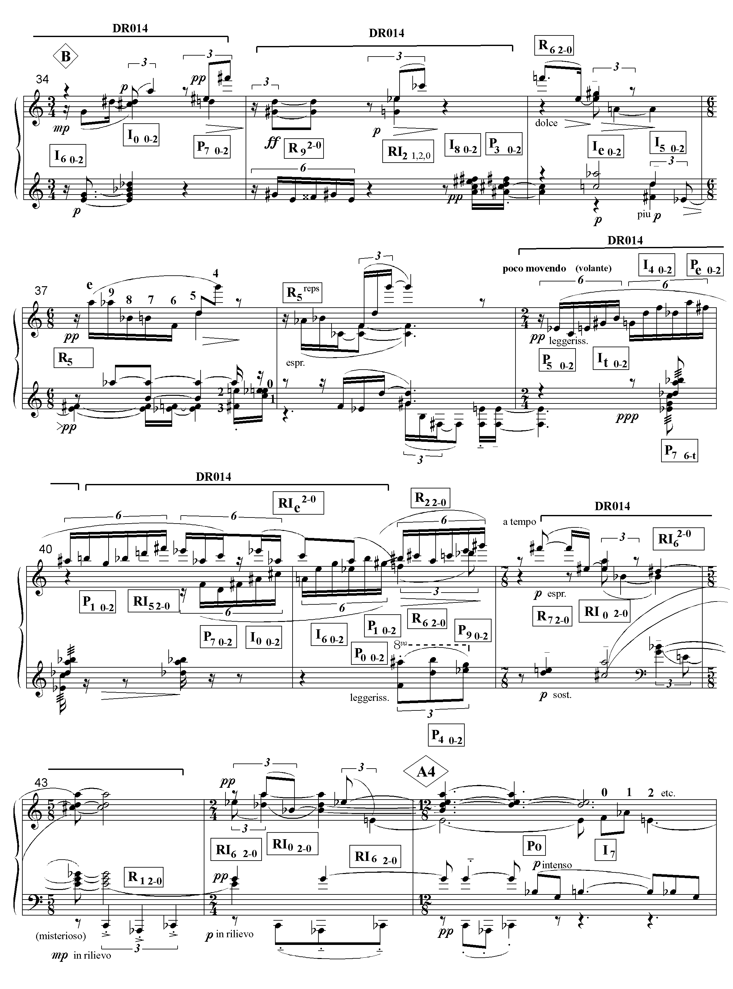
Ex. 3.10 Piccola musica notturna 34-45: twelve-tone organization
The coherence of the section depends on its saturation with the motive constructed out of ops 0-2 in its various transformations. Almost all material is constructed from trichords, ops 0-2. The resultant derived rows are marked DR014 to indicate that they are constructed by replicating 014 row segments. For instance, the trichords P₁ ₀₋₂ (from m.33 of section A3), I₆ ₀₋₂, I₀ ₀₋₂, and P₇ ₀₋₂, form one derived row in mm.33-34 (see m.33 in Ex. 3.3 and m.34 in Ex. 3.10), while another one is formed by R₉ ₂₋₀, I₈ ₀₋₂, RI_{2 1, 2, 0}, and P₃ ₀₋₂ in m.35. Having begun with a twelve-tone technique masquerading as tonality in section A1, Dallapiccola progresses by stages to section B, where one can begin to speak of a ‘pure’ dodecaphony.
Nevertheless, there is still a trace of linear organization emphasizing E. The octatonic pillars formed by the trichords, I₆ ₀₋₂, I₀ ₀₋₂, in m.34 and their retrograde, RI₀ ₀₋₂, RI₆ ₀₋₂, in m.42 frame section B. As a result, the powerful Collection III harmony, E-G-Bb-Db-D#-A, found in mm.34 and 43 supports the E that begins and ends the section.
Ex. 3.11 Piccola musica notturna, mm. 34-45: linear analysis
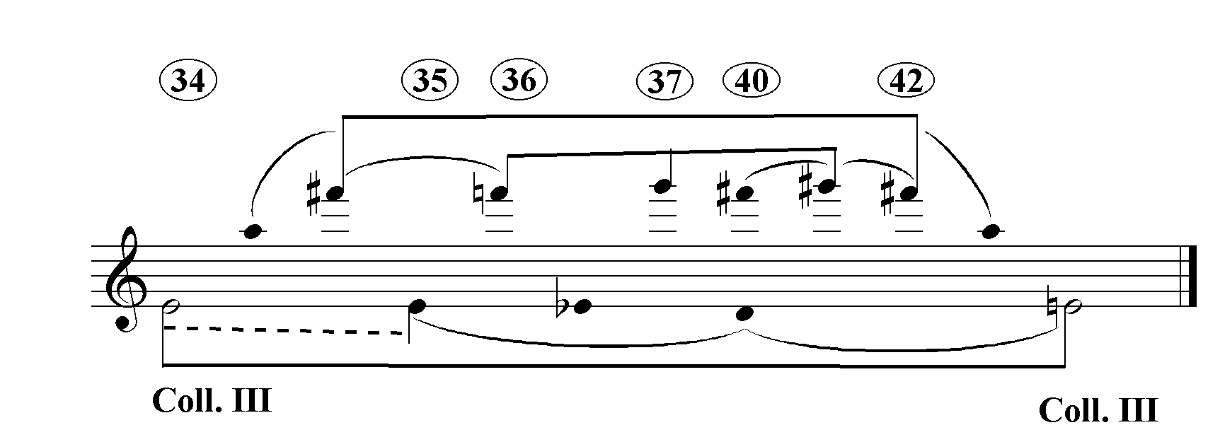

The highest voice exhibits a rather interesting neighbor-note motion around F#, which, nonetheless, does not seem to bear any identifiable relation to what is happening in the bass line, a sure sign that this is a harmonically unintegrated multiple linear structure.
Now let us return to the poem and the ways in which it is expressed by the musical structure. There is a direct relationship between the progressive decline of tonality from section A1 through section B, and the progressive intensification of the surreal in Machado’s poem. The first sentence, “It is a beautiful summer night,” is prosaic, the kind of line one might dash off in a hurry on a holiday postcard. It is set by section A in a quasi-tonal functional way, the system that has become prosaic by centuries of use.
The next sentence, “The tall houses have their balconies open to the spacious square of the old town,” is still earthbound, but it introduces an element of mystery with “open balconies.” One wonders what is in the rooms beyond. It is set by minor third- related dominants, a harmonic technique evocative of the ‘mystery’ of Wagner and Debussy.
The surreal enters with full force with the third sentence. It appears that the plaza is deserted, a highly unlikely occurrence on a beautiful summer night. Here serial begins to be identified with surreal. For the first time, trichords are layered on top of the statements of P₀ and I₆; the tonality is reduced to fragmented tonal allusion.
The surreal intensifies in the penultimate sentence with the reference to the moon and its terrestrial representative, the illuminated spherical clock. These images bring to mind the dreamlike cityscapes of di Chirico. Here, in section B, all tonal pretence is abandoned, and Dallapiccola’s serial technique reigns unchallenged.
The real and surreal commingle in the last sentence “I walk through this old town alone, like a phantom.” The poem returns to earth, but it is an earth that has turned ghostly. Just as the final lines of the poem synthesize the real and the surreal, the last section of the piece, A4, synthesizes the preceding sections.
Texturally, this is the most complex section of the piece. Passages characteristic of section A1 return, sandwiched between canons. P₀ and I₆ return, but for the first time, P₀ is accompanied by a complete presentation of another row form, I₇, and the trichord aggregate (derived row), P_{e 0-2}, RI₅ ₂₋₀, P_{t 0-2}, and I₄ ₀₋₂ (m.45-48). (That, and other derived rows are indicated by brackets.) The organizational techniques of the first three sections reappear: islands of tonality and octatonicism (m.50-52, for instance), minor third- related dominant chords (m.47), and other instances of tonal allusion. Dallapiccola is revisiting the ‘old town’ of his bygone formal technique. (See Ex. 3.12 on the next page.)

Ex. 3.12 Piccola musica notturna, mm. 45-57: row structure and tonal allusion
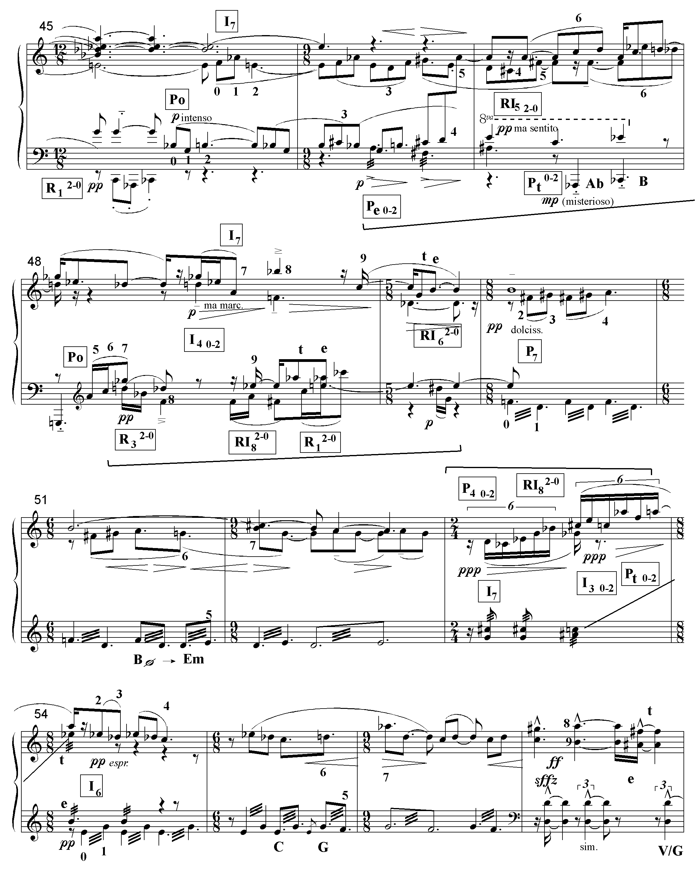

G attempts a return with the reiterated G’s of P₀ in m.45, yet the emphasis on Cb (B) in the bass and E in the alto in the same measure integrates it into an E minor area. The tonal allusion to a B dominant at the end of m.47 strengthens E, but it is immediately undercut by the low G in m.48. The stock of E rises once again in m.51 with the absolutely tonal progression, B half-diminished seventh to E minor seventh, yet, once again, its stock falls when mm. 6-12 return at mm. 54-57, with the implied V/G at the end of m.57. As Ex. 3.13 on the next page demonstrates, the expected G materializes on the fourth eighth of the next measure. However, it immediately becomes involved in a tug-of-war with E at the end of that measure and in the next one. Note that the trichord asserting the E, D#-B-E, mimics a strong tonal full cadence whereas the trichord supporting the G, Ab-C-G, implies a weaker half cadence. The E is reinforced by tonal allusion at the end of m.59, and confirmed as a pitch center by the leap down to an E on the fourth eighth of m.62.
However, in what would seem to be a deliberate act of self-restraint, the triumphant statement of E at the end of the piece never arrives. The F-C# in the lowest voice (mm. 63-68, highlighted by the dashed bracket) normally would move to E as the third member of a R₆ ₂₋₀ trichord. This expectation is heightened by virtue of the reiteration of the completed trichord motive, D#-B-Cx (mm.64-68), in the context of which, the F-C# sounds like an incomplete motive. Also contributing to the sense of denied expectation is the emphasis placed on F and C# as pedal tones, and the extended F in the highest voice (mm.64-68) which, earlier, was brought down to E in mm.33-34. (See Ex.3.13)
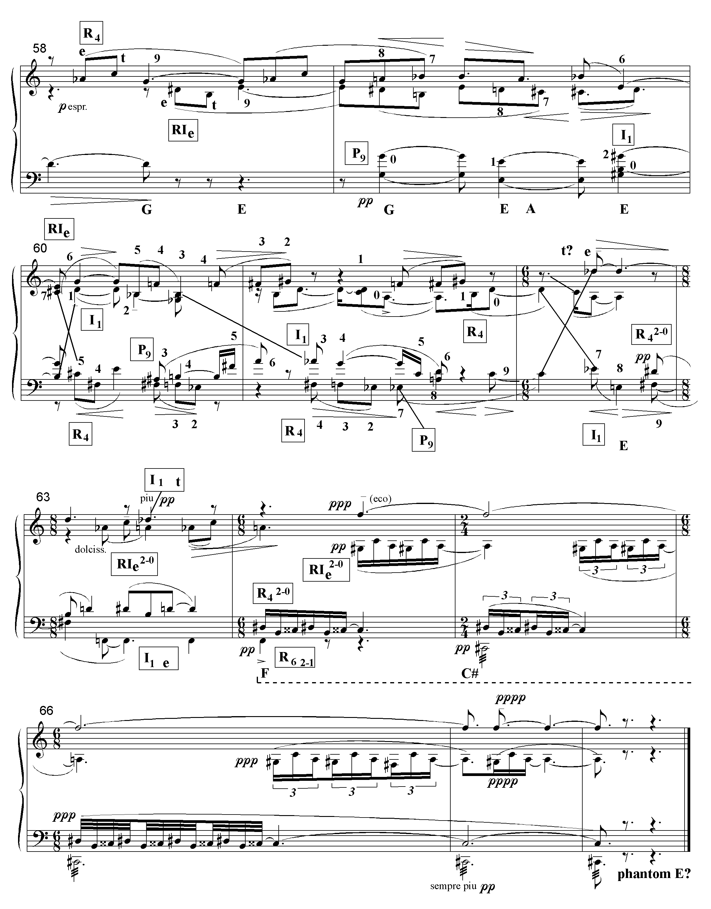
Ex. 3.13 Piccola music notturna, mm. 58-68: row structure and tonal allusion

The phantom E is the phantom of the poem. It is Dallapiccola revisiting the old town of superannuated compositional techniques to say farewell. Although he continued to employ linear and octatonic structure, after Piccola musica notturna, Dallapiccola eschewed tonal allusion, in favor of a Webernian motival mosaic drawn from the row.
Ex. 3.14 Piccola musica notturna, complete: linear graph
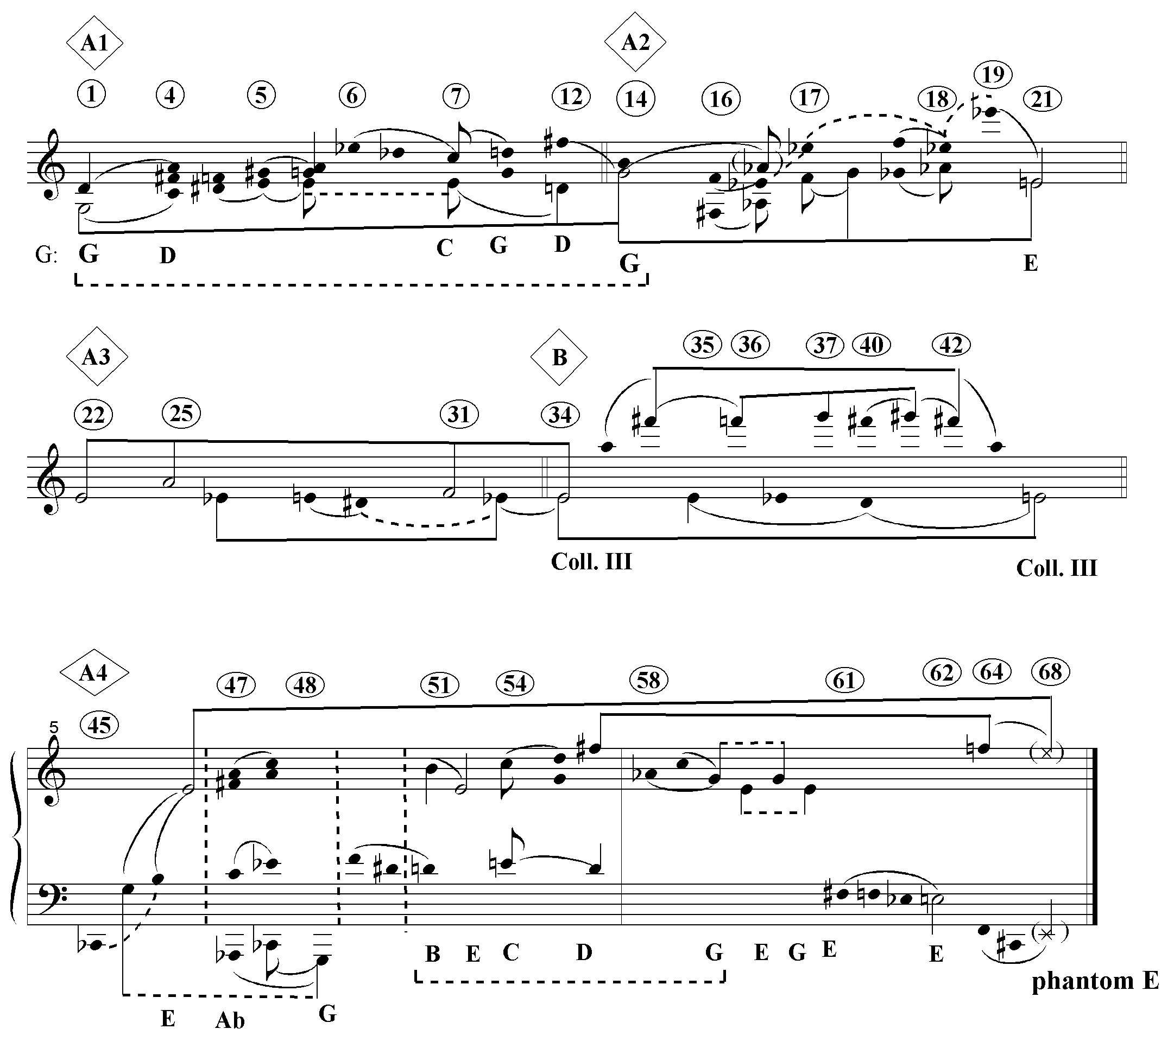
Example 3.14 is one interpretation of the linear structure of the entire work. The dashed brackets indicate tonally evocative progressions. An interesting analytical detail is the relationship between the linear Ab-C-G in m.58 and the harmonized Ab-Cb-G in mm.47-48. In both cases the Ab is heard progressing down to the G. The graph also illustrates a mid-range soprano connection between the F# of m.57 and the F of m.64-68, the two highest notes in that span of music. If related to the soprano F# an octave higher of section B, then the soprano line of sections B and A4 can, in turn, be related by chromatic descent to the underlying E.
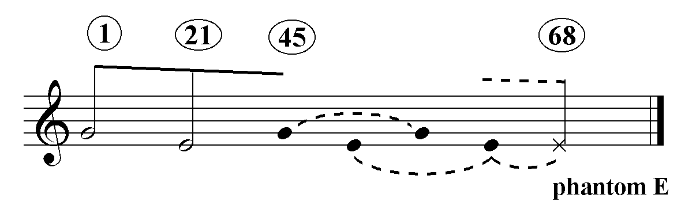Whereas the first four sections tend to be dominated by either G or E, A4 is characterized by a tug-of-war between the two pitch centers. This demonstrated in stark relief by Ex. 3.15, which boils Ex.3.14 down to its bare bones.
Ex. 3.15 Piccola music notturna: large-scale linear structure

Dallapiccola’s text-setting is not limited to correspondences between the text, twelve-tone texture and the harmonic/linear structure. Register and dynamics are also integrated into the text-setting design. Just as the poem opens up from the town to the heavens, from the prosaic to the surreal, and closes back again, so each succeeding section from A1 to B has a successively greater range, followed by a contraction in section A4. This is illustrated in Ex. 3.16. The numerals measure the range in octaves to the left of the decimal points and semitones to the right of it.
Ex. 3.16 Piccola musica notturna: range
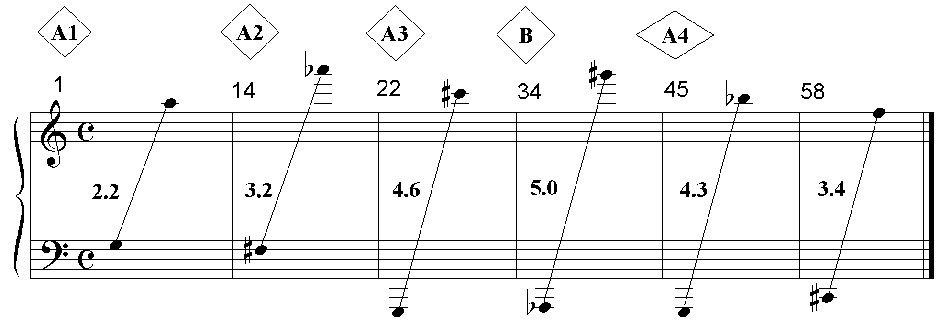
One of the most striking attributes of Piccola musica notturna is the way in which Dallapiccola’s structural employment of dynamics conjures a “phantom” dynamic at the end of the piece that is the counterpart to the phantom E and the poem’s phantom. Table 3.3 on the following page shows the dynamic contour of the piece. When one or more instruments have different dynamics simultaneously, the loudest one is the one assumed to be in force. The top row indicates sections and measure numbers; the middle row shows the dynamics in familiar notation, and the bottom row assigns a number to the dynamic, from 0-4, going from softest to loudest.

Table 3.3 Piccola musica notturna: dynamic contour
A1 (1) | A2 (14) | A3 (22) 28
p pp ppp ff | p pp ppp ff | p pp ff p pp ff
2 1 0 4 | 2 1 0 4 | 2 1 4 2 1 4

B (34) 39 | A4 (45) 57 58
p ff p pp p pp pp p mp ppp | p mp p pp ppp pp ff p pp ppp
2 4 2 1 2 1 1 2 3 0 | 2 3 2 1 0 1 4 2 1 0

Sections A1 and A2 have the same dynamic contour, a decrescendo followed by a sudden fortissimo. Section A3 presents this contour twice. Just as section B differs in other respects, so it differs in its dynamic contour, which comes to a sudden fortissimo and then softly undulates. Section A4 synthesizes the two contours (as it synthesizes the harmonic techniques and row textures). It begins with the dynamic undulation of section B, but in m. 57, reaches the fortissimo characteristic of the first three sections. At m. 58, it begins a decrescendo. At this point, it is mimicking section A3. One expects the double presentation of the opening contour (2, 1, 0, 4), ending with a fortissimo. However, the fortissimo never arrives, remaining a ghostly possibility.
To summarize: the more surreal the text becomes, the more the texture is infiltrated by trichord aggregates, the less tonal the music sounds, and the greater the range. The progressive emergence of E as a pitch center creates the possibility of a “phantom” E at the end of the work, which is paralleled by a pattern of dynamics that makes possible a “phantom” dynamic. Thus, one observes how Dallapiccola marshals the varied elements of construction at his disposal- row texture, harmonic technique, range and dynamics- to express the text’s curve of surreality, which culminates in his ghostly survey of the deserted town of abandoned compositional techniques.

The alterations are as follows: 1) m.5- the A is not held throughout the measure; it is absent for a triplet quarter on the downbeat. This has some effect on the ‘tonality’ of the section and will be discussed above. 2) m.23- the C, Bb and F on the 2cnd, 5th and 8th eighths of the measure are each shortened by an eighth so they do not overlap the next eighth. 3) mm. 24-25- the trichords E-G#-F and C#-A-C are omitted. 4) mm. 50-1 - the held E is eliminated. This also has some effect on the ‘tonality’ and will also be discussed. 5) mm.62-64- the trichords D#-B-D and Ab-C-A are transposed up an octave. Because the changes in dynamics in the chamber version simply reinforce the already strongly articulated form, perception of the work is not altered radically.
Dwelley, An Analysis, p.6.
The bracketed DR014 at the beginning of A3 refers to the derived row that is formed by the replication of the 014 trichord drawn from ops 0-2 of various row forms.
See Brown, “Dallapiccola’s Use”, pp.277-304 and Dapogny’s discussion of Goethe Lieder, “Style and Method”, pp. 8, 10-11 and 17.
Op t is missing.

