Chapter 2 Rencesvals (1946)

Rencesvals is a work for soprano and piano that sets text excerpted from The Song of Roland, a 4000-line chanson de geste that was composed in the 11th or early 12th centuries. In 778, Charlemagne invaded Spain to assist the Moorish rebel, Suleiman Ibn Al-Arabi against the Emir of Cordoba. After the invasion failed, the Frankish rearguard was annihilated by Basque guerillas at Roncesvaux during the retreat through the Pyrenees. The poem is the legendary account of the slaughter in the pass. In the heroic version, the Basques guerillas become a huge army of pagans and Saracens, Count Roland, the commander of the rearguard, and his men, slay enormous numbers of the enemy before they are overwhelmed, and Charlemagne returns with this army to exact vengeance from the Saracens. In reality, a Roland may or may not have commanded the rearguard action at Roncesvaux; all the other characters, with the exception of Charlemagne are invented. The guerillas melted away into the mountains.
The plot is enriched by the psychology of emulation and betrayal. When the pagans offer tribute and hostages, Charlemagne must decide which envoy he will put at risk to negotiate with them. After he rejects several candidates because they are too dear to him, his favorite nephew, Roland, nominates Ganelon, his own stepfather and Charlemagne’s brother-in-law. Ganelon accepts but is furious at the implication of his expendability, and at the favored treatment received by Roland in relation to that received by his true son, Baldwin. In revenge, he counsels the pagans to destroy Roland and the rearguard. Dallapiccola’s excerpts and my translation and formal indications follow.

Rencesvals (Fragments taken from La Chanson de Roland)

I

706 Vers dulce France chevalchet l’emperere.
Li quens Rollant ad l’enseigne fermee,
En sum un tertre cuntre le ciel levee.
Franc se herbergent par tute la cuntree.
710 Paien chevalchent par cez greignurs valees,
Halbercs vestuz e [bronies bien dublees],∗
Healmes lacez e ceintes lur epees,
Escuz as cols e lances adubees,
………………………………..
715 IIII/C. milie atendent l’ajurnee.
Deus! quel dulur que le Franceis nel sevent! AOI.

II

Tresvait le jur, la noit est aserie.
Carles se dort, li empereres riches.
Sunjat qu’il eret al greignurs porz de Sizer,
720 Entre ses poinz teneit sa hanste fraisnine
Guenes li quens l’ad sur lui saisie.
Par tel air l’at trussee e brandie
Qu’envers le cel en volent les escicles.
Carles se dort, qu’il ne s’esveillet mie.

III

1830 Halt sunt li pui e tenbrus e grant,
1831 Li val parfunt e les ewes curant.
814 Halt sunt li pui e li val tenebrus,
815 Les roches bises, les destreiz merveillus.
816 Le jur passerent Franceis a grant dulur.

Rencesvals (Fragments taken from La Chanson de Roland)

translation by Dana Richardson

I Musical Form

706 The emperor rides toward fair France. [Expo/1st row area, 1-9] Roland fixes the ensign to his lance;
From a hilltop he lifts it toward the sky. [trans., 10-12]
The French encamp in the vicinity. [2cd row area, 13-16]
710 The pagans ride through the wide dales [Dev., 17-32]
Wearing well-reinforced coats of chain-mail.
Helmets strapped on, and belted their swords,
Shields on their shoulders with their spears arrayed,
………………………………………..
715 Four hundred thousand await first light. [Return, 33-45]
God! What sorrow the French don’t know their might!

II

717 The night has come, the day has called a truce. [A, 46-51]
Charlemagne sleeps, the powerful emperor.
He dreamt that he was at the pass of Cize. [B, 52-54]
720 Within his fists he held his oaken spear;
By the hands of Ganelon it was taken [C, 55-60]
And so violently shaken
That its splinters flew through the air.
[B′, 61-63]
724 Charlemagne sleeps; he does not awaken. [A′, 63-69]

III
[A/pno solo, 70-74]
1830 The mountains are high, dark and great. [A/pno/sopr, 75-84]
The valleys are deep and the streams in spate.
814 The mountains are high and the valleys dark, [A′/pno solo, 85-87]
The rocks are shattered, the passes, threatening, stark. [A′/pno/sopr, 88-101]
This day the French pass through in great sadness.

The indications in bold to the right of the translation show how the form of the music maps onto the text. The lines of the text are identified by the numbers at left. The first two stanzas of Dallapiccola’s text describe events occurring before Roland’s defeat: the maneuvers of the French and pagan forces before the battle, and Charlemagne’s portentous dream of the shattered spear. Lines 1830-31 depict the scene as Charlemagne hurries in a vain attempt to rescue Roland. Somewhat anachronistically, the last three lines of the text, 814-8-16, return to the atmosphere of foreboding of Roland’s troops before the battle. This could be interpreted as an expression of Dallapiccola’s tragic view of life; the seeds of doom are sown at the beginning of the enterprise. More likely, he simply wanted a varied repeat of the forbidding landscape and wasn’t too concerned about where he got it. At the end of the text, therefore, the reader is not sure whether the battle has taken place (although I think most will tend to assume that it has). In any event, Dallapiccola’s text seems fairly well unified, and the music is even more so.
One concludes, then, that the parenthetical qualification in its full title, Rencesvals (Three Fragments from “The Song of Roland”), is no more than an act of literary conscience; he wants to make his method of choosing the text explicit. As a result, henceforth the ‘fragments’ will be referred to as movements. Although the movements are perceptible as discrete entities, the music flows directly from one to the other without pause. Furthermore, as shall be seen, he unifies the first and third movements harmonically and motivically, and integrates all three with a global linear structure.
As is common in his work, the text-setting of Rencesvals ranges from details of vocal and accompanimental text-painting to the correspondence between text and musical structure on the largest formal scale. Each stanza of the text is expressed by a different musical form (as indicated by the boldface on p.26). The first movement, setting the most action-packed part of the text, can be heard as a twelve-tone analogue to sonata form despite its genre and brevity, a mere 45 bars. A ‘tonic’ row level is established at the beginning of the ‘exposition’ followed by a transition to a contrasting row level. After a development in which other row levels turn over at a much faster rate, the ‘recapitulation’ returns to the original row level.
The second movement narrates a dream that is evoked by an asymmetry in the row-level structure; the concluding sections of its arch form do not return at their original row level, a procedure that suggests the fluidity of dreams. Its row is completely unrelated to the rows of the outer movements, thereby expressing its different state of consciousness.
The last movement returns to a highly organized row level structure utilizing a pair of rows that is strongly related to the main row of the first movement. However, it ends on a row level, P_{e,} a semitone lower than the opening row, P_{0,} so that the row level falls in a sigh expressing “This day the French pass through in great sadness.” Simultaneously, on the scale of the entire work, the global linear structure is constituted by a fall from Bb to G#. Since the avoidance of closure at a referential row level is, in fact, characteristic of Dallapiccola’s oeuvre, one speculates that he developed this procedure as a response to subject matter expressing the contingency of the human condition.
One of the most striking structural attributes of Rencesvals I is that the linear skeleton of its three-chord module in m.1, M₀ (see Ex.2.2), is also the linear skeleton of the entire movement, each element of which corresponds to an important focal point of the sonata form. Since the linear skeleton also appears in several mid-range contexts, it becomes the privileged pattern.
Ex. 2.1 Rencesvals I: global linear structure

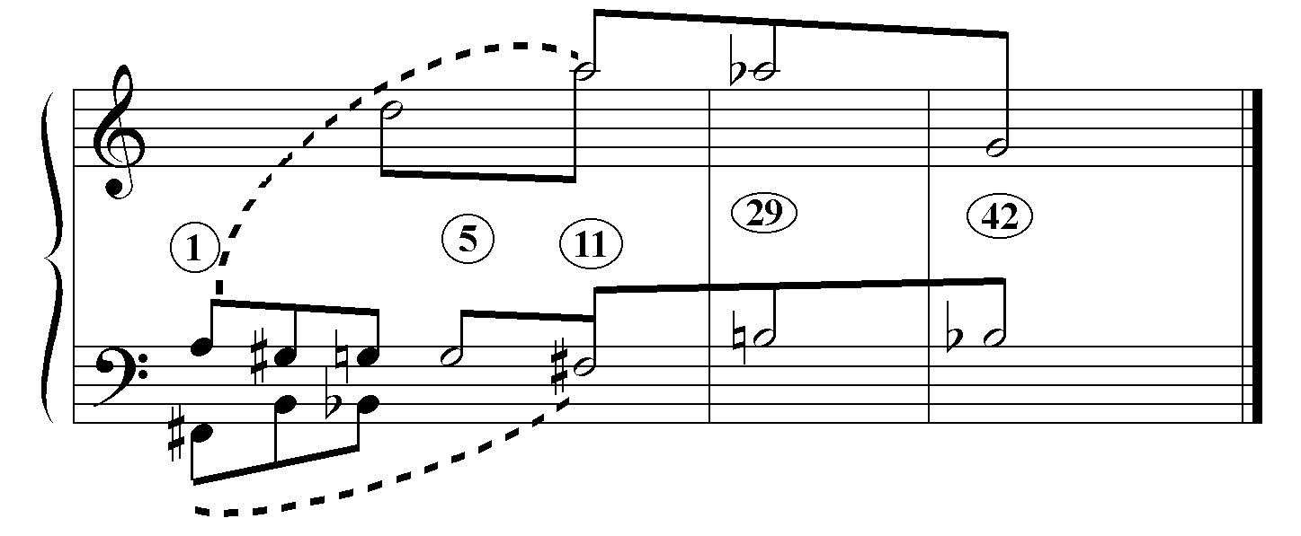
In order to understand how the sonata form and linear organization work together, it will be useful to investigate the rather idiosyncratic twelve-tone structure from which they are built. It is important to keep in mind that Rencesvals was written during the 1940s, a period of Dallapiccola’s development in which tonality infiltrated by dodecaphony gave way to dodecaphony infiltrated by tonal elements. According to Hans Nathan, Dallapiccola composed the three characteristic chords of m.1 first and only later realized that he could derive a row from them. Here one observes Dallapiccola deriving a line from a harmonic progression, a procedure that is characteristic of 19th century tonal composition, and then manipulating both line and harmony according to twelve-tone principles. The chord progression is treated as a series with three elements. Because the series of three four-note chords nearly always appears as a unit, it will be designated the ‘M’ row in contradistinction to the ‘P’ row which is derived from it. Transposed to various pitch levels, the three-chord series becomes a harmonic module, hence the designation, ‘M’. Example 2.2 shows the three-chord progression of M₀ in m.1. The three chords are labeled with the large Arabic numerals in bold italic. The smaller Arabic numerals next to the chord tones indicate the order position of the pitches relative to the row P₀.
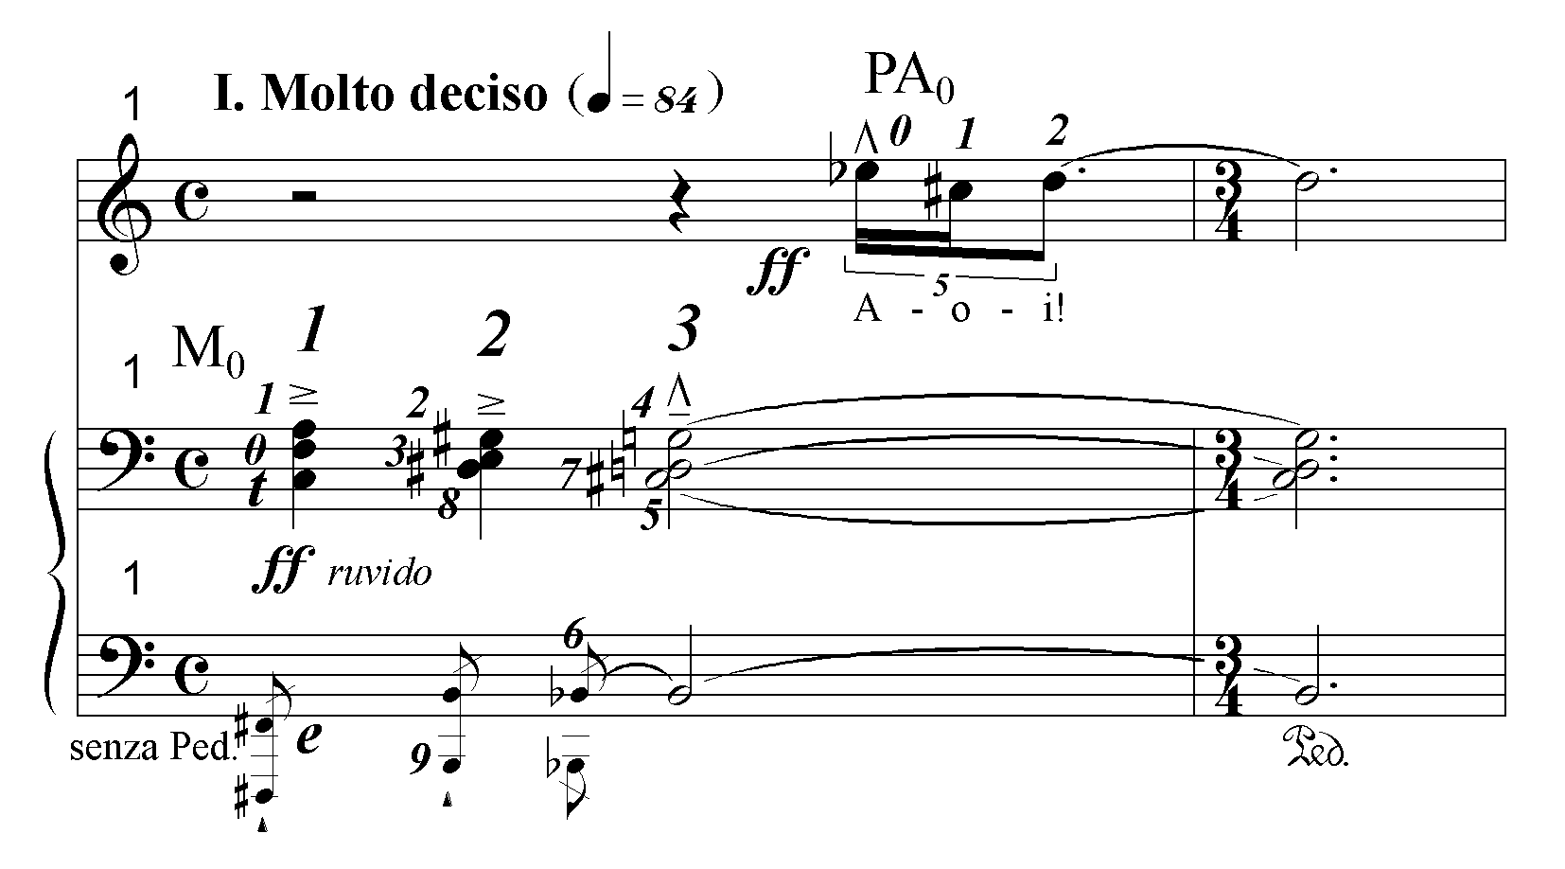Ex. 2.2 M₀

Example 2.3 below shows the row P₀ derived from M₀ in the register first presented by the vocal part in mm.6-11. The op numbers are shown above the pcs.
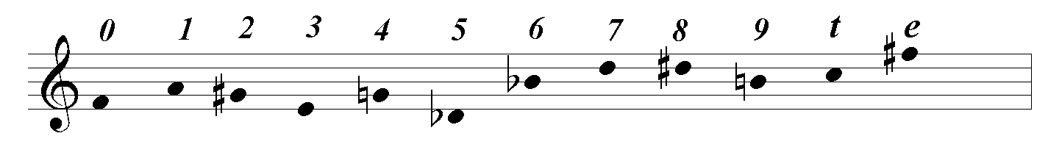
Ex. 2.3 P₀

The first tetrachord of P₀ corresponds to the soprano and alto voices of chords 1 and 2. The second tetrachord corresponds to chord 3, and the third tetrachord corresponds to the tenor and bass voices of chords 1 and 2. There is no necessity for future presentations of M to maintain that op configuration. That is the source of the difference between M and P; although P is initially derived from M, they go on to lead separate existences. In referring to row forms of M other than the prime form, the ‘M’ is retained to remind the reader of their special nature. For example, the retrograde of M is designated RM.
A little study reveals that the retrograde of M is its transposed inversion. Therefore, M produces only two row forms, M and RM. ‘IM’ will be heard as RM and RIM will be heard as M. In contrast, P produces all four distinct row forms. Yet, in the first movement, Dallapiccola deploys only the prime and retrograde of P, suggesting that he was thinking purely in terms of primes and their retrogrades for both P and M. The exclusive use of prime and retrograde forms is instrumental in the construction of this movement’s tonal analogue because, as was pointed out in the introduction, it is much easier to hear a prime and its retrograde with the same subscript, say P₀ and R₀, as projecting the same row level than it is to hear a prime and its inversion as doing so.
In addition to the transformationally-related P and M, there is a third, independent, secondary row, PA, which is completed by replicating a chromatic cell three times, beginning a minor third lower each time. Its forms are designated RA, IA and RIA.
(See the following page.)
Ex.2.4 PA₀
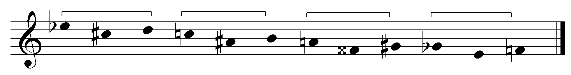
The first movement’s exposition is inscribed with its row levels in Ex. 2.5 and 2.6 on the pages 33 and 35. The ‘tonic’ row level is established by the presentation of the harmonic module, M₀, in mm.1-3 and its repetition in mm.4-5. Between those two presentations, the soprano sings the war cry, “Aoi”, to the first three pitches of PA_{0.} PA₀ is then completed in the upper register of the piano, replicating the “Aoi” motive three times. This is followed by a canon between P₀ in the voice and P_{e} in the piano, evoking the emperor riding toward France. The ‘tonic’ row level returns in the piano with RM₀, mm.10-11. Whereas the progression M sounds like a full cadence, RM has an open quality owing to the upward rather than downward stepwise motion between chords 2 and 3. Thus, RM₀ in m.10 is well suited to begin the short transition section to the contrasting row level RM_{4.}
Just as a classical transition section typically begins with a restatement of the tonic before cadencing on the dominant of the second key area, here the transition begins with RM₀ before cadencing on RM₄. The upward flourish of RM₄ into both the high piano and vocal registers depicts the raising of the French standard on the hilltop. The row level organization of the first row area and transition, mm.1-12, is diagrammed in Table 2.1 on page 34.

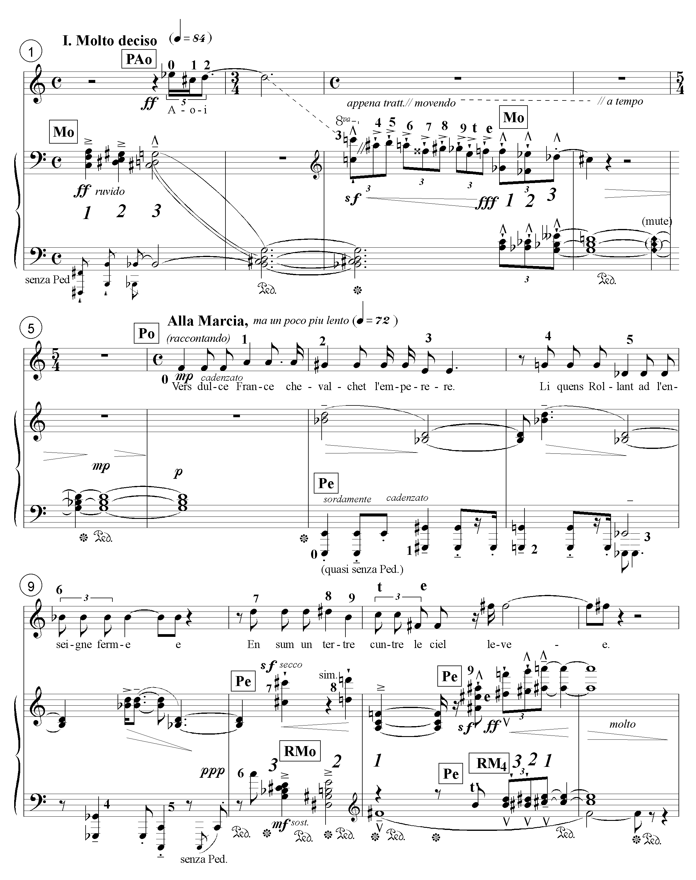
Ex. 2.5 Rencesvals I, Exposition: ‘first row area’ and transition

Table 2.1 Rencesvals I, first row area and transition: row levels

meas. | 1-2 | 3-5 | 6-9 | 10-11 | 11-12
section | First Row Area |  |  | Transition
voice | PA₀ ₁₋₃ |  | P₀
pno rh | M₀ | PA_{0 4-e} |  | Pe _{7-e} | RM₄
pno lh | M₀ | M₀ | Pe ₀₋₅ | Pe₆ RM₀ | RM₄

The identification of mm.1-9 as the ‘first row area’ is supported by the association between the G minor triads in mm.4-5 and m.8.The first of these triads occurs when the C# of chord 3 of M₀ drops out, leaving the G-Bb-D sounding. This creates an initial impression that chord 3 (Bb, C#, D, G) in mm.1-3 is really an altered form of G minor. Zeroing in on D, the ‘Aoi’ motive in m.1 enhances this perception. Because the Bb-D is carried over in the piano right hand, another G minor triad is formed in m.8 when op4 of P₀ in the voice and op3 of Pe in the piano, both G’s, are sounded together. Equally implicated in creating the G minor triad, the row forms M_{0,} P₀ and P_{e} tend to be heard as belonging to the same formal unit. Thus, the tonal allusions support the tonal analogue.
Measures 13-16 (shown on the following page) also support the tonal analogue, although not in quite so straightforward a manner. Here the idea of second theme area is implemented literally. The secondary row, PA, introduced in a subsidiary role in mm.1-3, becomes the primary source of material. In contrast, the soprano’s presentation of P₅ is truncated. The roles of the rows are therefore reversed. In the first row area M and P are the primary rows while PA is decorative, whereas in the second row area, PA is primary while M is absent and P is vestigial. The textural saturation of chromatically ascending and descending lines of PA depicts the French host encamping all over the country.
Ex. 2.6 Rencesvals I: ‘second row area’
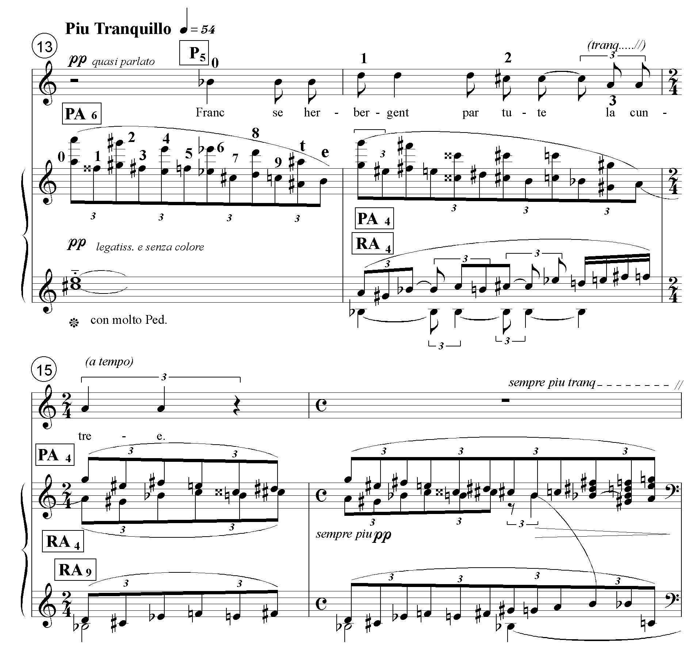
Owing to its exclusively linear presentation and serpentine chromatic character, PA does not have a well-defined harmonic profile. Neither do the simultaneities produced by the canonic texture. As a result, these measures are heard as a harmonic extension of the cadential harmony (F#-C#-E-A#-A) at the end of the transition section in m.12.
In m.13, the C#-E-A on the downbeat and the Bb in the voice are retained elements of the cadential harmony in the previous measure. The F#⁺⁶ chord in m. 15 (last triplet eighth) and m.16 (sixth triplet eighth) sounds like the harmony of greatest stability. Again, this perception is enhanced by the way the first three pitches in the right hand of mm.14-16 zero in on F#. Thus, the tonal analogue of a second row area (PA) in mm. 13-16 is supported by the tonal allusions that link it to RM₄ at the end of the transition, mm.11-12. The forms of PA in mm.13-16 are heard as extensions of RM₄. The row level organization of the entire exposition, mm.1-16, is diagrammed in the table below.
Table 2.2 Rencesvals I, exposition: row levels

meas. | 1-2 | 3-5 | 6-9 | 10-11 | 11-12
section | First Row Area |  |  | Transition
voice | PA₀ ₁₋₃ |  | P₀
pno rh | M₀ | PA_{0 4-e} |  | Pe _{7-e} | RM₄
pno lh | M₀ | M₀ | Pe ₀₋₅ | Pe₆ RM₀ | RM₄

meas. | 13 | 14 | 15 | 16
section | Second Row Area
voice | P₅ ₀₋₃
pno rh | PA₆ | PA₄ | PA₄ ₀₋₅ RA_{4 e-6} | PA₄ RA₄
pno lh |  | RA₄ | RA_{9 e-6} | RA₉

There is another bit of evidence that suggests that Dallapiccola intended to construct a structural gradient between row levels zero and four. It has already been shown that M moves from level zero to level four between mm.1-11. It must be more than coincidence that, if one includes the incomplete statements, six out of nine presentations of PA in the second row area (mm.13-16) are also at level four. However, without the tonal allusion that brings PA₄ into the ambit of RM₄, this would have been no more than a ‘plan on paper’ owing to the very different natures of the two rows.
Example 2.7 is one reading of the linear structure of the exposition and, after the barline, the beginning of the development. Take note of the voice leading structure of the module M in m.1, F#-A, B-G#, Bb-G. It will be expanded to the level of the entire movement and also appear in other short and mid-range contexts. (Recall that beams and slurs are associational, not prolongational.)
Ex. 2.7 Rencesvals I: exposition, linear structure
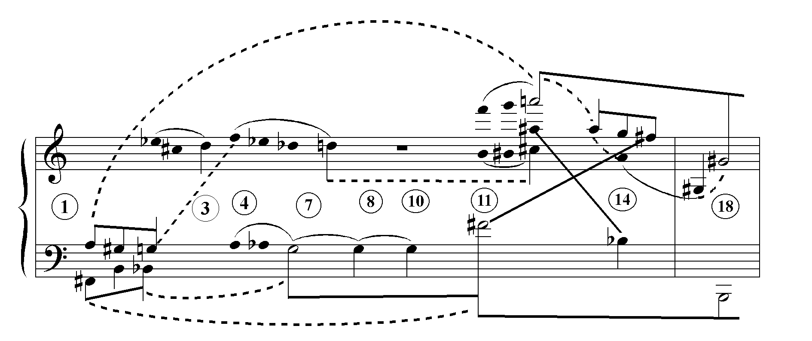
The motion G-F# is the foundation of mm.1-16. In m.1, Chords 1 and 2 of M₀ are heard as upbeats to chord 3. However, the G in m.3-4 is given a higher ranking than the Bb in m.1 because the unveiled pure G minor triad in m.4 emphasizes the G.
The G triad is reiterated in m.8 with octaves between the piano and soprano. Then in m.10, the G returns in the bass of Chord 3. F# is clearly the most important bass note of m.11-12 as a result of its duration, vocal-piano doubling and tonal allusiveness. In Wilson’s model, these pitches are initiating and goal tones.
The high A in mm.11-12 is important because it is the last tone in the highest voice. The most important tones in first row area reading up from the bass are G-D; the cadence at the end of the transition is represented by the vertical F#-C#-A. (The reader is cautioned that this does not mean that the first row area prolongs a G minor triad. The graph is purely linear; the harmonies cannot be assimilated to a tonal context.)
Dotted lines in the detailed graph on top show that the F#-A of the last chord recalls the F#-A of the first chord. Up until m.11, the F# is subsidiary to the G. At that point, the listener becomes aware that the F# brackets the exposition. The reversal of chord order in RM₀ in mm.10-11, which cadences on chord 1 creates an association between M₀ in m.1 and RM₀ in mm.10-11 in which chord 1 (with its F#), as the first chord of M₀ and the last chord of RM₀, becomes the most important chord, participating as it does in a departure and return. Heard this way, the first row area and transition project the first element (F#-A) of the modular frame of M_{0,} (F#-A), (B-G#), (Bb-G), which will become the longest- range associative structure of the first movement.
The high A is the overriding upper tone of the second row area beginning m.13, an interpretation consistent with hearing that area as an extension of the cadential harmony at the end of the transition in m.12. It makes sense if one identifies the G# as the most important upper voice in the development section beginning in m.17, as it begins and ends the section in the upper voice of the piano part. (See discussion on pp. 43-44.) The A is heard moving down an octave into an inner voice in mm. 14-16 and connecting to the G# a minor ninth below in m.17. The A-G-F# of mm.13-16 are therefore subservient to the A-G# motion, m.12-m.17. The voice ending on the A in mm. 14-15 supports this interpretation. (See Ex. 2.6, p.35) The Bb-F# in m.14 are interpreted as associated to the F#-A# of mm.11-12, thus supporting the idea that the ‘second row area’ shares F# as its most important tone.
In the development, the piano accompaniment explores other row levels with a much higher rate of turnover just as a classical development intensifies the opposition of the second key area by moving through more remote keys at a faster rate of harmonic change. Whereas in the exposition, the ‘tonic’ row level (either M₀, P₀ or RM₀) is present for the first 10½ measures and the contrasting row level, 4, dominates the next 5½ measures, the first phrase of the development, M_{e,} M_{3,} RM_{7,} cycles through interval 4, in a manner analogous to a sonata form development that cycles through major third related keys.
The text of the exposition narrates the actions of the French whereas the development is exclusively devoted to the invasion and armament of the pagans. Thus, the French are associated with row level stability, the pagans with instability.

Ex. 2.8 Rencesvals I: development, row levels
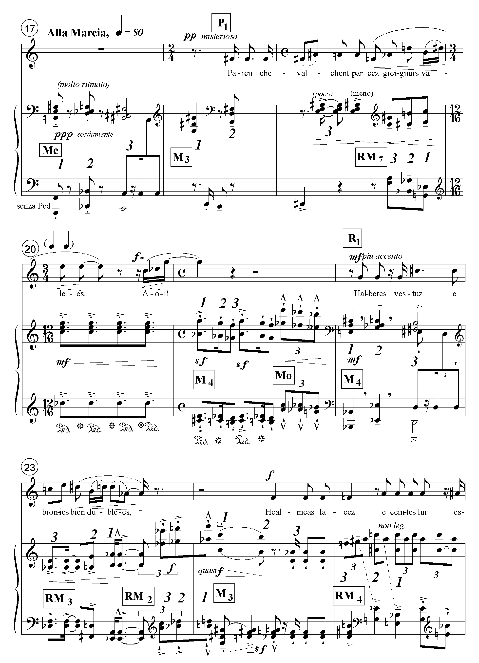
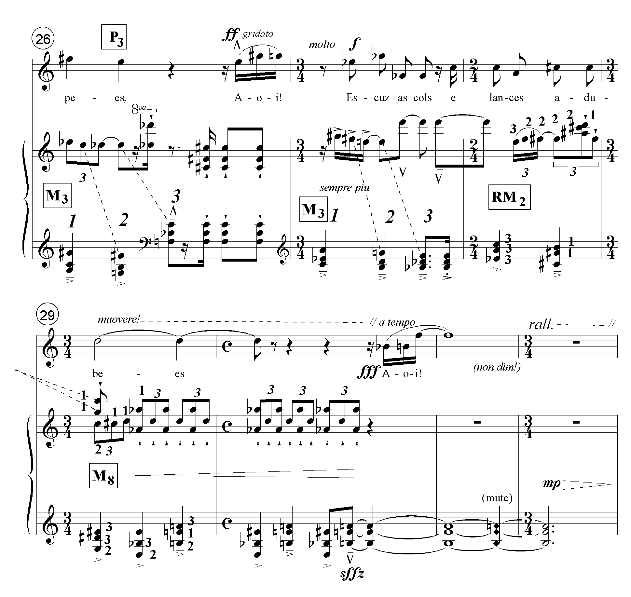
Ex. 2.8 continued

Table 2.3 Row level succession in Rencesvals: development

meas. | 17-21  21 | 22-25  24-25 | 26-32  29-32
voice | P₁ | R₁ | P₃
piano | M_{e} M₃ M₇ M₄ M₀  M₄ M₀ | M₄ RM₃ RM₂ M₃ RM₄  M₃ RM₄ | M₃ M₃ RM₂ M₈  M₈

The table above shows that the modules in the piano accompaniment are grouped into three sections. (See also the row levels inscribed on the score of the development on pp.40-41) The accompaniment at the beginning of the first section is transposed up a fourth at the beginning of the second section, which begins and ends with the same row level. The third section begins with a repetition of M₃ and ends with the same rocking triplet figure that ends section 2. The registral outline of each of the first two sections, mm.17-21 and mm.22-25, starts low and ends high, summarizing the similar but longer, and therefore less precipitous registral outline of mm. 1-13. The last section rests on a plateau. The precipitous registral changes in the beginning of the development evoke the shock of the invasion. Thus, in addition to the tonal analogue the treatment of register contributes to the unstable nature of the development. On a more local level, the change in rhythm in m. 21 depicts the changing speeds of the invading horsemen. (The numbers 1, 2, or 3 adjacent to pitches in the piano part in mm. 28-29 refer to the chord number of the module to which they belong. Here, the chords of the module have been partially linearized, creating new configurations inexplicable in terms of P.)
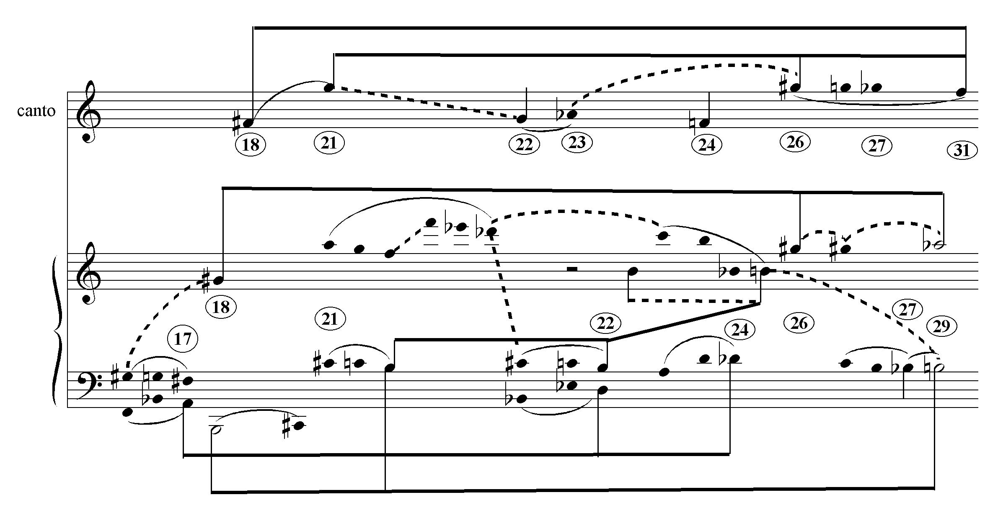
Ex. 2.9 Rencesvals I: development, linear analysis
There are three parallel structures in the linear graph, Ex.2.9 above: the F#-F motion in the canto (mm.18-31), the B-G# linear skeleton that expands the second element of M₀ over the entire course of the development, and the A-F#; D-B; Db-Bb linear skeleton that expands M at the mid-range level (mm. 17, 22 and 24).
In Ex. 2.10 below, the latter two structures are abstracted from Ex. 2.9. Referring to the upper graph, ‘B’ is the most important bass note of the development because with the possible exception of the C#, it appears in the bass register more often than any other pitch; it is the last bass note of the section; it is also emphasized in the inner voices by means of a stepwise descent (mm.21-22 and mm.21-25) and the chordal identity between the B-D-Gb-F in m.21 and the D-E#-F#-B of m.22 and m.25.
Ex. 2.10 Rencesvals I: development, modular elements
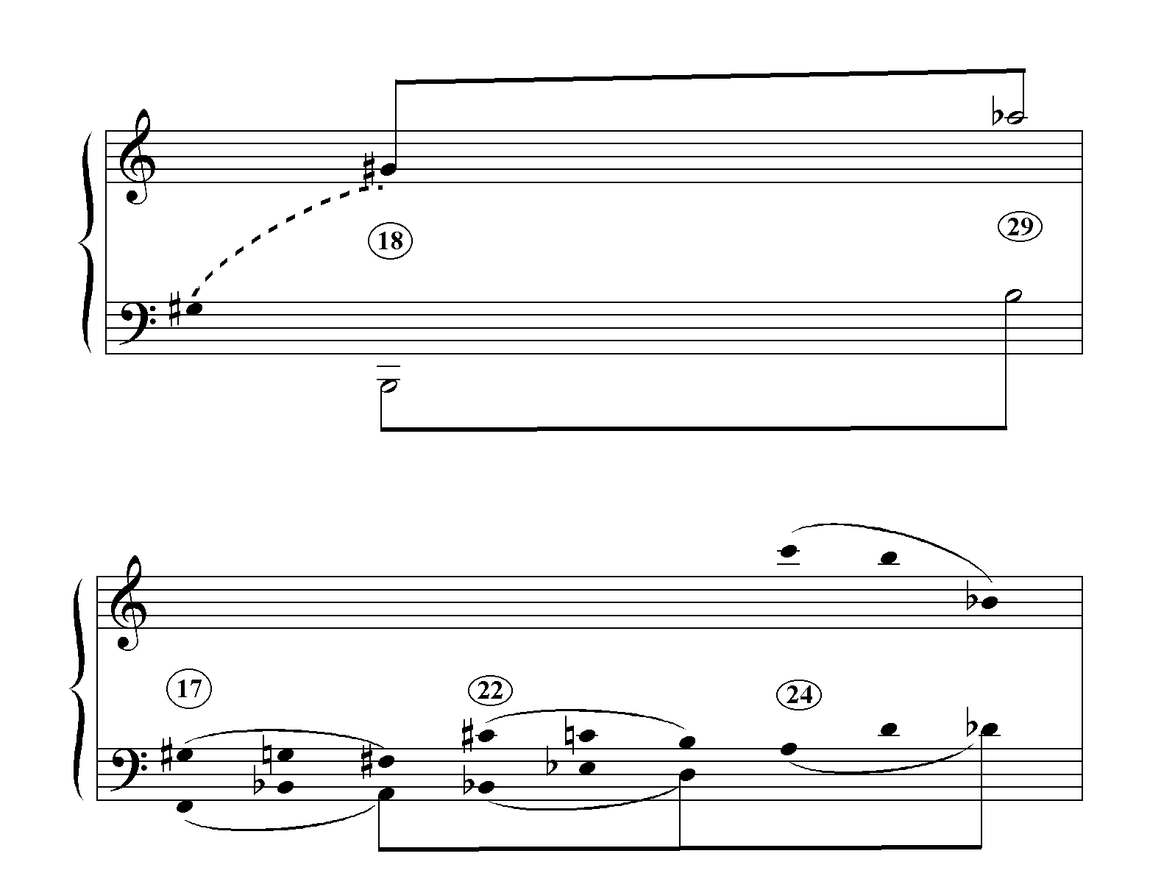

The case for the G# (Ab) as the most important pc in the upper voice is more tenuous, but still plausible. It is the first and last pc of the piano’s top voice and the highest note in the vocal part (m. 26). The held F in the vocal part (m.31) is assuredly more important than its G# in m. 26 as it is the goal of a linear descent. (See Ex. 2.9, canto.) Nevertheless, to my ear, the high Ab of the piano in mm.29-30 is still pre-eminent at that point. The primacy of B-G# is enhanced by its departure and return (m.18 - m.29).
In the case of the mid-range structure shown in the lower of the two graphs, the module is transposed through the interval succession of the module’s bass line, creating the higher order module, A-F#; D-B; Db-Bb. Although the development contains many other modules, these three are the only ones that preserve the voice-leading skeleton of the opening module in m.1. Each of them initiates a vocal entrance (mm. 18, 22 and 24).
The upper and lower graphs of Ex. 2.10 exhibit structural multiplicity. There are good reasons for hearing both the B-G# and the A-D-Db, yet they cannot be organized into one hierarchy.
In the classical sonata, the recapitulation resolves the tension posited by the exposition’s contrasting second key by presenting the material of the second key area in the tonic. If one considers that sonata form is largely a drama of keys, then the recapitulation of Rencesvals performs the same function. This is evident in Ex. 2.114 .
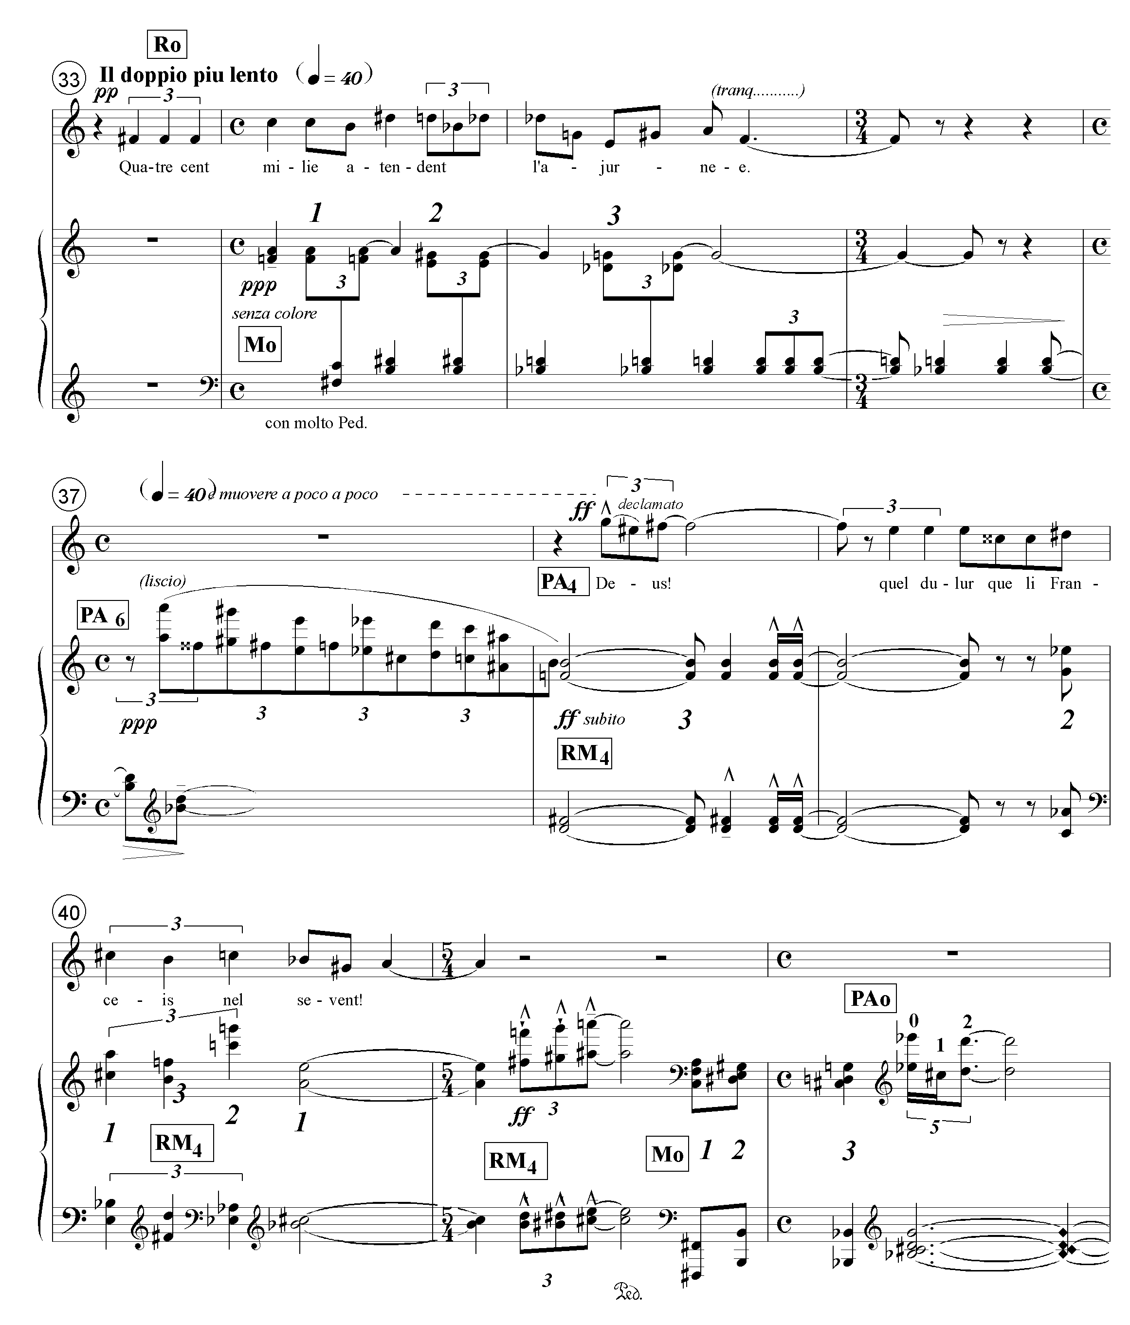
Ex. 2.11 Rencesvals I: recapitulation

The ‘tonic’ level of the first row area returns in m.33. After this, however, Dallapiccola introduces a new formal idea. He reminds the listener of the second row level in mm.37-41 before resolving it to the ‘tonic’ level at the end of the movement, mm.41-45.5 Note that the row levels that appear in the return are the ones that have already appeared in the exposition. M is presented at level 4 and PA is presented at levels 6 and 4 before they are both taken down to level 0. The ‘tonic’ level of PA is implied by its first three pcs in m.42. The final presentation of M₀ and PA₀ in mm. 41-2 appears in the same register as the opening presentation in m. 1.
Table 2.4 Rencesvals I: recapitulation, row levels

meas. | 33-37  34-36  37 |  |  | 38-45  41  42-45
section | 1st row area |  |  | 2nd row area
voice | R₀→ |  |  | PA₄→
piano |  | M₀ | PA₆ | RM₄ | RM₄ M₀ | PA₀ ₀₋₂ / M₀

The pagans waiting for the dawn (mm.34-36), sung to R₀, can be considered the reverse of Charlemagne riding toward France (mm. 6-7), sung to P_{0.} (Pagans are the opposite of Charlemagne, and waiting is the opposite of riding.) The French ignorance of the next day’s disaster is differentiated from the pagan vigil by the use of the secondary row PA (mm.38-41). With the exception of mm. 41-42, the return exhibits fewer extreme changes of register than either the exposition or the development, as befits its more stable function.

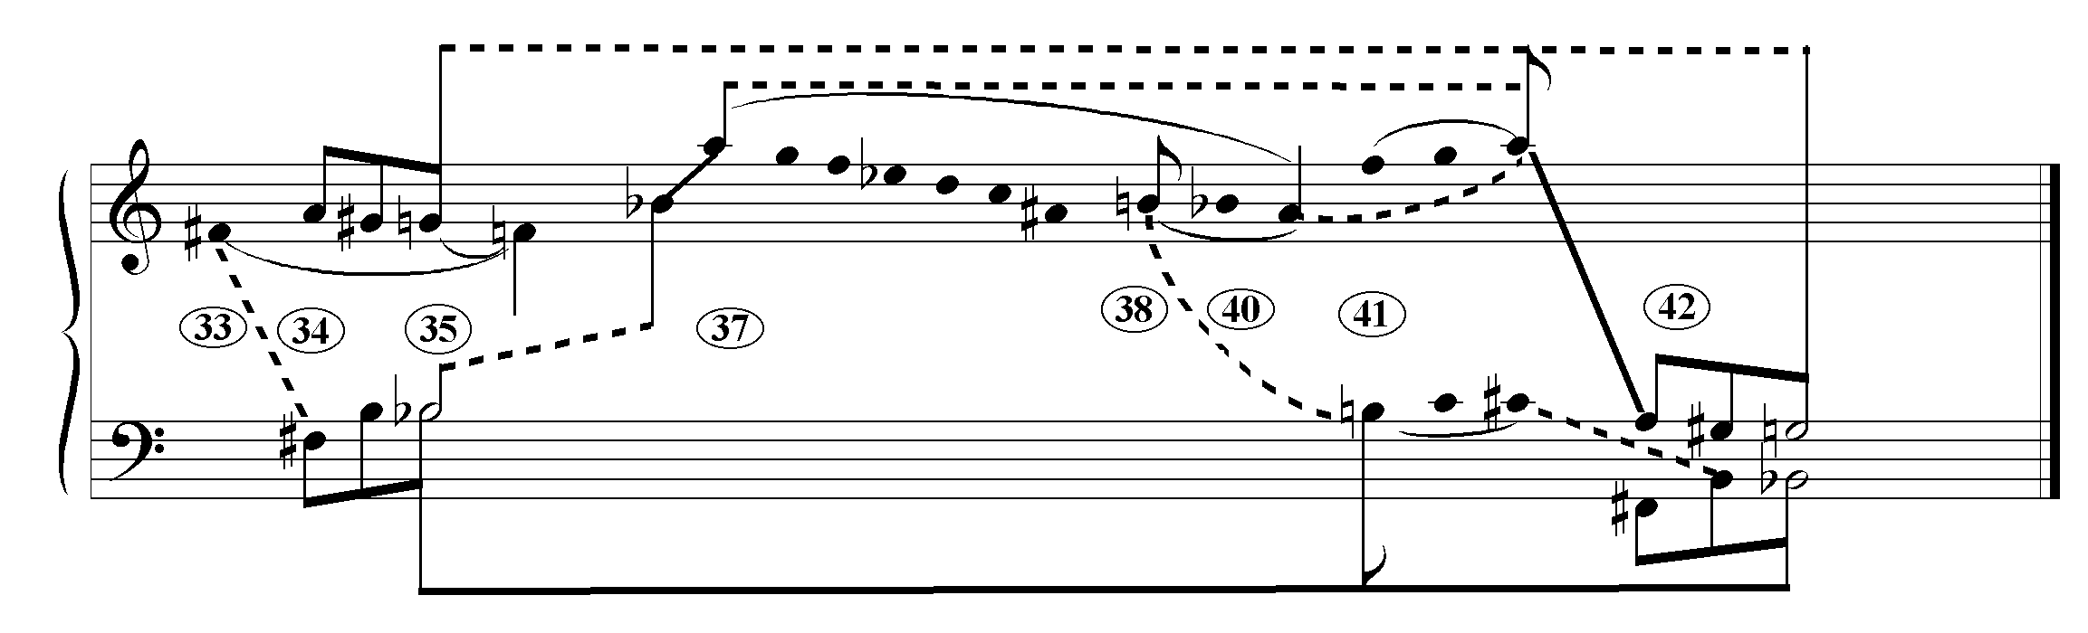
Ex. 2.12 Rencesvals I: recapitulation, linear graph

Bb is clearly the most important bass tone for the following reasons: the first and last cadences of the recapitulation land on chords built on Bb in the lowest voice; the tonal allusion to a Bb⁺⁶ chord in m. 36 and a Bb triad in m.37 reinforce the salience of the Bb; Bb is the bass note for seven out of the thirteen measures of the recapitulation. The neighbor note motion in the bass (Bb- B- Bb, in mm. 35, 41 and 42) further strengthens the Bb.
G is the most important pitch of the top voice because the last cadence lands on G after a directed descent from A. The graph shows how this A of the A-G#-G progression of m.34 is expanded across mm.37-42 where it is finally taken back down to the G. The B in m.41 (as shown below) also participates in a mid-range expansion of the modular bass line, F#-B-Bb.
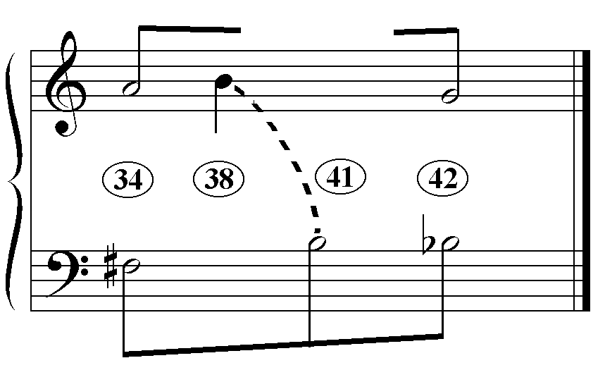Ex. 2.13 the modular bass line as the linear skeleton of the recapitulation.

The strong arrival on D-F-F#-B in m.38 is linked to its inversion B-D-F#-F in m.41.
With the arrival on the vertical Bb-G in m.42, the return completes the associative linear skeleton, (F#-A, B-G#, Bb-G), each element of which corresponds to one of the three major sections of the sonata form.
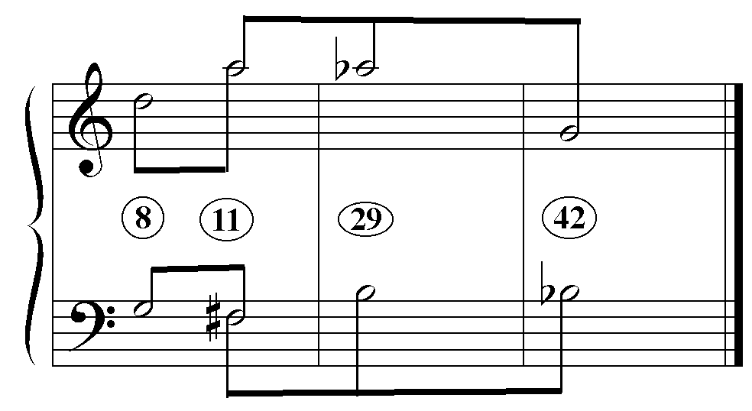Ex. 2.14 Rencesvals I: linear graph of the expanded module

The (F#-A, B-G#, Bb-G) skeleton operates on four different levels:
- as a chord progression (see m.1)
- across mm.17-24, transposed up a minor third
- as a linear structure spanning the entire recapitulation and
- as a linear structure spanning the whole first movement.
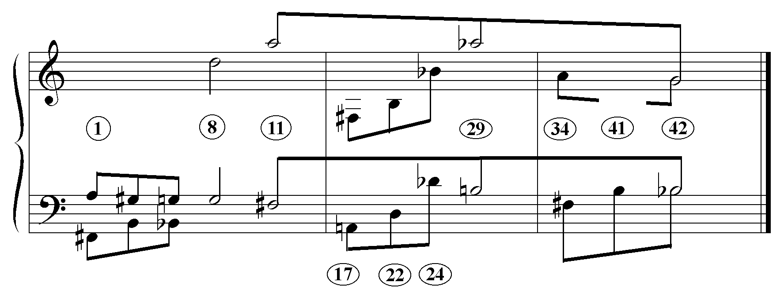
Ex. 2.15 Rencesvals I: the modular skeleton on different levels

Note that the striking root- position G minor triads of the exposition (mm.5 and 8) are not part of the modular skeleton. There is an irreconcilable conflict between hearing mm.1-16 as a sonata form exposition that moves from G-D to F#-A, and hearing it as the first element of the expanded module, M₀, in which case it departs from, and returns to F#-A. If one accepts my argument on page 38 about the reinterpretation of the G and F# over the course of mm.1-12, then one will hear F# as the exposition’s pre-eminent pitch.
As a result, the modular skeleton projects a simple three-part form while the row- levels create a sonata form analogue (as can be observed in Table 2.5 below). This decoupling of the harmonic and linear structure is found elsewhere in Dallapiccola’s music, and may be a characteristic of post-tonal music.6
Table 2.5 Rencesvals I: row levels
exposition
meas. | 1-2 | 3-5 | 6-9 | 10-11 | 11-12
section | First Row Area |  |  | Transition
voice | PA₀ ₁₋₃ |  | P₀
pno rh | M₀ | PA_{0 4-e} |  | Pe _{7-e} | RM₄
pno lh | M₀ | M₀ | Pe ₀₋₅ | Pe₆ RM₀ | RM₄

meas. | 13 | 14 | 15 | 16
section | Second Row Area
voice | P₅ ₀₋₃
pno rh | PA₆ | PA₄ | PA₄ ₀₋₅ RA_{4 e-6} | PA₄ RA₄
pno lh |  | RA₄ | RA_{9 e-6} | RA₉

development
meas. | 17-21  21 | 22-25  24-25 | 26-32  29-32
voice | P₁ | R₁ | P₃
piano | M_{e} M₃ M₇ M₄ M₀  M₄ M₀ | M₄ RM₃ RM₂ M₃ RM₄  M₃ RM₄ | M₃ M₃ RM₂ M₈  M₈

return
meas. | 33-37  34-36  37 |  |  | 38-45  41  42-45
section | 1st row area |  |  | 2nd row area
voice | R₀ |  |  | PA₄
piano |  | M₀ | PA₆ | RM₄ | RM₄ M₀ | PA₀ ₀₋₂ / M₀

Table 2.5 summarizes the row-level activity of the first movement. The exposition moves from the ‘tonic’ row level to row level 4, the development moves through various row levels, and the return moves from the tonic row level to level 4 and finishes on the tonic row level.

After the rather detailed account of the first movement, the following two movements will be analyzed more summarily.

Rencesvals II
One of the ways that Dallapiccola differentiates the dream state of the middle movement from the real action in the rest of the piece is to employ PB, a row unrelated to the rows of the of the outer movements. (Note that the row is divided between two octatonic collections that share op5, a procedure that is fairly common in Dallapiccola’s row construction in the 40’s and early 50’s.)

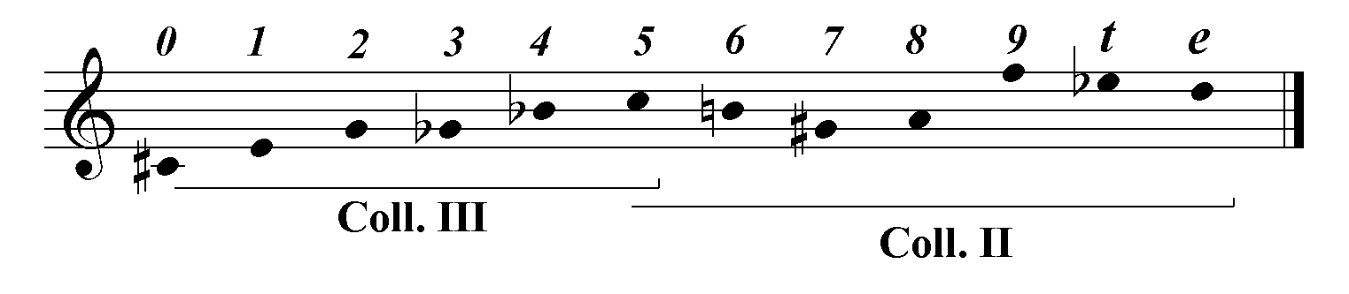 Ex. 2.16 Rencesvals II: PB₀

The movement’s arch form, A B C B′ A′, is perhaps inspired by the reference to Charlemagne sleeping that appears at the beginning and end of the stanza. The sense
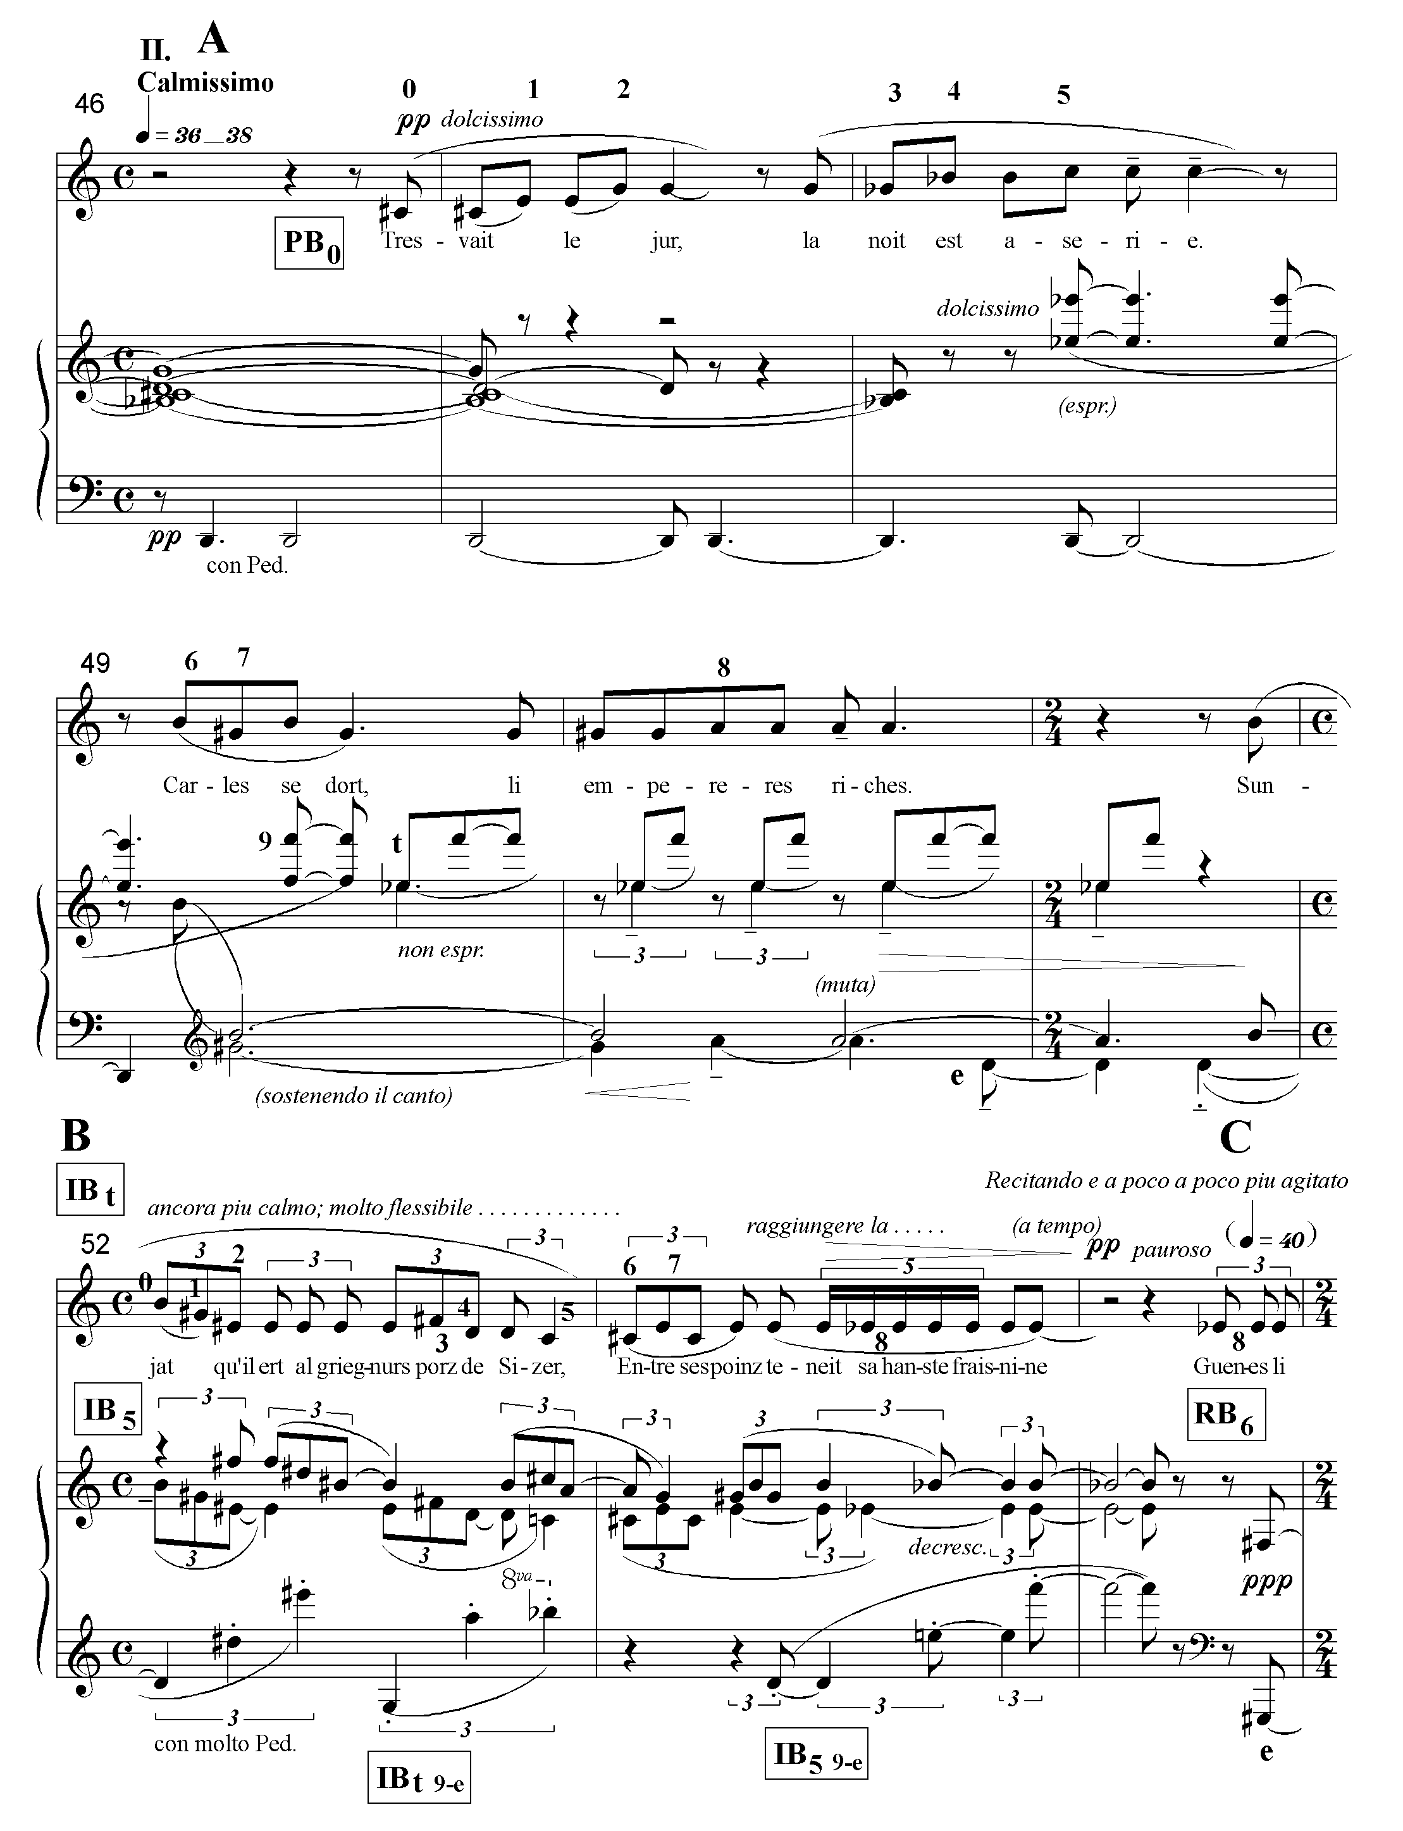Ex. 2.17 Rencesvals II, sections A and B: row levels
of drifting off to sleep is evoked by the long chord that is held over from the first movement into the second as well as the rhythmic decelerando in section A. In mm.46-49, the repeated low D’s become progressively longer, increasing in value by one eighth with each new attack while the notes of the held chord, Bb-C#-D-G are released one by one. (See Ex. 2.17 on the previous page.)
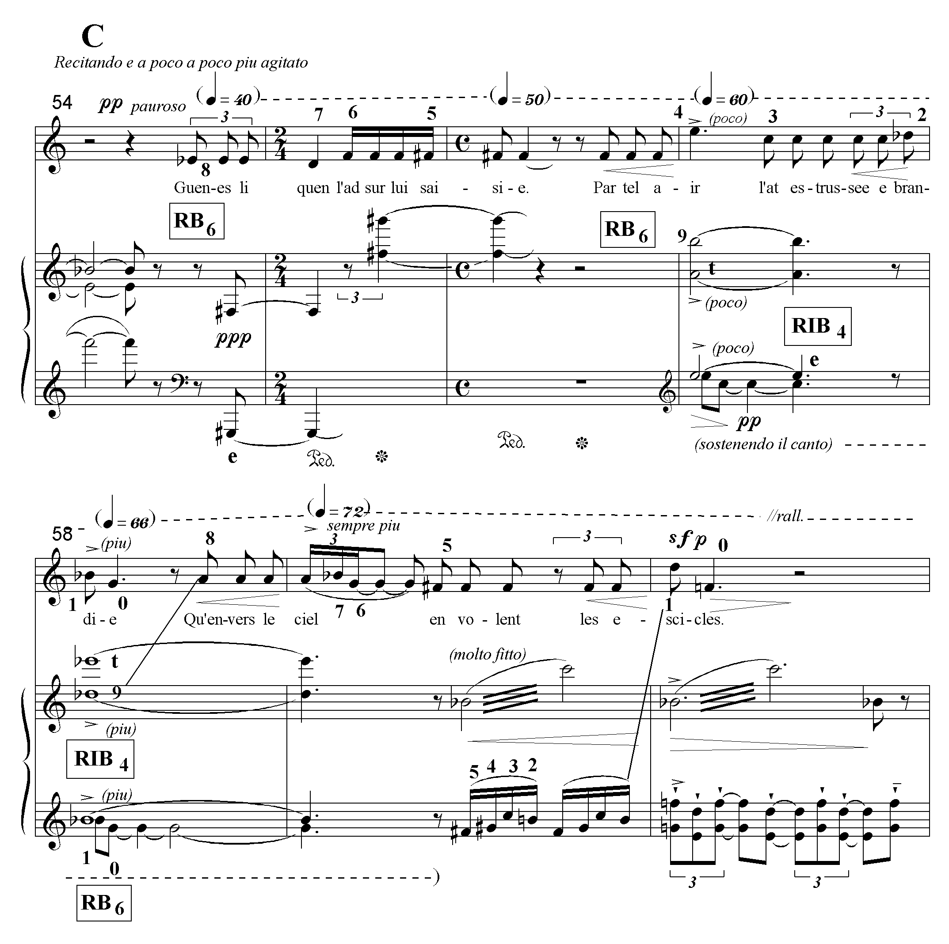Ex. 2.18 Rencesvals II, section C: row levels

Each of the first four sections, A, B, C and B′, is distinguished by a different twelve-tone texture and restricted to either prime, inverted, or retrograde and retrograde inverted forms of the row. In Section A, a linear presentation of one row form, PB₀, is split between voice and piano. Section B is a canon between two row forms, IB_{t} and IB₅. In section C, the soprano and piano split R₆ and RI₄, which follows R₆ with some overlap. Section B′ is a transposition of section B. (Since this section is textless, one concludes that, in this instance, the musical design is independent of the poem- unless one interprets section B′ as Charlemagne’s unstated desire to reconstitute the spear.) 7 Finally, section A′ is a transposition of section A with elements of sections B and C added. The last section presents various transpositions of PB, IB and RB, at first concurrently, and then consecutively. The row presentations become more chordal, with a return to linearity in the last three measures. Section A′, therefore, constitutes the textural culmination of the movement.
The shattering of the spear in section C is expressed by the textural discontinuity of the piano accompaniment. The explosive action of these verses is evoked by the increasing agitation of the tempo (quarter note = 40→72) while the dynamic level remains pianissimo throughout, suggesting that the action is not real.
Although the movement briefly hints at an ending on the ‘tonic’ row level with RB₀ in m.66, there is no tonal analogue; the material in sections A and B returns in sections B′ and A′ at different transpositional levels. The absence of the original row levels at the end of the arch form projects an unbalanced symmetry that expresses the fluid nature of the dream.
Table. 2.6 Rencesvals II: row levels

section | A | B | C | B′ | A′
meas. | 46-51 | 52-54 | 55 57 58-60 | 61-62 | 63 64 66 67-70
voice | PB₀ | IB_{t} | RB₆ RIB₄ |  | PB₈→
piano | PB₀ | IB_{t}/IB₅ | RB₆ RIB₄ | IB₁/IB₈ | IB₂ PB₄ RB₀ PB₈

Because D is the held bass tone of section A (see mm.46-51), by ending the movement with PB₈ rather than PB₀, Dallapiccola is able to finish with the held bass tone Bb. As Ex. 2.19 demonstrates, this permits section A′ (see mm.63-69 in the score) to be heard as a linear echo of the bass Bb at the end of the first movement.
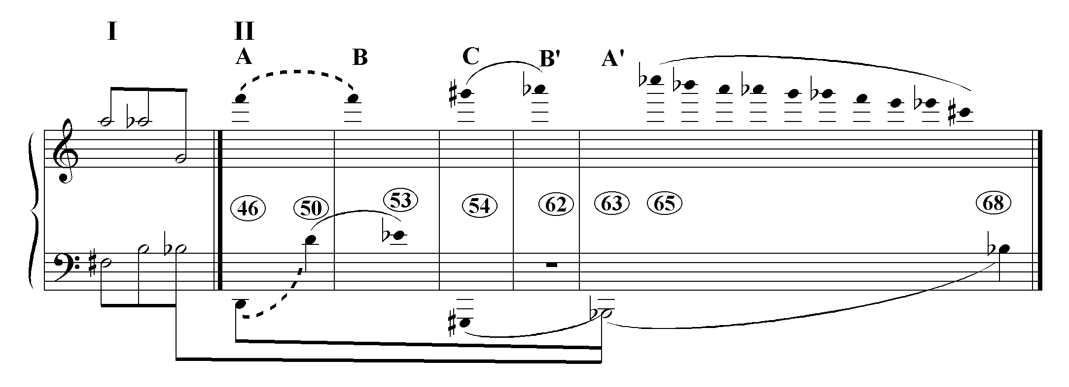Ex. 2.19 linear graph of Rencesvals II in relation to Rencesvals I

Rencesvals III
The piano accompaniment in the third movement returns to the texture of three-chord modules typical of the first movement. Example 2.20 demonstrates the close relationship between the modules MA and MB of the third movement and M of the first movement. If C and C# are exchanged MA₀ is transformed into MB₀ and vice versa. If chords two and three are reversed and the E and Eb exchanged, MB₀ is transformed into M₅ and vice versa. MA and MB are in the closest relationship, followed by MB and M. MA and M (two pc exchanges and a chord reversal) are the furthest removed.
Ex. 2.20 Rencesvals: modules
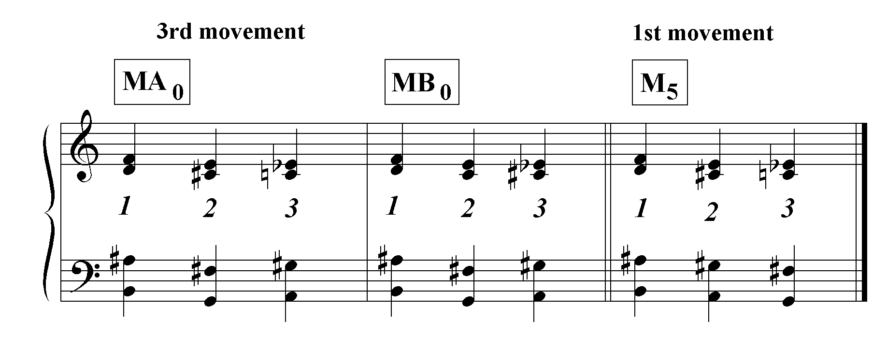
Dallapiccola achieves a motivic connection to the first movement row, PA, by spacing the modules MA₀ and MB₀ so that the bass notes form the motive B-G-A
(-4 semitones + 2 semitones). (See Ex. 2.21 on the next page, m.70.) This motive is an intervallic expansion of the chromatic neighbor note motif Eb-C#-D that appears in m.1 as the first three pcs of PA₀.
Even though Dallapiccola uses similar modular material in the first and third movements, he imbues them with characteristics appropriate to their respective stanzas, by means of rhythm and register. The deep valleys of the third movement are suggested by the registral chasms that open up between MB₀ and RMB₁ in mm.75-80 (see Ex.2.21), and MB₁ and RMB₂ in mm.88-93. To convey the solidity of the mountains, each chord takes on the value of a whole note. There is very little that
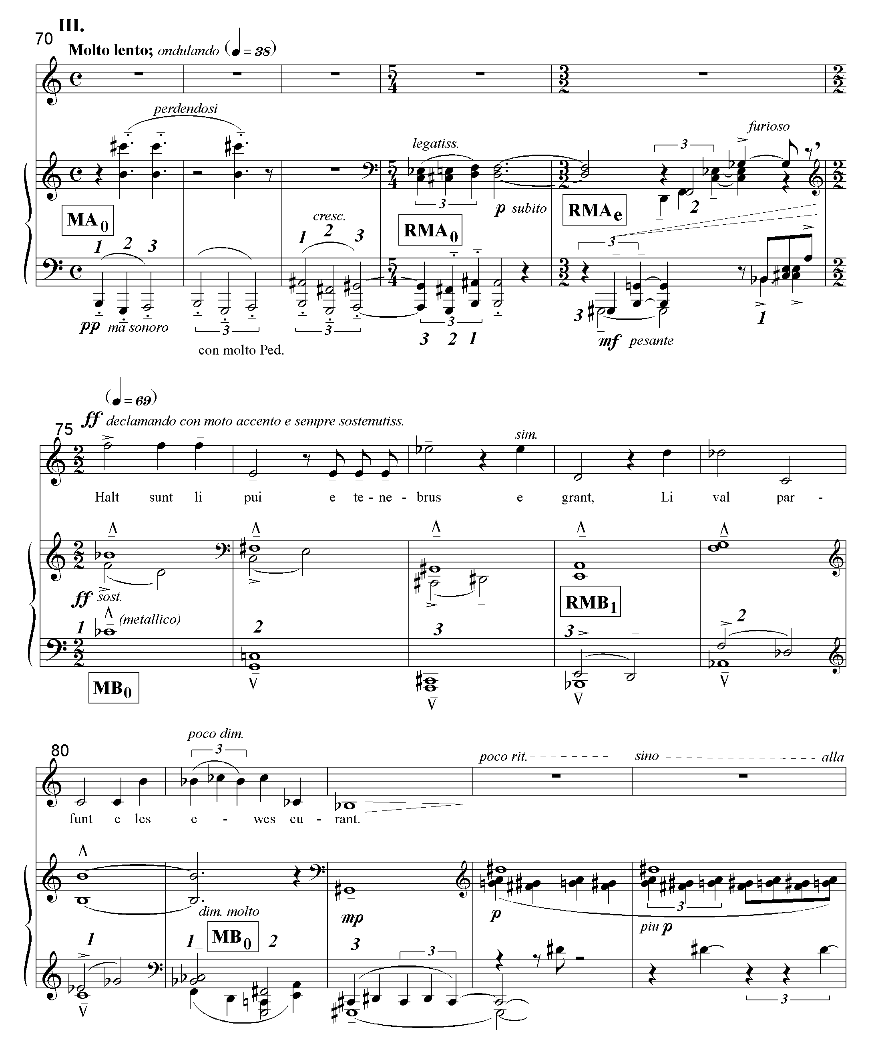Ex. 2.21 Rencesvals III, mm.70-84: row levels

could be construed as a melodic line in the accompaniment; it is monolithically chordal. Nor is there an independent linear presentation of row material in the voice. Its jagged line, outlining peaks and valleys, is extracted from the piano harmonies.
As demonstrated in Ex. 2.20, MA and MB are similar enough so that their row levels can be considered equivalent. Table 2.7 illustrates the row level structure of the third movement.
Table 2.7 Rencesvals III: row levels

section | A
texture | pno. solo | pno. & sopr.
meas. | 70-74 | 75-84
level | MA₀ MA₀ RMA₀ RMA_{e} | MB₀ RMB₁ MB₀

section | A′
texture | pno. solo | pno. & sopr.
meas. | 85-87 | 88-97 | 98-100
level | MA₄ RMA₃ MA₃ MA₁ RMA_{t} | MB₁ RMB₂ MB₁ | MA_{e}

section | Coda
texture | pno. solo  .
meas. | 101-102 | 103-104 | 105-110
level | MA₅ RMA₄ MA₄ MA₂ | MA₁ RMA₂ MA₂ MA₀ | MA_{e}

Section A establishes a ‘tonic’ row level. MA₀ first appears in incomplete forms, as the bass line of the three-chord progression only (mm.70-71), and then as the bass and tenor voices only (m.73); the first complete module at the ‘tonic’ level is RMA₀. In mm.75-84, the ‘tonic’ level, MB_{0,} brackets MB₁. (The major ninth, B-C#, in m.70 is held over from the second movement similar to the way the chord Bb-C#-D-G is held over from the first movement into the second.) However, as in the second movement, the return to the tonic level (m.103) is only a feint before the conclusion on the ‘e’ level, MA_{e}. The long-range motion MA₀→ MA_{e} is prefigured in the opening piano solo, MA₀→ RMA_{e} (mm.70-74). This long-range motion is recapitulated at the end of the coda, MA₀→ MA_{e} (mm.104-105). The global linear motion of the entire piece, Bb-G#, is also recapitulated between measures 103 and 105. See Ex. 2.22 and the linear graph that follows on p.60, Ex. 2.23.
Ex. 2.22 Rencesvals III, mm. 103-110: row levels

Example 2.23 shows that the A-G# first appears 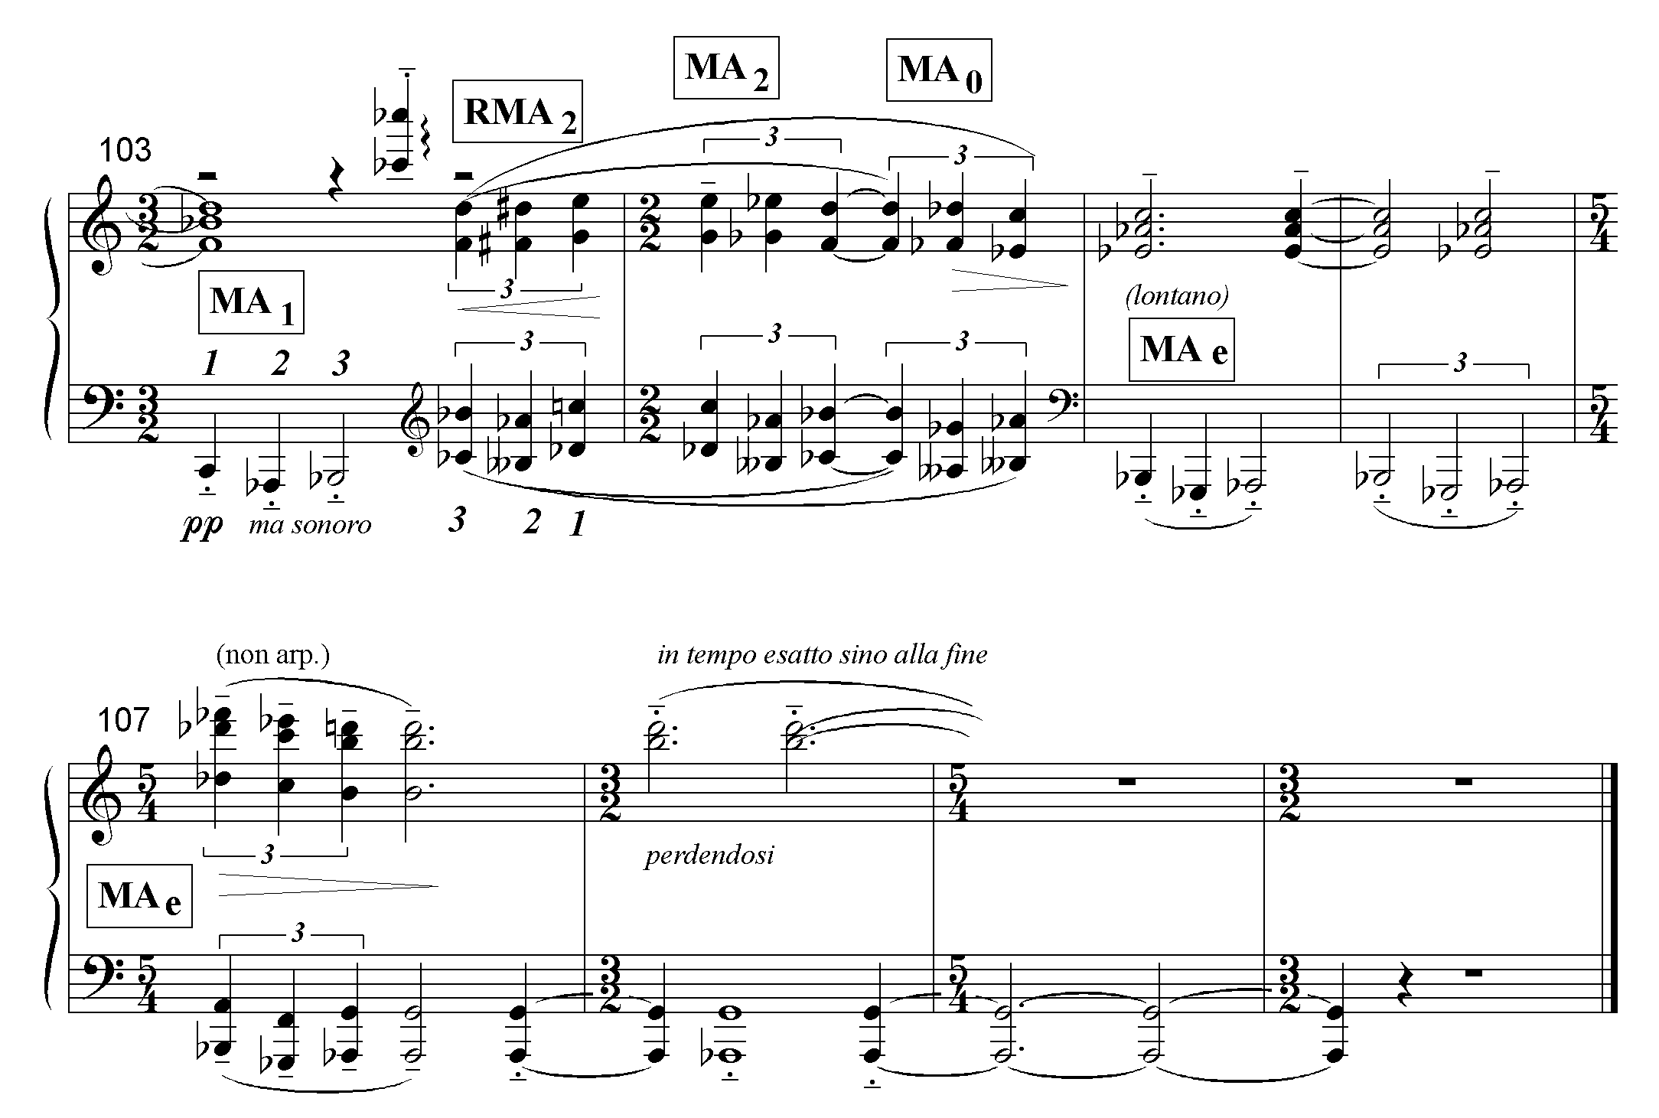in the opening piano solo (mm.70-74) where the G# is heard as auxiliary to the A. However, the two replications of the structural A-G# motion, and the final Bb-Ab that follow (mm.77-82, 95-100 and 103-05) make it clear that G# (Ab) is the goal tone. Example 2.24 demonstrates the global motion of the entire piece. Thus, although it very difficult to trace a tonal analogue through all three movements owing to the different rows used in each movement, there is a linear thread running throughout the piece. Like a great sigh, the whole-tone long-range descent expresses the poem’s sense of impending doom.

Click here to view Ex. 2.23 and Ex. 2.24

Owen, The Song, pp.13-14.
 reconstruction suggested by Dallapiccola’s friend Prof. Luigi Foscolo Benedetto
Nathan, “On Dallapiccola’s”, p.35.
Nathan, “On Dallapiccola’s”, p.35.
4 The movement ends with a three-measure extension of the chord played by the left hand in m.42, further emphasizing the return of that harmony which first appeared in mm.1-2.
5 Berlioz does something similar in the third movement of the Symphonie Fantastique. The second theme is in the dominant, C. In the recap it comes back in C over a C pedal before the movement ends in F.
6 The attempt to reconcile the harmonic and linear structure of Rencesvals I by identifying the final chord, Bb-C#-D-G, with a G root is ill-advised. A chromatic chord is always ambiguous, and in this case, a vii chord in B minor would be equally, if not more, plausible!
7 For sections B′ and A′ see the score.

